**Drawing Rotations GREEN**

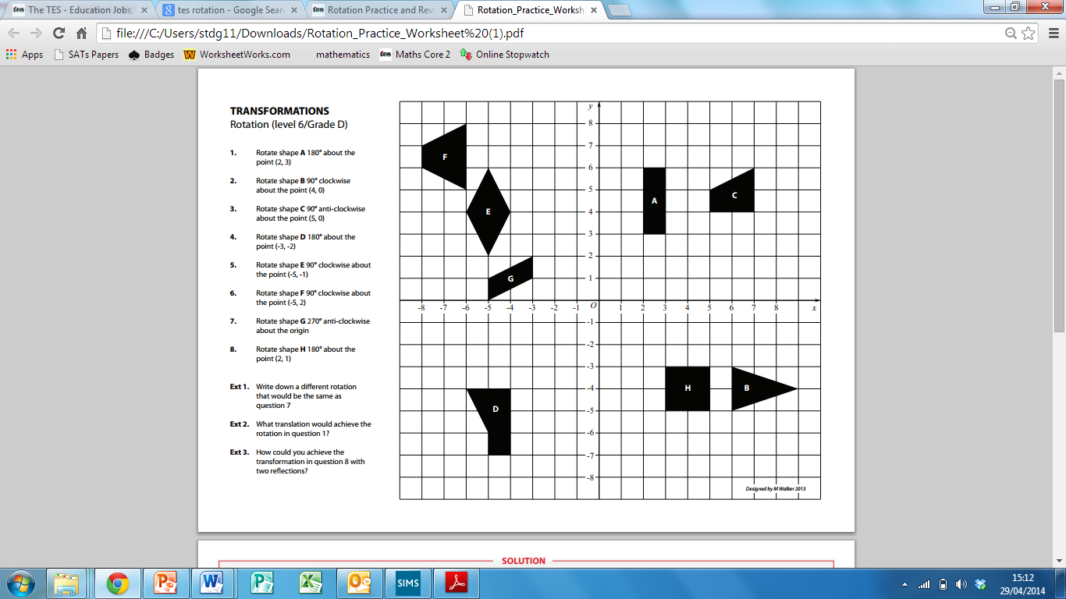

1) Rotate shape A 180° about the point (2, 3)

2) Rotate shape B 90° clockwise about the point (4, 0)

3) Rotate shape C 90° anti-clockwise about the point (5, 0)

4) Rotate shape D 180° about the point (-3, -2)

5) Rotate shape E 90° clockwise about the point (-5, -1)

6) Rotate shape F 90° clockwise about the point (-5, 2)

7) Rotate shape G 270° anti-clockwise about the origin

8) Rotate shape H 180° about the point (2, 1)

**Ext**) Write down a di­fferent rotation that would be the same as question 7.

**Ext**) What translation would achieve the rotation in question 1?

**Ext**) How could you achieve the transformation in question 8 with two reflections?

**Drawing Rotations AMBER**

Rotate 180° from (-1, 3) Rotate 180° from (-2, 1)

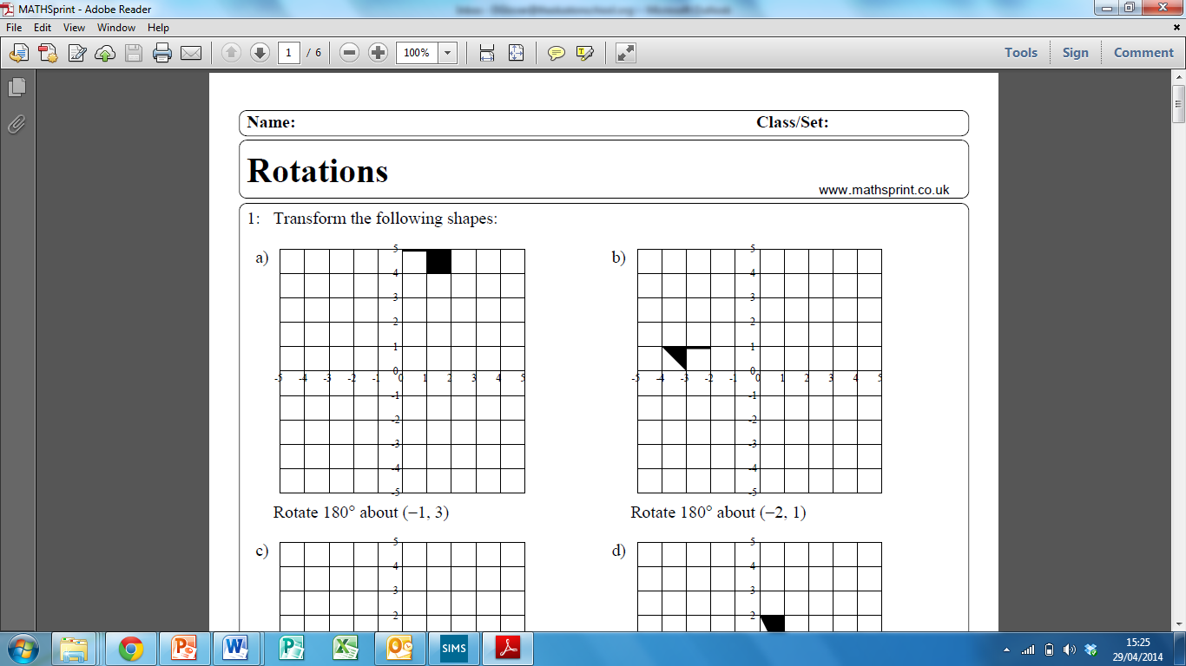 

Rotate 90° clockwise from (-3, -2) Rotate 90° anticlockwise from (-1, -1)

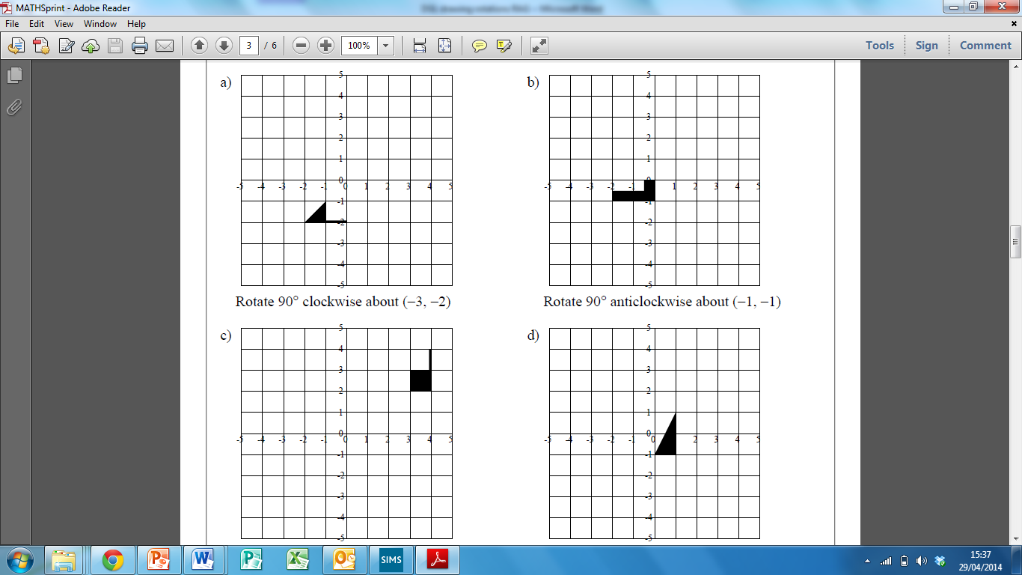 

Rotate 90° clockwise from (3, 2) Rotate 90° anticlockwise from (-1, -1)

 

**Drawing Rotations RED**

Rotate 180° from (-1, 3) Rotate 180° from (-2, 1)

1) Identify the centre of rotation ()

2) Draw vertical and horizontal lines to the object from the centre.

3) Rotate these lines 90° clockwise and the shape with it around the centre.

 

Rotate 90° clockwise from (-3, -2) Rotate 90° anticlockwise from (-1, -1)

 

Rotate 90° clockwise from (3, 2) Rotate 90° anticlockwise from (-1, -1)

 