Bands 4 – 6 Problem Solving – Test 2 Answers

1. | 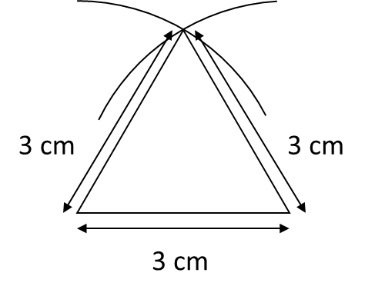  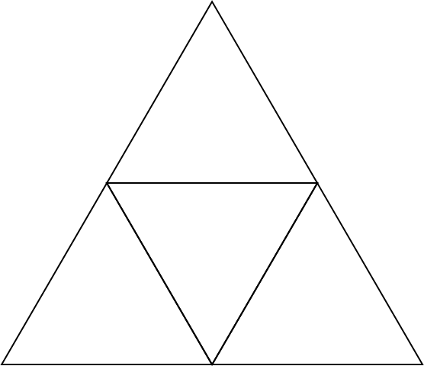 or 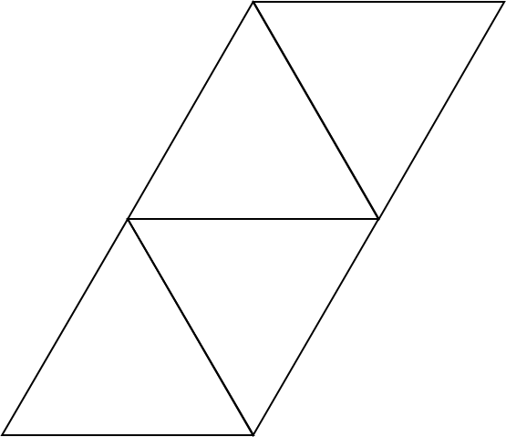 | 1 mark for a 3 cm line drawn  1 mark for compass lines drawn at 3 cm  1 mark for first complete triangle  3 marks for other 3 triangles drawn to complete the net | 6
2. | AB = 12.5 cm  5 : 12.5 = 2 : 5  7 : 17.5 cm (BC)  6 : 15  15 – 6 = 9 cm (EC)  7.5 + 7 + 17.5 + 9 = 41 cm | 1 mark for AB calculated  1 mark for 2 : 5 seen oe  1 mark for BC calculated  1 mark for EC calculated  1 mark for adding side lengths  1 mark for correct answer | 6

3. | L = $\sqrt{9^{2}+ 4^{2}}$ = $\sqrt{81+16}$ = $\sqrt{97}$ = 9.8488…  $π$rL = $π$ x 4 x 9.8488… = 123.76439… = 123.8 cm² | 1 mark for 9² or 4² or √ seen  1 mark for L calculated  1 mark for L and r substituted into formula  1 mark for 123 seen  1 mark for correct answer | 5
4. | 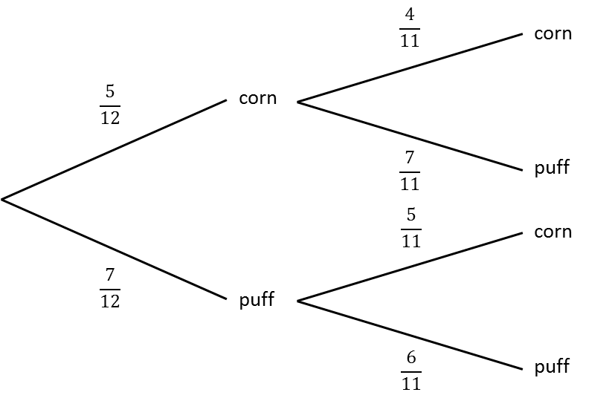  P(corn AND puff OR puff AND corn = $\left(\frac{5}{12} x \frac{7}{11}\right)+ \left(\frac{7}{12} x \frac{5}{11}\right)$  = $\frac{35}{121}$ + $\frac{35}{121}$  = $\frac{70}{121}$ | 1 mark for first choice shown on probability tree diagram  1 mark for second choice shown on probability tree diagram  1 mark for correct branches chosen  1 mark for adding/multiplying correctly  1 mark for correct answer | 5

5. | 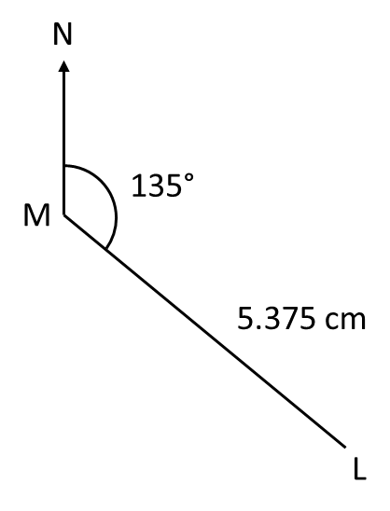  215 ÷ 40 = 5.375 cm | 1 mark for calculating distance on map  1 mark correct angle  1 mark for correct distance | 3
6. | x + 2y = 18  x + 3y = 21  y = 3  x + 6 = 18  x = 12  £12 line rental | 1 mark for each equation from question  1 mark for cost per hundred minutes  1 mark for substituting cost per 100 minutes  1 mark for correct answer | 5
7. | x(x – 5) = x² - 5x  (x – 7)² = x² - 14x + 49 | 1 mark for (x – 5) seen  1 mark for correct answer (expanded correctly)  1 mark for (x – 7) seen  1 mark for correct answer (expanded correctly) | 4

8. | $\frac{30}{600}$ = $\frac{1}{20}$ of the bats are tagged  $\frac{1}{20}$ of 40 bats = 2 bats tagged | 1 mark for $\frac{30}{600}$ seen  1 mark for $\frac{1}{20}$ of 40  1 mark for correct answer | 3
9. | 500 x 9 x 10⁻³  = 5 x 10² x 9 x 10⁻³  = 45 x 10⁻¹  = 4.5 cm  The paper tray is not deep enough | 1 mark for multiplying 500 x 9 x 10⁻³  1 mark for 45 x 10⁻¹  1 mark for 4.5 cm  1 mark correct conclusion | 4
10. | EB = $\sqrt{5^{2}+ {12}^{2}}$ = $\sqrt{25+144}$ = $\sqrt{169}$ = 13 cm  13 – 4 = 9 cm  tan⁻¹ $\left(\frac{5}{12}\right)$ = 22.6…°  9 x tan 22.6… = 3.75 cm | 1 mark for 5² and 12² seen  1 mark for EB or AB calculated  1 mark for calculations for angle EBD  1 mark for angle EBD  1 mark for calculations for side AC  1 mark for correct answer | 6

