Band 4 – Test 2 Answers

1. | 565 – 500 = 65  65 ÷ 500 x 100 = 13% | 1 mark for calculating change value  1 mark for change x 100  original  1 mark for correct answer | 3
2. | 475 x 1.57 = €745.75 | 1 mark for multiplying by exchange rate  1 mark for correct answer | 2
3. | 35.5 secs 34.4 secs 34.5 secs 34 secs 34.9 secs | Correct answer | 1
4. | 400 x 6 = 2400 = 12000  0.2 0.2 | 1 mark for rounding one value to 1 significant figure  1 mark for rounding all values to 1 significant figure  1 mark for correct answer | 3
5. | f¹⁸ | Correct answer | 1
6. | 4 x 10⁷ 0.000014 | 1 mark for each correct answer | 2
7. | 3m(2n – 3m)  g² + 7g – 3g – 21  g² + 4g - 21 | 1 mark for partially factorised  Or 2 marks for fully factorised  1 mark for expanding correctly  1 mark for simplifying correctly | 4

8. | 5p + 7 = 3(4 – p)  5p + 7 = 12 – 3p  8p + 7 = 12  8p = 5  P = 5/8 | 1 mark for correctly expanding brackets  1 mark for 8p = 5  1 mark for correct answer | 3
9. | m = 5n – 21  m + 21 = 5n  m + 21 = n  5 | 1 mark for +21 or ÷5  1 mark for correct answer | 2
10. | 5x + 12 > 2  5x > -10  x > -2 | 1 mark for 2  1 mark for correct inequality symbol used | 2
11. | 360 ÷ 10 = 36º  180 – 36 = 144º  OR  (10 – 2) x 180 = 144º  10 | 1 mark for calculating exterior angle  1 mark for 180 – exterior angle  1 mark for correct answer  OR  1 mark for calculating total interior angles  1 mark for ÷ 10  1 mark for correct answer | 3
12. | Correct perpendicular bisector with all construction lines present | 1 mark for correct answer  1 mark for construction lines | 2
13. | 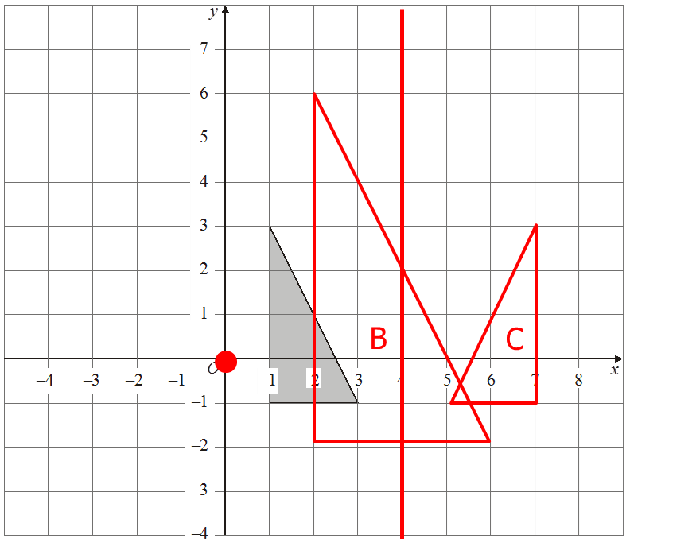 | 1 mark for identifying C of E  1 mark for an enlargement of scale factor 2  1 mark for fully correct enlargement  1 mark for identifying x = 4  1 mark for fully correct reflection | 5
14. | $\sqrt{{1.7}^{2}+{3.2}^{2}}= \sqrt{2.89+10.24}= \sqrt{13.13}$ = 3.62353… = 3.62 cm | 1 mark for 1.7² and 3.2²  1 mark for adding and square rooting  1 mark for correctly rounded answer | 3
15. | 6 km  20 mins  24 km | 1 mark for each correct answer | 3
16. | 4² x π x 10 = 16π x 10 = 502.6548… = 503 cm³ | 1 mark for correctly calculating area of cross section  1 mark for multiplying by depth  1 mark for correct answer rounded correctly | 3
17. | Only asking people who will definitely be using sports facilities  Ask somewhere else | 1 mark for each correct answer | 2
18. | The more people in towns, the fewer in farming jobs OR the fewer people in towns, the more people in farming jobs OR negative correlation  Correct line segment that can be used as a line of best fit  Accept answers between 55 and 60 | 1 mark for each correct answer | 3
19. | No negative option  Check for question with timeframe and exhaustive options that do not overlap | 1 mark for correct answer  1 mark for question  1 mark for options | 3
20. | 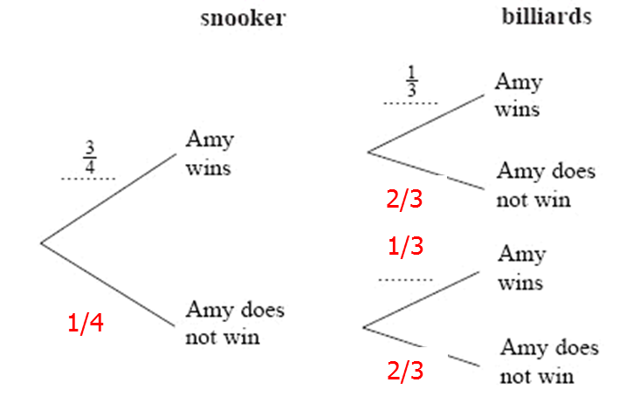 | 1 mark for correct answer for snooker  1 mark for correct answers for billiards | 2

