Band 6 – Test 3 Answers

1. | 100x = 45.4545…  - x = 0.4545…  99x = 45  x = $\frac{45}{99}$ = $\frac{5}{11}$ | 1 mark for x100  1 mark for calculating x  1 mark for answer in simplest form | 3
2. | UB C = 170.5 UB d = 54.5  LB C = 169.5 LB d = 53.5  UB $\frac{C}{d}$ = $\frac{170.5}{53.5}$ = 3.18 LB $\frac{C}{d}$ = $\frac{169.5}{54.5}$ = 3.11 | 1 mark for correct UB/LB circumference  1 mark for correct UB/LB diameter  1 mark for each correct answer | 4
3. | √60 = 4 x √15 = 2√15 | 1 mark for correct working  1 mark for correct answer | 2
4. | Gradient = -1 ÷ 2 = -½  y = -½x + c  7 = -½(4) + c  c = 9  y = -½x + 9 | 1 mark for gradient  1 mark for y-intercept  1 mark for correct answer | 3

5. | x -2 -1 0 1 2  y 1/16 1/4 1 4 16  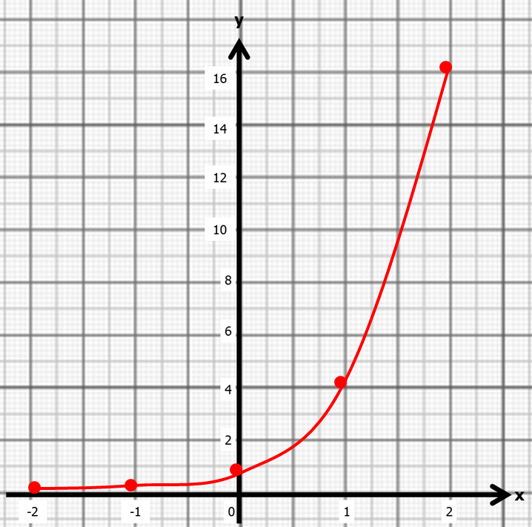 | 1 mark for at least 2 y values correct  Or 2 marks for all y values correct  1 mark for coordinates plotted correctly  1 mark for correct graph drawn | 4

6. | x³ - 3x² - 2x + 5 = 0  x³ - 2x + 5 = 3x²  $\frac{x^{3}-2x+5}{3}$ = x$²$  $\sqrt{\frac{x^{3}-2x+5}{3} }$ = x  x₁ = 2.9439…  x₂ = 2.8650…  x₃ = 2.7561…  x₄ = 2.6091… = 2.609 | 1 mark for isolating x²  1 mark for correct answer  1 mark for at least 2 correct iterations  1 mark for answer rounded correctly | 4
7. | 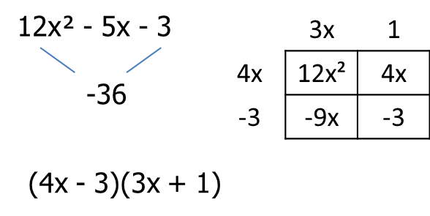  x = ¾ or -1/3 | 1 mark for correct working  1 mark for correct factorisation  1 mark for correct answer | 3
8. | x² + x – 3 = 0  $$x=\frac{-1±\sqrt{1^{2}-4(1)(-3)}}{2(1)}$$  $$x=\frac{-1±\sqrt{1+12}}{2}$$  x = 1.30 or -2.30 | 1 mark for rearranging to equal 0  1 mark for correct substitution  1 mark for correct answer | 3
9. | 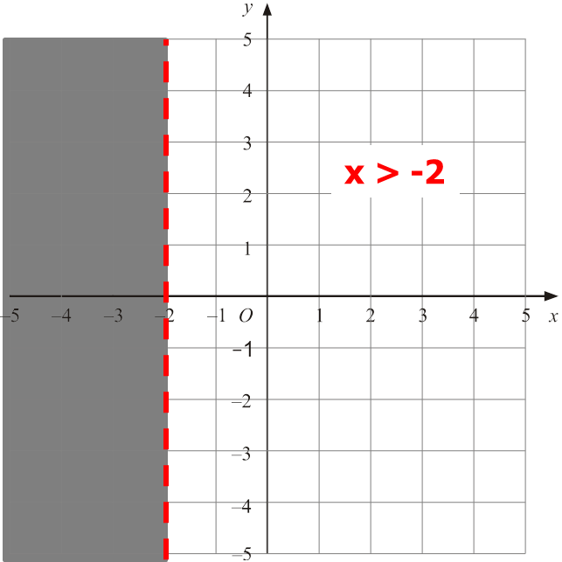 | 1 mark for dotted line  1 mark for correct side indicated | 2
10. | 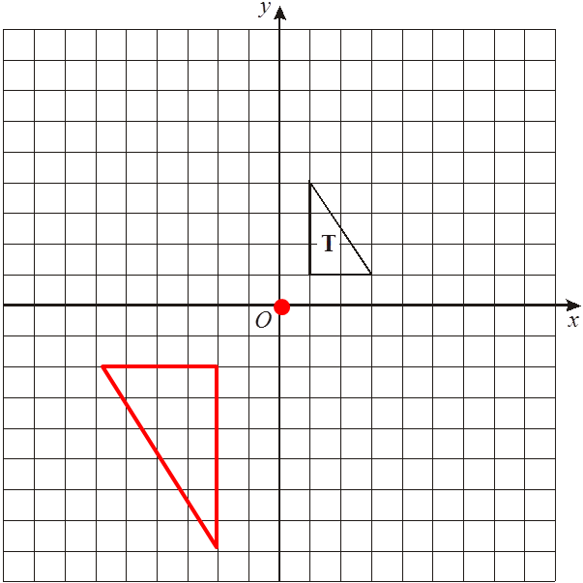 | 1 mark for C of E correctly identified  1 mark for SF -2  1 mark for correct enlargement | 3
11. | $\sqrt{3^{2}+ 5^{2}+ 7^{2}}= \sqrt{83}$ = 9.1104… = 9.11 cm | 1 mark for 2 dimensions squared  1 mark for correct working  1 mark for correct conclusion | 3
12. | $\sqrt{{12}^{2}+ 2^{2}}= \sqrt{148}$ = 12.1655…  tan⁻¹$\left(\frac{5}{\sqrt{148}}\right)$ = 22.342538… 22.3º | 1 mark for $\sqrt{148}$ oe  1 mark for tan used  1 mark for correct working  1 mark for answer rounded correctly | 4
13. | ½ x 11.7 x 28.3 x sin67 = 143.80629… = 144 cm² | 1 mark for correct substitution  1 mark for correct working  1 mark for correct answer | 3

14. | 6 ÷ 4 = 1.5  80 x ${1.5}^{3}$ = 270 cm³ | 1 mark for sf 1.5  1 mark for correct working  1 mark for correct answer | 3
15. | Weight (w g.) Frequency Midpoint M x f  50 ≤ w < 60 5 55 275  60 ≤ w < 70 9 65 585  70 ≤ w < 80 22 75 1650  80 ≤ w < 90 27 85 2295  90 ≤ w < 100 17 95 1615  6420 = 80.25 grams  80 | 1 mark for correct third column  1 mark for correct fourth column  1 mark for Σmf  Σf  1 mark for correct answer rounded correctly | 4
16. | 4 < x ≤ 6  4 < x ≤ 6 | 1 mark for each correct answer | 2

