**Probability (H)**

Pre-Intervention Assessment

Name: _______________________________

Class: _______________________________

Date: _______________________________

|  |  |  |
| --- | --- | --- |
| **Question** | **Objective** | **RAG** |
| 1 | Calculate probability from Venn Diagrams |  |
| 2 | Draw and complete probability trees |  |
| 3 | Calculate with conditional probability |  |
| 4 | Solve probability problems involving algebra |  |

**1.** 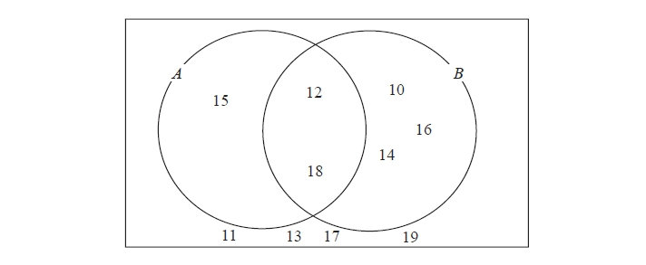Here is a Venn diagram.

(a)   Write down the numbers

that are in set

(i)   *A* ∪ *B*

.............................................

(ii)   *A* ∩ *B*

.............................................

One of the numbers in the diagram is chosen at random.

(b)   Find the probability that the number is in set *A'*

...........................................................

**2**. Matthew puts 3 red counters and 5 blue counters in a bag. He takes at random a counter from the bag. He writes down the colour of the counter. He puts the counter in the bag again. He then takes at random a second counter from the bag.

(a) Complete the probability tree diagram.



(b) Work out the probability that Matthew takes two red counters.

...........................................................

**3**. These 6 coins are in a box.



Pritesh takes at random 2 coins from the box.

Work out the probability that the total value of the 2 coins is at least 40p.

...........................................................

**4**. There are *N* beads in a jar.  
40 of these beads are black.

Julie takes at random a sample of 50 beads from the jar.  
5 of the beads in her sample are black.

Work out an estimate for the value of *N*.

      ...........................................................

[Glue here]