**Transformations (H)**

Intervention Booklet

Name: _______________________________

Class: _______________________________

**Useful websites:**

**www.mathswatchvle.com**

*(Video explanations and questions)*

Username: STH…@twgash

Password: stmaths

**www.methodmaths.com**

*(Past papers online that get instantly marked)*

Centre ID: wga

Username: firstname

Password: lastname

**www.hegartymaths.com**

*(Online tutorials and quizzes)*

Login: first name and last name are case sensitive

**www.bbc.co.uk/schools/gcsebitesize/maths**

**Describing Transformations**

**Things to remember:**

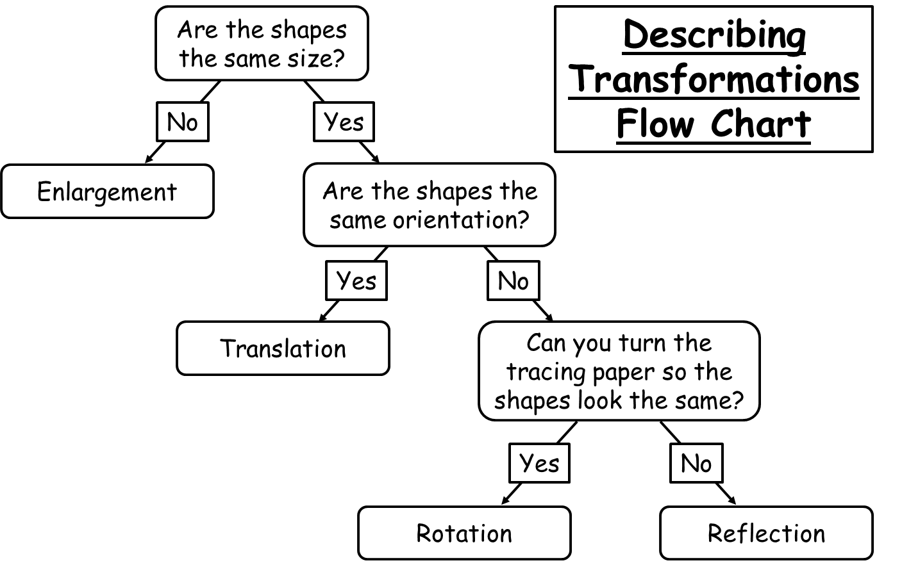

**Questions:**

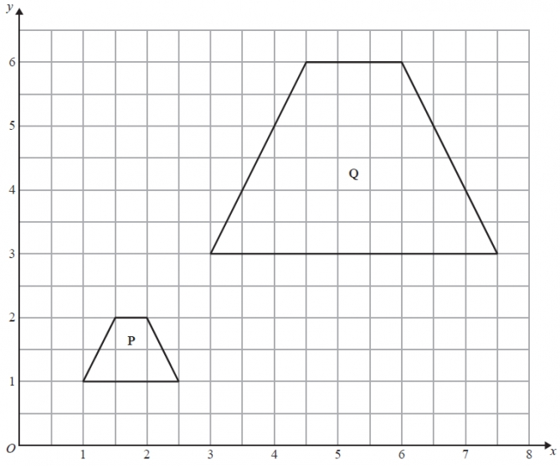**1.** Describe fully the single

transformation that maps shape P onto shape Q.

…………………………………

…………………………………

…………………………………

**(Total for Question is 3 marks)**

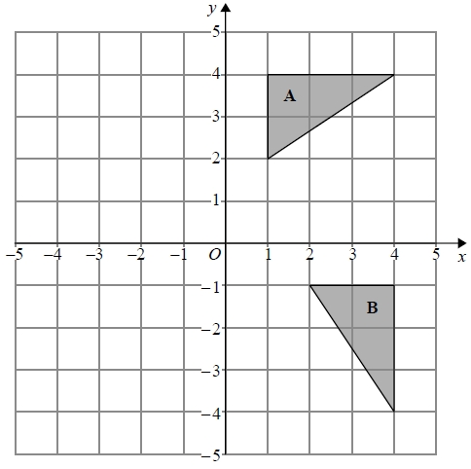

**2.** Describe fully the single transformation

that maps triangle A onto triangle B.

…………………………………

…………………………………

…………………………………

**(Total for question = 2 marks)**

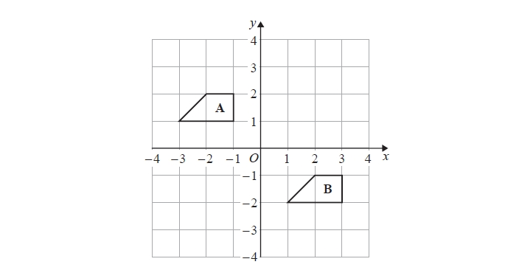**3.** Describe the single transformation that

maps shape A onto shape B.

…………………………………

…………………………………

**(Total for question = 2 marks)**

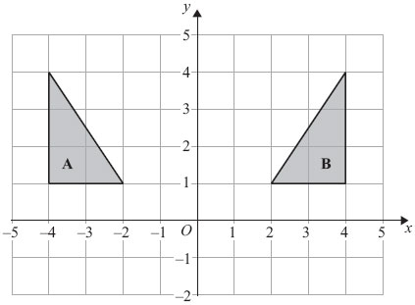**4.** Describe fully the single

transformation that maps shape A onto shape B.

…………………………………

…………………………………

**(Total for Question is 2 marks)**

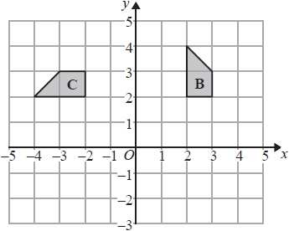**5.** Describe fully the single

transformation that maps shape B onto shape C.

…………………………………

…………………………………

…………………………………

**(Total for question = 3 marks)**

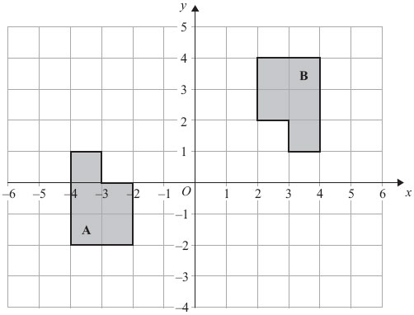**6.** Describe fully the single

transformation that maps shape A onto shape B.

…………………………………

…………………………………

…………………………………

**(Total for Question is 3 marks)**

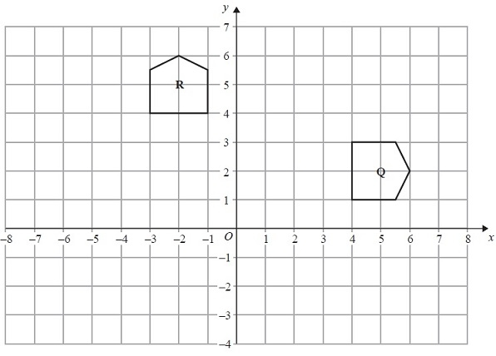**7.** Describe fully the single

transformation that maps shape Q onto shape R.

…………………………………

…………………………………

…………………………………

**(Total for Question is 3 marks)**

**Transformations – Enlargement (Fractional and Negative Scale Factors)**

**Things to remember:**

* The shape is made bigger or smaller by a scale factor from a centre.
* If the scale factor is greater than 1, the shape gets bigger.
* If the scale factor is between 0 and 1, the shape get smaller.
* If the scale factor is negative, the shape is inversed through the centre of enlargement.
* Remember to enlarge the distance from the centre to the shape too!

**Questions:**

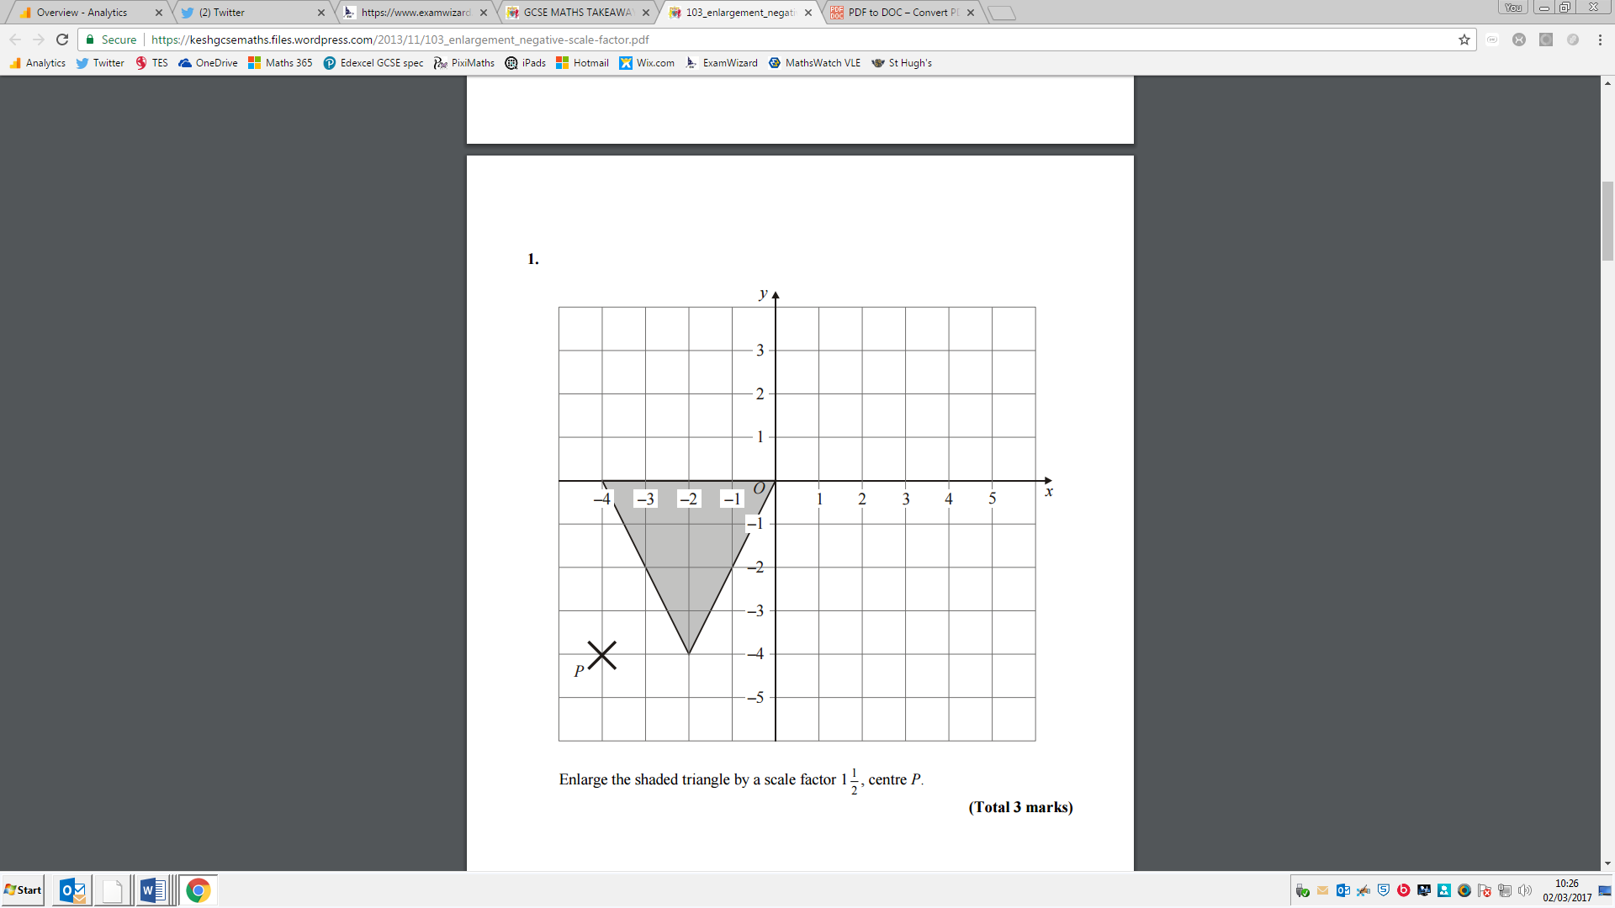**1.** Enlarge the shaded triangle by a

scale factor 1 ½, centre *P*.

**(Total 3 marks)**

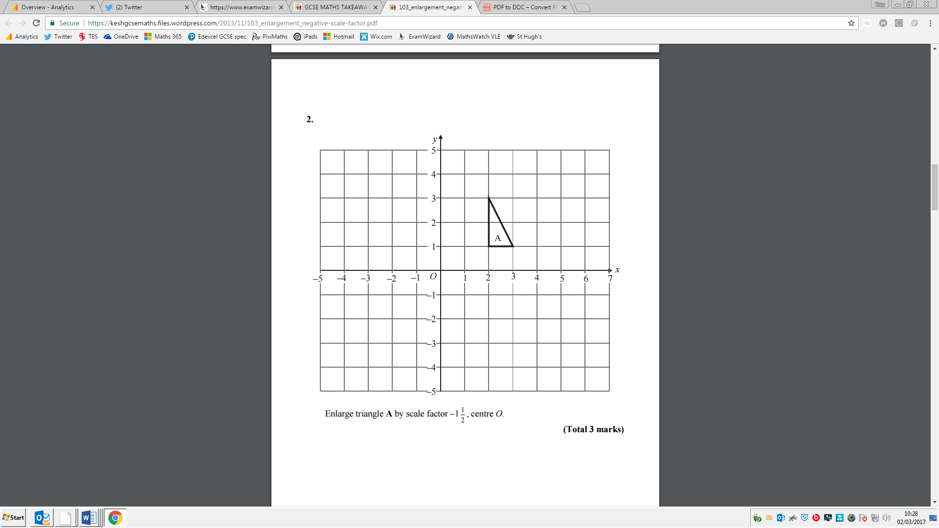**2.** Enlarge triangle A by a scale factor -1 ½, centre *O*.

**(Total 3 marks)**

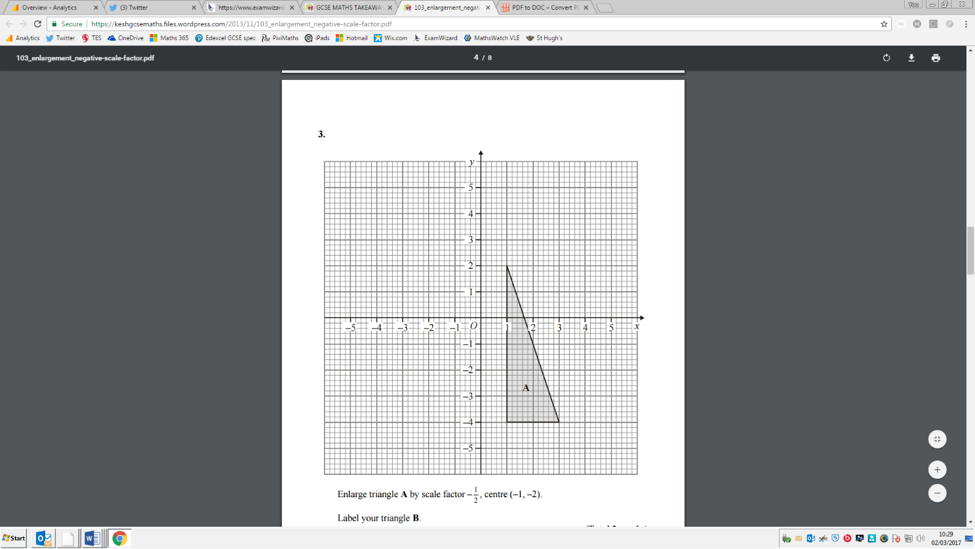**3.** Enlarge triangle A by scale factor –½, centre (–1, –2). Label your triangle B.

**(Total 3 marks)**

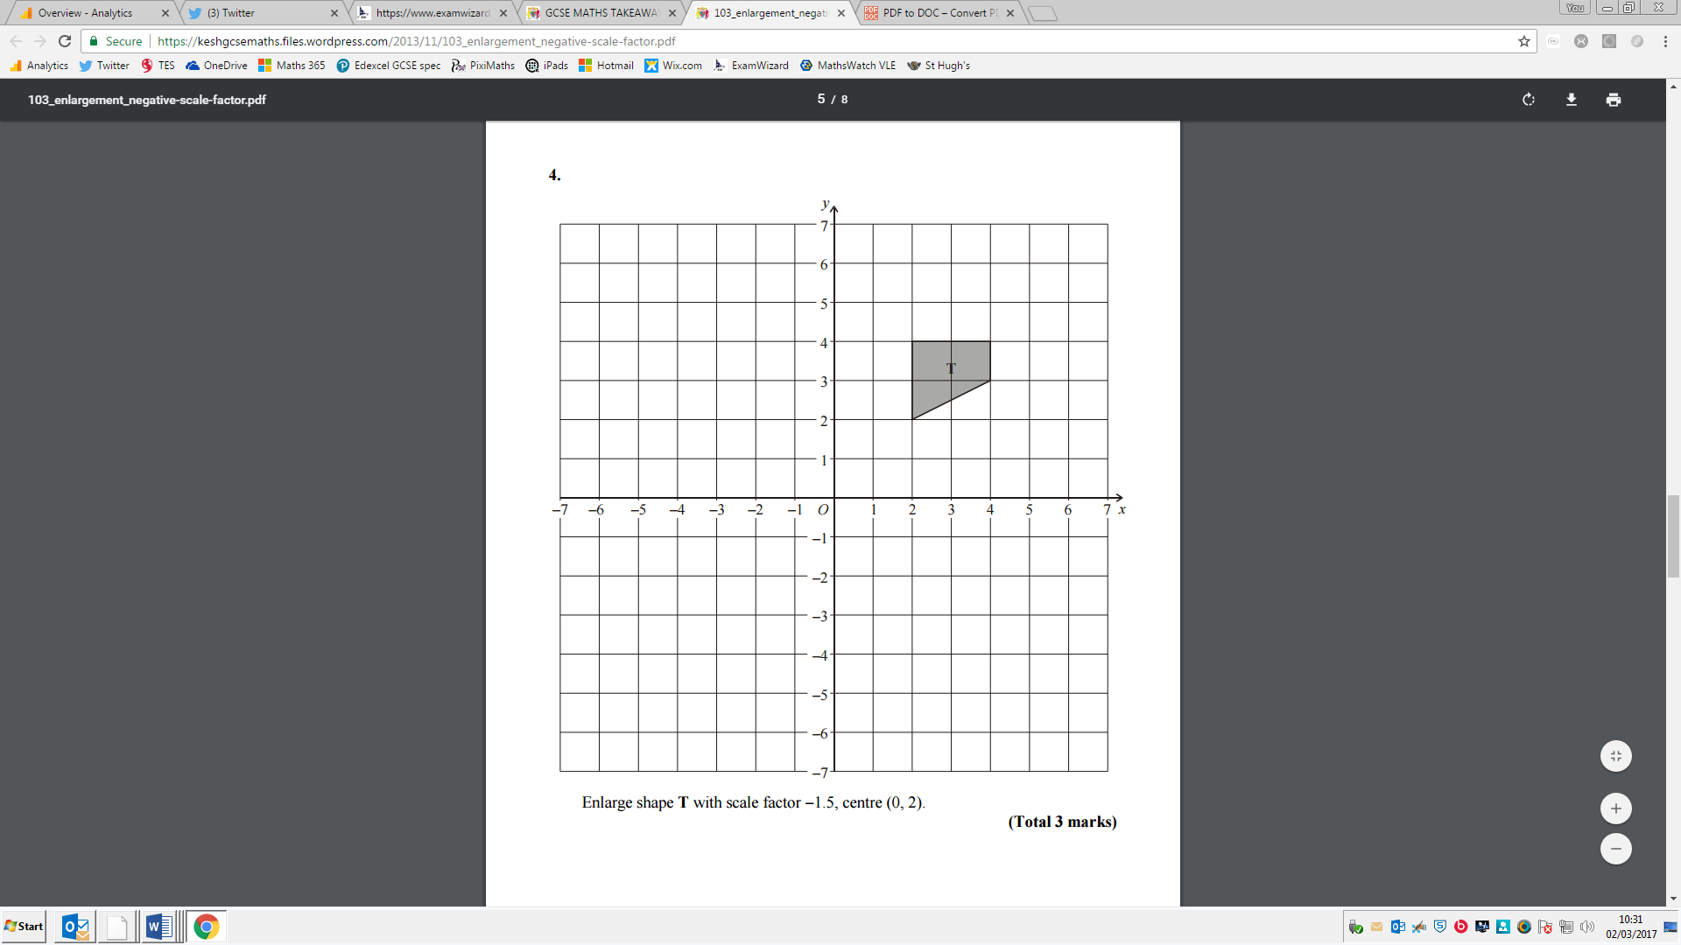**4.** Enlarge shape T with scale factor -1.5, centre (0, 2).

**(Total 3 marks)**

**Vectors**

**Things to remember:**

* Use the letter provided in the question.
* Going against the arrow is a negative.
* Vectors need to be written in bold or underlined.
* They can be manipulated similarly to algebra.

**Questions:**

**1.** The diagram shows a regular hexagon *ABCDEF* with centre *O*.



** = 6**a** ****= 6**b**

(a) Express in terms of **a** and/or **b**

(i) ,

...........................................................

(ii) .

...........................................................

**(2)**

*X* is the midpoint of *BC*.

(b) Express in terms of **a** and/or **b**

...........................................................

**(2)**

*Y* is the point on *AB* extended, such that *AB* : *BY* = 3:2

(c) Prove that *E*, *X* and *Y* lie on the same straight line.

**(3)**

**(Total 7 marks)**

**2.** *T* is the point on *PQ* for which *PT* : *TQ* = 2 : 1.  


*OPQ* is a triangle.  
 = **a** and  = **b**.

(a) Write down, in terms of **a** and **b**, an expression for .

 = ...........................................................

**(1)**

(b) Express  in terms of **a** and **b**.  
Give your answer in its simplest form.

 = ...........................................................

**(2)**

**(Total 3 marks)**

**3.** *OABC* is a parallelogram.



*P* is the point on *AC* such that *AP* = *AC*.

 = 6**a.**  = 6**c.**

1. Find the vector .  
   Give your answer in terms of **a** and **c**.

...........................................................

**(3)**

The midpoint of *CB* is *M***.**

(b) Prove that *OPM* is a straight line.

**(2)**

**(Total 5 marks)**

**4.** *OPQ* is a triangle.  
*R* is the midpoint of *OP*.  
*S* is the midpoint of *PQ*.  
 = **p** and  = **q**



1. Find  in terms of **p** and **q**.

 = ...........................................................

(ii) Show that *RS* is parallel to *OQ*.

**(Total** **5** **marks)**

**5.** Diagram **NOT** accurately drawn



*ABCD* is a parallelogram.  
*AB* is parallel to *DC.  
AD* is parallel to *BC.*

* =* **p*** =* **q**

(a) Express, in terms of p and q

(i) 

...........................................................

(ii) 

...........................................................

**(2)**

Diagram **NOT** accurately drawn



*AC* and *BD* are diagonals of parallelogram *ABCD.  
AC* and *BD* intersect at *T.*

1. Express in terms of **p** and **q.**

...........................................................

**(1)**

**(Total 3 marks)**

**6.** Diagram **NOT** accurately drawn

*OAB* is a triangle.  
*B* is the midpoint of *OR*.  
*Q* is the midpoint of *AB*.

 = 2**a**  = **a**  = **b**



(a) Find, in terms of **a** and **b**, the vectors

(i) ,

...........................................................

(ii) ,

...........................................................

(iii) .

...........................................................

**(4)**

(b) Hence explain why *PQR* is a straight line.

**(2)**

The length of *PQ* is 3 cm.

(c) Find the length of *PR*.

........................................................... cm

**(1)**

**(Total 7 marks)**