End of Unit Test Name: ____________________________
Lines, Angles and Shapes - FOUNDATION

1. (a) The diagram shows a regular octagon. Not drawn
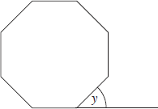
accurately. The base line of the octagon is extended. Work out the size of angle y.

………………………………………………………………..

………………………………………………………………..

………………………………………………………………..

Answer …………………………………………………°
(2)
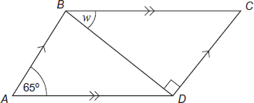
(b) ABCD is a parallelogram. BD is a diagonal. Not drawn accurately. Work out the size of angle w.

…………………………………………

…………………………………………

…………………………………………………………………………………………………..

Answer …………………………………………………°
(3)
(Total 5 marks)
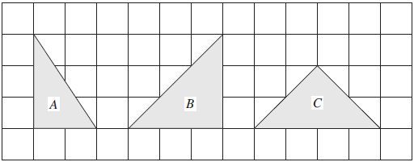
2. Three triangles are shown on the centimetre grid.
(a) Which triangle is not isosceles?

Answer ...............................
(1)
(b) Work out the area of the triangle with the greatest area. State the units of your answer.

…………………………………………………………………………………………………

Answer ......................................................................
(3)
(Total 4 marks)
3. (a) Work out the size of angle x. Not drawn accurately.

…………………………………………………………………

…………………………………………………………………

…………………………………………………………………

Answer …………………………………………………°
(2)
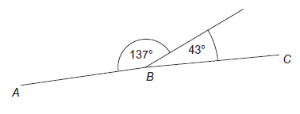
(b) Not drawn accurately. Give a reason why, if drawn accurately, ABC would be a straight line.

…………………………………

…………………………………

…………………………………………………………………………………………………
(1)
(Total 3 marks)
4.
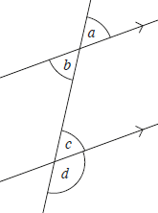
(a) Which angles are vertically opposite? Circle your answer

a and b a and c b and c b and d c and d
(1)
(b) Which angles are alternate? Circle your answer

a and b a and c b and c b and d c and d
(1)
(c) Which angles are corresponding? Circle your answer

a and b a and c b and c b and d c and d
(1)
(Total 3 marks)
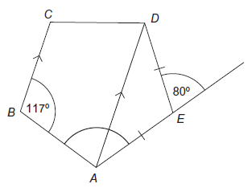
5. AD is parallel to BC. AE = DE. Not drawn accurately. Work out the size of angle BAE.

……………………………………………………

……………………………………………………

……………………………………………………

……………………………………………………

……………………………………………………

……………………………………………………

Answer …………………………………………………°
(Total 3 marks)
6. (a) These triangles are congruent. Not drawn accurately

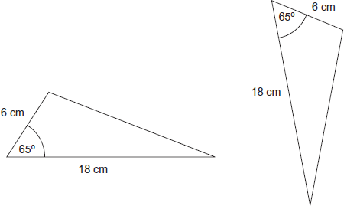
State the condition they satisfy.
Answer ......................................................................
(1)
(b) These triangles are congruent. Not drawn accurately

State the condition they satisfy.
Answer ......................................................................
(1)
(Total 2 marks)

(Total for test = 20 marks)

