Calculate the volume of this cuboid  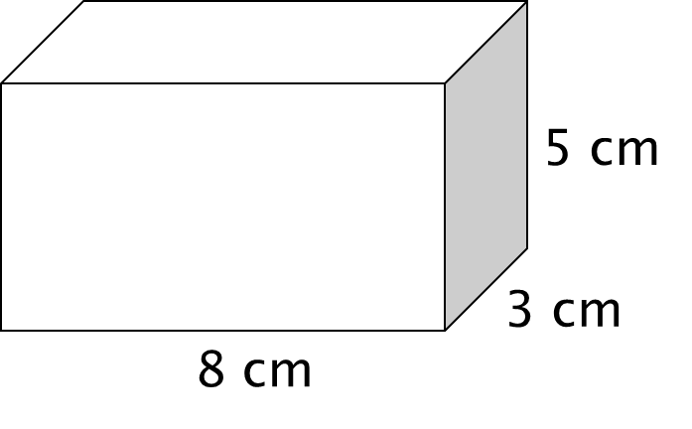 | Calculate the volume of this cuboid
Calculate the volume of this cuboid | Calculate the volume of this cuboid
Calculate the volume of this cuboid | Calculate the volume of this cuboid
Calculate the volume of this cuboid | Calculate the volume of this cuboid
Calculate the volume of this cuboid | Calculate the volume of this cuboid
Calculate the volume of this cuboid | Calculate the volume of this cuboid
Calculate the volume of this cuboid | Calculate the volume of this cuboid
Calculate the surface area of this cuboid | Calculate the surface area of this cuboid
Calculate the surface area of this cuboid | Calculate the surface area of this cuboid
Calculate the surface area of this cuboid | Calculate the surface area of this cuboid
Calculate the surface area of this cuboid | Calculate the surface area of this cuboid
Calculate the surface area of this cuboid | Calculate the surface area of this cuboid
Calculate the surface area of this cuboid | Calculate the surface area of this cuboid
Calculate the surface area of this cuboid | Calculate the surface area of this cuboid
Calculate the volume of this prism  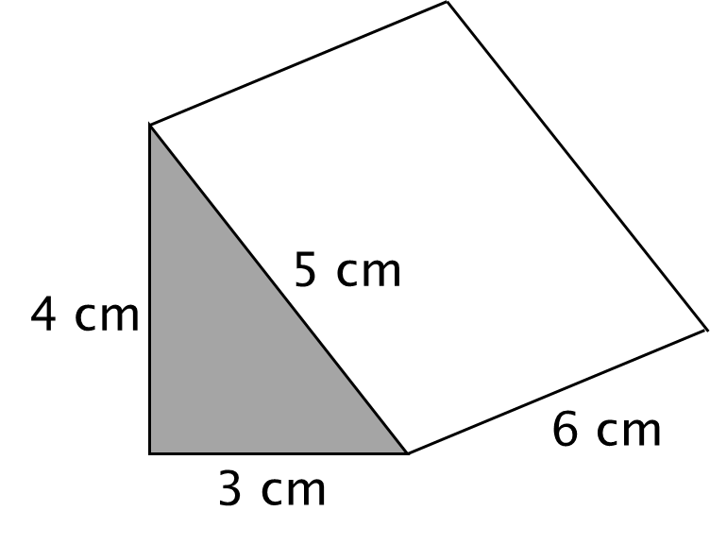 | Calculate the volume of this prism
Calculate the volume of this prism | Calculate the volume of this prism
Calculate the volume of this prism | Calculate the volume of this prism
Calculate the volume of this prism | Calculate the volume of this prism
Calculate the volume of this prism | Calculate the volume of this prism
Calculate the volume of this prism | Calculate the volume of this prism
Calculate the volume of this prism | Calculate the volume of this prism
Calculate the volume of this cylinder  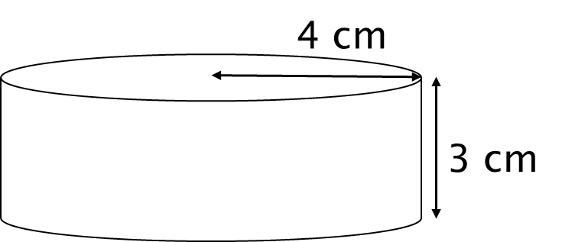 | Calculate the volume of this cylinder
Calculate the volume of this cylinder | Calculate the volume of this cylinder
Calculate the volume of this cylinder | Calculate the volume of this cylinder
Calculate the volume of this cylinder | Calculate the volume of this cylinder
Calculate the volume of this cylinder | Calculate the volume of this cylinder
Calculate the volume of this cylinder | Calculate the volume of this cylinder
Calculate the volume of this cylinder | Calculate the volume of this cylinder
Calculate the surface area of this cylinder | Calculate the surface area of this cylinder
Calculate the surface area of this cylinder | Calculate the surface area of this cylinder
Calculate the surface area of this cylinder | Calculate the surface area of this cylinder
Calculate the surface area of this cylinder | Calculate the surface area of this cylinder
Calculate the surface area of this cylinder | Calculate the surface area of this cylinder
Calculate the surface area of this cylinder | Calculate the surface area of this cylinder
Calculate the surface area of this cylinder | Calculate the surface area of this cylinder
Calculate the volume of this prism  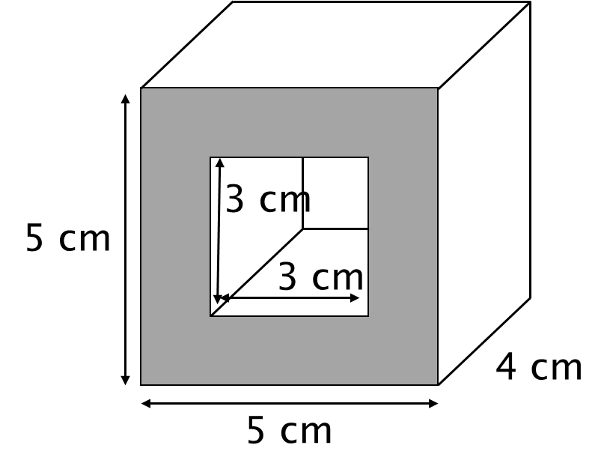 | Calculate the volume of this prism
Calculate the volume of this prism | Calculate the volume of this prism
Calculate the volume of this prism | Calculate the volume of this prism
Calculate the volume of this prism | Calculate the volume of this prism
Calculate the volume of this prism | Calculate the volume of this prism
Calculate the volume of this prism | Calculate the volume of this prism
Calculate the volume of this prism | Calculate the volume of this prism
The volume of a hemisphere is $\frac{250}{3}π$ cm³  Work out the radius of the hemisphere. | The volume of a hemisphere is $\frac{250}{3}π$ cm³  Work out the radius of the hemisphere.
The volume of a hemisphere is $\frac{250}{3}π$ cm³  Work out the radius of the hemisphere. | The volume of a hemisphere is $\frac{250}{3}π$ cm³  Work out the radius of the hemisphere.
The volume of a hemisphere is $\frac{250}{3}π$ cm³  Work out the radius of the hemisphere. | The volume of a hemisphere is $\frac{250}{3}π$ cm³  Work out the radius of the hemisphere.
The volume of a hemisphere is $\frac{250}{3}π$ cm³  Work out the radius of the hemisphere. | The volume of a hemisphere is $\frac{250}{3}π$ cm³  Work out the radius of the hemisphere.
The volume of a hemisphere is $\frac{250}{3}π$ cm³  Work out the radius of the hemisphere. | The volume of a hemisphere is $\frac{250}{3}π$ cm³  Work out the radius of the hemisphere.
The volume of a hemisphere is $\frac{250}{3}π$ cm³  Work out the radius of the hemisphere. | The volume of a hemisphere is $\frac{250}{3}π$ cm³  Work out the radius of the hemisphere.
The volume of a hemisphere is $\frac{250}{3}π$ cm³  Work out the radius of the hemisphere. | The volume of a hemisphere is $\frac{250}{3}π$ cm³  Work out the radius of the hemisphere.
A frustum is made by removing a small cone from a large cone as shown in the diagram. Work out the volume of the frustum. Give your answer to an appropriate degree of accuracy. | A frustum is made by removing a small cone from a large cone as shown in the diagram. Work out the volume of the frustum. Give your answer to an appropriate degree of accuracy.
A frustum is made by removing a small cone from a large cone as shown in the diagram. Work out the volume of the frustum. Give your answer to an appropriate degree of accuracy. | A frustum is made by removing a small cone from a large cone as shown in the diagram. Work out the volume of the frustum. Give your answer to an appropriate degree of accuracy.
A frustum is made by removing a small cone from a large cone as shown in the diagram. Work out the volume of the frustum. Give your answer to an appropriate degree of accuracy. | A frustum is made by removing a small cone from a large cone as shown in the diagram. Work out the volume of the frustum. Give your answer to an appropriate degree of accuracy.
A frustum is made by removing a small cone from a large cone as shown in the diagram. Work out the volume of the frustum. Give your answer to an appropriate degree of accuracy. | A frustum is made by removing a small cone from a large cone as shown in the diagram. Work out the volume of the frustum. Give your answer to an appropriate degree of accuracy.
A frustum is made by removing a small cone from a large cone as shown in the diagram. Work out the volume of the frustum. Give your answer to an appropriate degree of accuracy. | A frustum is made by removing a small cone from a large cone as shown in the diagram. Work out the volume of the frustum. Give your answer to an appropriate degree of accuracy.
A frustum is made by removing a small cone from a large cone as shown in the diagram. Work out the volume of the frustum. Give your answer to an appropriate degree of accuracy. | A frustum is made by removing a small cone from a large cone as shown in the diagram. Work out the volume of the frustum. Give your answer to an appropriate degree of accuracy.
A frustum is made by removing a small cone from a large cone as shown in the diagram. Work out the volume of the frustum. Give your answer to an appropriate degree of accuracy. | A frustum is made by removing a small cone from a large cone as shown in the diagram. Work out the volume of the frustum. Give your answer to an appropriate degree of accuracy.

