Linear Graphs from a Table of Values Starter

For each question:
- Complete the table of values using substitution.
- Write the coordinates underneath.
- Plot the coordinates on the given axes with a PENCIL.
- Join the coordinates with a RULER.

x | 0 | 1 | 2 | 3 | 4 | 5
y = 3x + 1 | 1 | 4
1.

( 0, 1 ) ( 1, 4 ) ( 2, ) ( 3, ) ( 4, ) ( 5, )

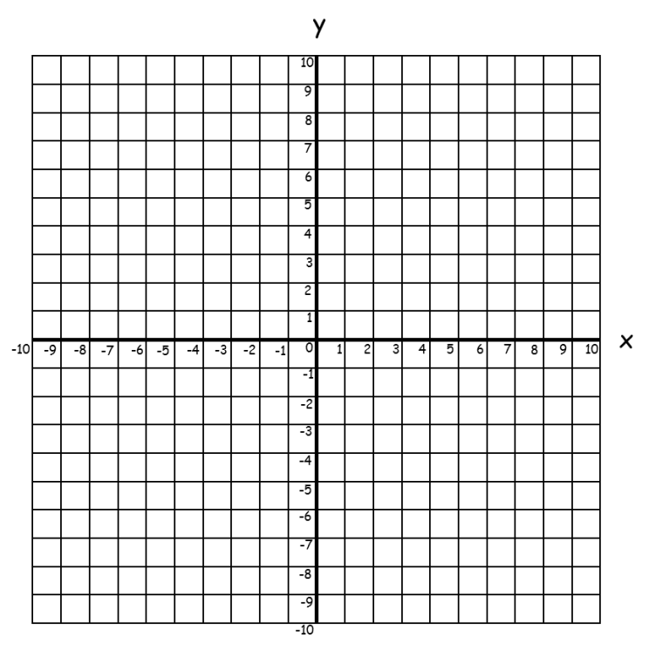
x | 0 | 1 | 2 | 3 | 4 | 5
y = 2x - 4 | -4 | -2
2.

