**Probability (F)**

Pre-Intervention Assessment

Name: _______________________________

Class: _______________________________

Date: _______________________________

|  |  |  |
| --- | --- | --- |
| **Question** | **Objective** | **RAG** |
| 1 | Solve probability problems |  |
| 2 | Calculate probability from sample space diagrams |  |
| 3 | Calculate with relative frequency |  |
| 4 | Calculate probability from Venn Diagrams |  |
| 5 | Draw and complete probability trees |  |

**1.** A company makes hearing aids.

A hearing aid is chosen at random. The probability that is has a fault is 0.09

Work out the probability that a hearing aid, chosen at random, will **not** have a fault.

…………………

**2**. Kerry has two fair 6-sided dice, A and B.

Kerry is going to roll both dice.

(a)   Complete the sample space diagram to show all the possible outcomes.

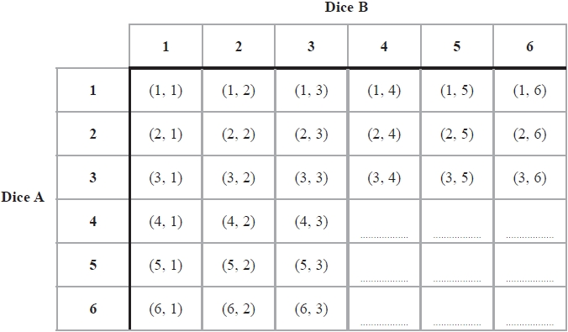

(b)   Write down the probability that Kerry will get a 1 on dice A and a 1 on dice B.

...........................................................

Kerry rolls dice A and dice B.

(c)   Compare the probability that Kerry will get a total of 6 with the probability that she will get a total of 7

....................................................................................................................

....................................................................................................................

**3**. The probability that a pea plant will grow from a seed is 93%.

Sarah plants 800 seeds.

Work out an estimate for the number of seeds that will grow into pea plants.

...........................................................

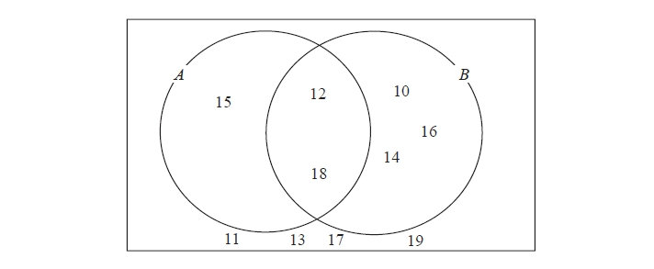**4**. Here is a Venn diagram.

(a)   Write down the numbers

that are in set

(i)   *A* ∪ *B*

.............................................

(ii)   *A* ∩ *B*

.............................................

One of the numbers in the diagram is chosen at random.

(b)   Find the probability that the number is in set *A'*

...........................................................

**5**. Matthew puts 3 red counters and 5 blue counters in a bag. He takes at random a counter from the bag. He writes down the colour of the counter. He puts the counter in the bag again. He then takes at random a second counter from the bag.

(a) Complete the probability tree diagram.



(b) Work out the probability that Matthew takes two red counters.

...........................................................

[Glue here]