Bands 3 – 5 Problem Solving – Test 3 Answers

1. | 10% of £240 = £24  5% of £240 = £12  15% of £240 = £36  The increase is not more than Jim asked for | 1 mark for 10% or 5% calculated  1 mark for 15% calculated  1 mark for correct conclusion | 3
2. | 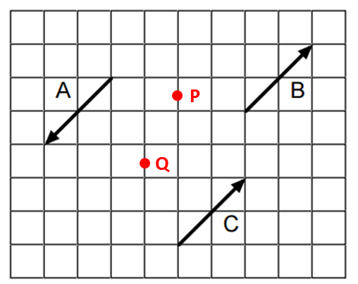 | 1 mark for each point plotted correctly | 2
3. | 2x + x + 3 + 2 + (2x + 3) + (x + 2)  = 6x + 10  = 2(3x + 5) | 1 mark for attempt to write expression for perimeter  1 mark for all sides included in expression  1 mark for correctly simplifying  1 mark for correctly factorised | 4
4. | 90 ÷ 3 = 30 cm diameter  Radius + diameter + radius = 15 + 30 + 15 = 60 cm | 1 mark for diameter or radius calculated  1 mark for adding lengths  1 mark for correct answer | 3

5. | Area of grass = ((17 – 28) x 9.5) – (2 x $π$ x 1.9²)  = (14.2 x 9.5) – (2 x 3.61$π$)  = 134.9 – 22.682…  = 112.217701…  112.217701… ÷ 12 = 9.35147…  10 bags of fertiliser | 1 mark for area of rectangle  1 mark for area of circle  1 mark for area of grass  1 mark for ÷ 12 seen  1 mark for correct answer | 5
6. | $\sqrt{6^{2}-{1.5}^{2}}= \sqrt{36-2.25}= \sqrt{33.75}$  = 5.809475… = 5.8 m  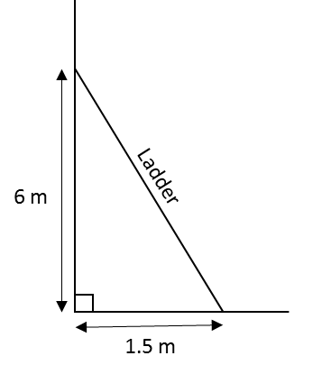 | 1 mark for 6 or 1.5 squared  1 mark for $6^{2}-{1.5}^{2}$  1 mark for correct answer to 1 decimal place | 3

7. | 1.25 x 0.6 x 1.4 = 1.05  5% increase | 1 mark for at least 1 multiplier correct  1 mark for multiplying 3 correct multipliers  1 mark for 1.05 seen  1 mark for correct answer | 4
8. | Fixed charge is £10  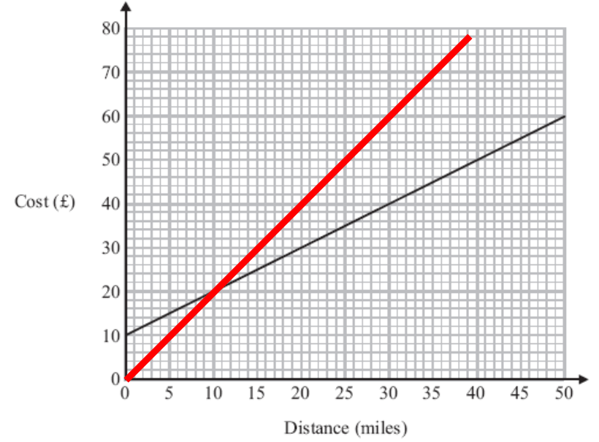  Bill is cheapest less than 10 miles  Ed is cheapest more than 10 miles  They cost the same for 10 miles | 1 mark for correct answer  1 mark for correct line segment drawn from (0, 0), intersecting Bill’s graph at (10, 20)  1 mark for less than 10 miles comparison  1 mark for more than 10 miles comparison | 4
9. | Lower bound of 141.4 = 141.35  141.35² = 19979.8225  19980 is smallest number | 1 mark for LB of 141.4  1 mark for squaring LB  1 mark for correct answer | 3
10. | Slice A = 100x  Slice B = 10(10 – x)x  = 100x – 10x²  Slice C = x(10 – x)(10 – x)  = x(100 – 20x + x²)  = 100x – 20x² + x³ | 1 mark for Slice A correct  1 mark for expression for Slice B  1 mark for Slice B correct  1 mark for expression for Slice C  1 mark for brackets expanded  1 mark for Slice C correct | 6
11. | P(2 stars) = $\frac{4}{9}$ x $\frac{3}{8}$ = $\frac{12}{72}$  P(2 hearts) = $\frac{3}{9}$ x $\frac{2}{8}$ = $\frac{6}{72}$  P(winning) = $\frac{12}{72}$ + $\frac{6}{72}$ = $\frac{18}{72}$ = $\frac{1}{4}$  1440 x £1 = £1440 income  $\frac{12}{72}$ x 1440 x £1.50 = £360 loss  $\frac{6}{72}$ x 1440 x £2 = £240  £1440 – (£360 + £240) = £840 raised for charity | 1 mark for P(2 stars)  1 mark for P(2 hearts)  1 mark for adding together  1 mark for correct answer oe  1 mark for total made from scratch card sales  1 mark for taking away stars prizes  1 mark for taking away hearts prizes  1 mark for correct answer | 7
12. | Coffee upper bound = 130.5 ml  Cup lower bound = 174.5 ml  Milk upper bound = 21.5 ml  130.5 + (2 x 21.5) = 173.5  173.5 is less than 174.5 so Beryl’s cup will never overflow | 1 mark for each correct bound  1 mark for adding liquid contents  1 mark for 73.5 seen  1 mark for correct conclusion | 6

