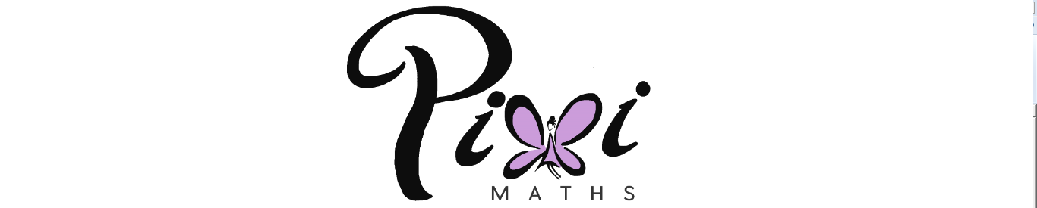**Lines, Angles and Shapes (F)**

Intervention Booklet

Name: _______________________________

Class: _______________________________

**Useful websites:**

**www.mathswatchvle.com**

*(Video explanations and questions)*

Centre ID: twgash

Username: firstname

Password: lastname

**www.methodmaths.com**

*(Past papers online that get instantly marked)*

Centre ID: wga

Username: firstname

Password: lastname

**www.hegartymaths.com**

*(Online tutorials and quizzes)*

Login: first name and last name are backwards and case sensitive

**www.bbc.co.uk/schools/gcsebitesize/maths**

**Interior and exterior angles**

**Things to remember:**

* Interior Angles:
  + For n sides, the sum of interior angles = (n – 2) x 180
  + Each interior angle = (n – 2) x 180

n

* Exterior Angles:
  + The sum of exterior angles in any shape (or polygon) is 360°

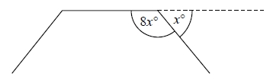**Questions:**

**1.** The diagram shows three sides of a regular polygon.

The size of each exterior angle of the regular polygon is x°.

The size of each interior angle of the regular polygon is 8x°.

Work out the number of sides the regular polygon has.

………………………………………

**(Total for question = 3 marks)**

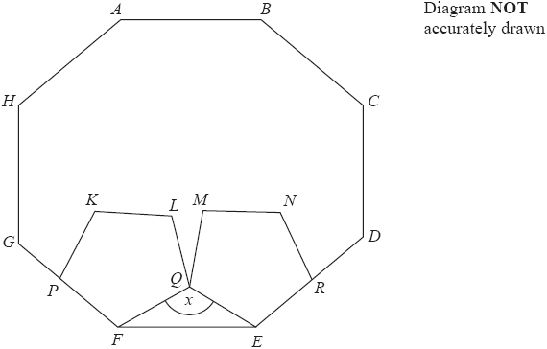**2.** ABCDEFGH is a regular octagon.

KLQFP and MNREQ are two identical regular pentagons.

Work out the size of the angle marked x.

You must show all your working.

………………………………………°

**(Total for question = 4 marks)**

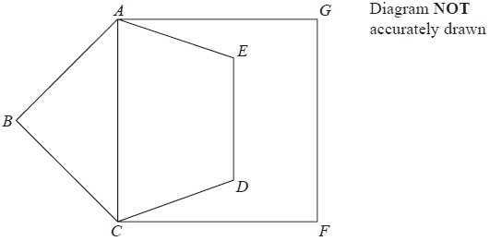**3.** Diagram not drawn accurately.

ABCDE is a regular pentagon.

ACFG is a square.

Work out the size of angle DCF.

You must show all your working.

………………………………………°

**(Total for question = 4 marks)**

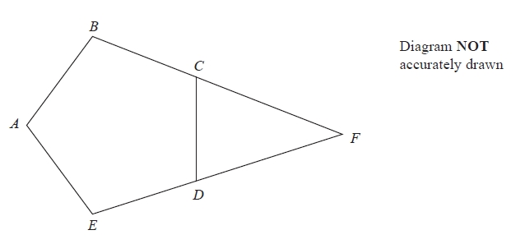**4.** ABCDE is a regular pentagon.

BCF and EDF are straight lines.

Work out the size of angle CFD.

You must show how you got your answer.

………………………………………°

**(Total for question = 3 marks)**

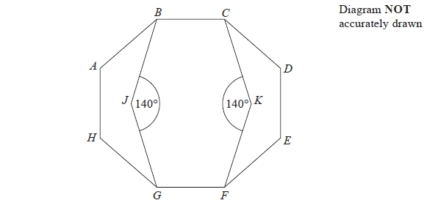**5.** Diagram not drawn accurately.

ABCDEFGH is a regular octagon.

BCKFGJ is a hexagon.

JK is a line of symmetry of the hexagon.

Angle BJG = angle CKF = 140°

Work out the size of angle KFE.

You must show all your working.

........................................................... °

**(Total for Question is 4 marks)**

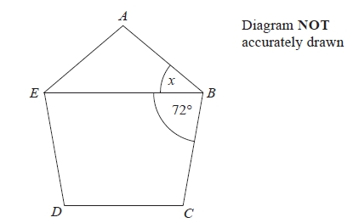

**6.** Diagram not drawn accurately .

ABCDE is a regular polygon.

EB is a straight line.

Angle EBC = 72°.

Work out the size of the angle marked x.

........................................................... °

**(Total for question = 3 marks)**

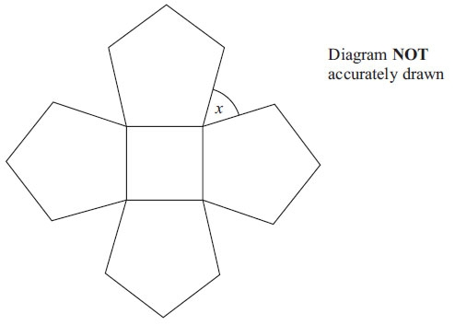**7.** The diagram shows a square and 4 regular pentagons.

Work out the size of the angle marked x.

........................................................... °

**(Total for question = 3 marks)**

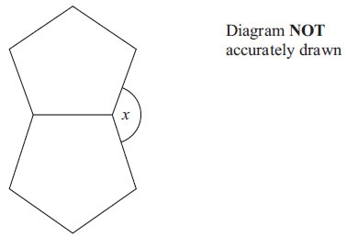**8.** The diagram shows two regular shapes.

Work out the size of the angle marked x.

........................................................... °

**(Total for Question is 3 marks)**

**Proofs of congruence and similarity**

**Things to remember:**

* To prove congruence, look for:
  + Side, angle, side
  + Angle, side, angle
  + Side, side, side, or
  + Right-angle, hypotenuse, (other) side

**Questions:**

**1.** These shapes have been drawn on a grid of centimetre squares.

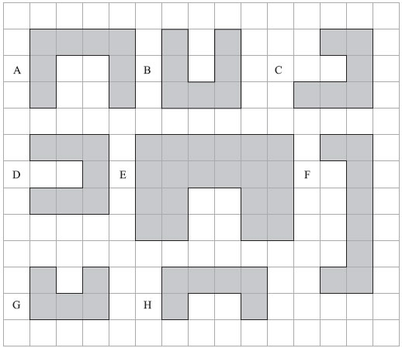

(a) (i) Write down the letters of a pair of shapes that are congruent.

.......................................................................................................................................

(ii) Write down the letters of a different pair of shapes that are similar.

.......................................................................................................................................

**(2)**

(b) Find the perimeter of shape D.

       .......................................................................................................................................

**(1)**

**(Total for Question is 3 marks)**

**2.** Here are some triangles drawn on a grid.

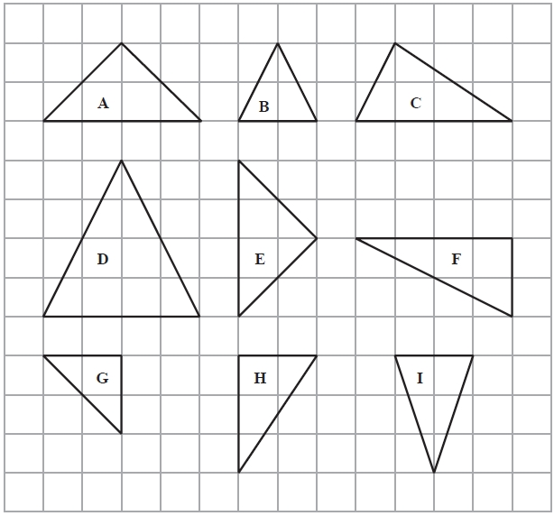

Two of these triangles are congruent.

(a) Write down the letters of these triangles.

.............................. and ..............................

**(1)**

One of the triangles is similar to triangle **B**.

(b) Write down the letter of this triangle.

..............................

**(1)**

**(Total for Question is 2 marks)**

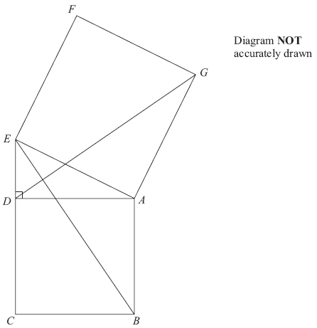**3.** Diagram not drawn accurately.

In the diagram,

*ADE* is a right-angled triangle,

*ABCD* and *AEFG* are squares.

Prove that triangle *ABE* is congruent to triangle *ADG*.

**(Total for Question is 3 marks)**

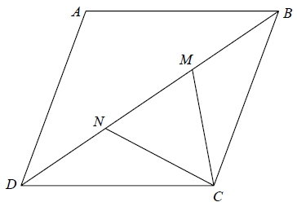**4.** *ABCD* is a rhombus.

*M* and *N* are points on *BD* such that *DN* = *MB*.

Prove that triangle *DNC* is congruent to triangle *BMC*.

**(Total for question = 3 marks)**

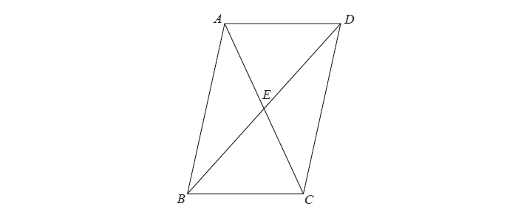**5.** *ABCD* is a parallelogram.

*E* is the point where the diagonals *AC* and *BD* meet.

Prove that triangle *ABE* is congruent to triangle *CDE*.

**(Total for question = 3 marks)**

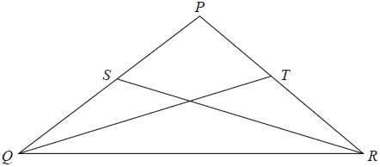**6.** *PQ* = *PR*.   
*S* is the midpoint of *PQ*.   
*T* is the midpoint of *PR*.

Prove triangle *QTR* is congruent to triangle *RSQ*.

**(Total for question is 3 marks)**

**Circle theorems**

**Things to remember:**

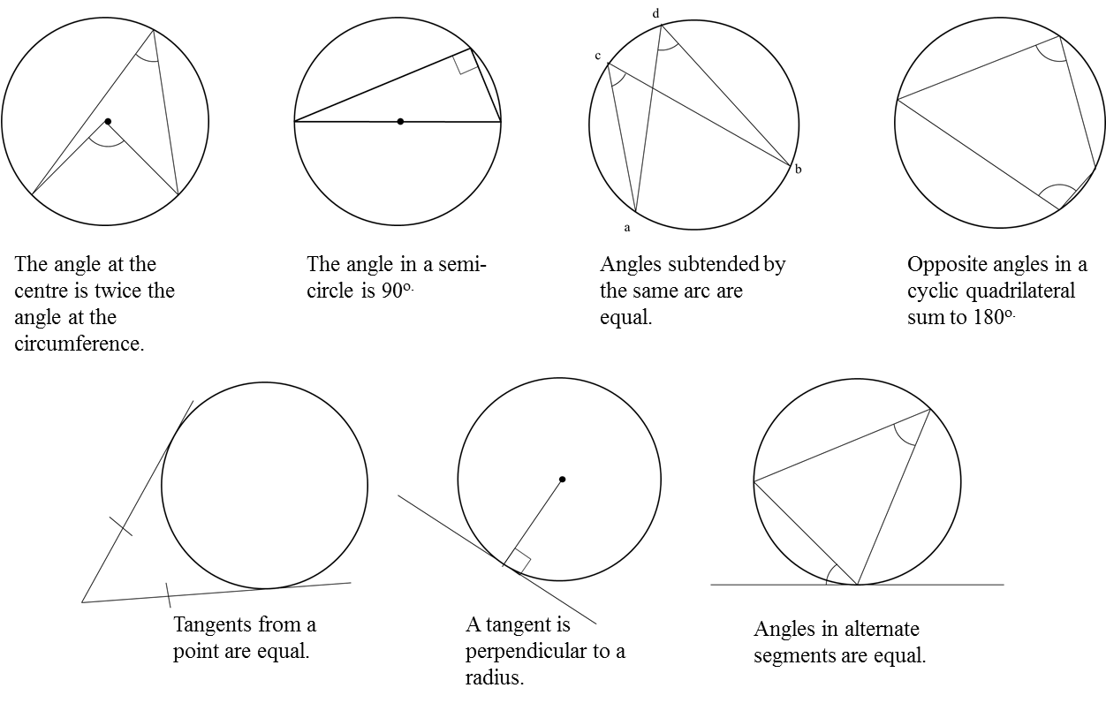

**Questions:**

**1.**



Diagram **NOT** accurately drawn

*P* is a point on the circumference of the circle, centre *O*.  
*PQ* is a tangent to the circle.

(i) Write down the size of angle *OPQ*.

........................................................... °

(ii) Give a reason for your answer.

………………………......................................................................................................

………………………......................................................................................................

**(Total 2 marks)**

**2.**



Diagram **NOT** accurately drawn

*A*, *B* and *C* are points on the circumference of a circle, centre *O*.  
*AC* is a diameter of the circle.

(a) (i) Write down the size of angle *ABC*.

........................................................... °

(ii) Give a reason for your answer.

………………………......................................................................................................

………………………......................................................................................................

**(2)**



Diagram **NOT** accurately drawn

*D*, *E* and *F* are points on the circumference of a circle, centre *O*.  
Angle *DOF* = 130°.

(b) (i) Work out the size of angle *DEF*.

........................................................... °

(ii) Give a reason for your answer.

………………………......................................................................................................

………………………......................................................................................................

**(2)**

**(Total 4 marks)**

**3.**



Diagram **NOT** accurately drawn

*A* and *B* are points on the circumference of a circle, centre *O*.  
*PA* and *PB* are tangents to the circle.  
Angle *APB* is 86°.

Work out the size of the angle marked *x*.

........................................................... °

**(Total 2 marks)**

**4.**



Diagram **NOT** accurately drawn

In the diagram, *A*, *B*, *C* and *D* are points on the circumference of a circle, centre *O*.  
Angle *BAD* = 70°.  
Angle *BOD* = *x*°.  
Angle *BCD* = *y*°.

(a) (i) Work out the value of *x*.

........................................................... °

(ii) Give a reason for your answer.

………………......................................................................................................

………………......................................................................................................

**(2)**

(b) (i) Work out the value of *y*.

........................................................... °

(ii) Give a reason for your answer.

………………......................................................................................................

………………......................................................................................................

**(2)**

**(Total 4 marks)**

**5.**



Diagram **NOT** accurately drawn

The diagram shows a circle centre *O*.  
*A*, *B* and *C* are points on the circumference.

*DCO* is a straight line.  
*DA* is a tangent to the circle.

Angle *ADO =* 36°

(a) Work out the size of angle *AOD*.

........................................................... °

**(2)**

(b) (i) Work out the size of angle *ABC*.

........................................................... °

(ii) Give a reason for your answer.

………………......................................................................................................

………………......................................................................................................

**(3)**

**(Total 5 marks)**