
Transformations of Graphs Starter Investigation

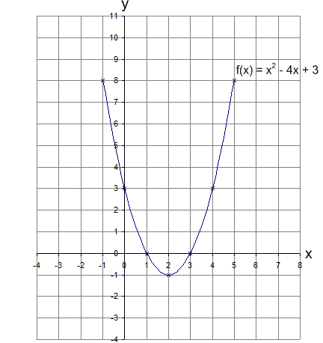
This is the graph of $f(x)=x^{2}-4x+3$

For each of the following
- write out the new function.
- fill in the table of values.
- draw and label the graph on the grid.
$$f(x)=x^{2}-4x+3$$

a) $f(x)+2=$

$$x$$ | $$-1$$ | $$0$$ | $$1$$ | $$2$$ | $$3$$ | $$4$$ | $$5$$
$$f(x)$$

- What do you notice?

______________________________________________________________________________

- What transformation is this?

______________________________________________________________________________

b) $f(x+2)=$

$$x$$ | $$-3$$ | $$-2$$ | $$-1$$ | $$0$$ | $$1$$ | $$2$$ | $$3$$
$$f(x)$$

- What do you notice?

______________________________________________________________________________

- What transformation is this?

______________________________________________________________________________

This is the graph of $f(x)=x^{2}-4x+3$

For each of the following
- write out the new function.
- fill in the table of values.
- draw and label the graph on the grid.
$$f(x)=x^{2}-4x+3$$

c) $2f(x)=$

$$x$$ | $$-1$$ | $$0$$ | $$1$$ | $$2$$ | $$3$$ | $$4$$ | $$5$$
$$f(x)$$

- What do you notice?

______________________________________________________________________________

- What transformation is this?

______________________________________________________________________________

d) $f(2x)=$

$$x$$ | $$-1$$ | $$0$$ | $$1$$ | $$2$$ | $$3$$
$$f(x)$$

- What do you notice?

______________________________________________________________________________

- What transformation is this?

______________________________________________________________________________

This is the graph of $f(x)=x^{2}-4x+3$

For each of the following
- write out the new function.
- fill in the table of values.
- draw and label the graph on the grid.
$$f(x)=x^{2}-4x+3$$

e) $-f(x)=$

$$x$$ | $$-1$$ | $$0$$ | $$1$$ | $$2$$ | $$3$$ | $$4$$ | $$5$$
$$f(x)$$

- What do you notice?

______________________________________________________________________________

- What transformation is this?

______________________________________________________________________________

f) $f(-x)=$

$$x$$ | $$-5$$ | $$-4$$ | $$-3$$ | $$-2$$ | $$-1$$ | $$0$$ | $$1$$
$$f(x)$$

- What do you notice?

______________________________________________________________________________

- What transformation is this?

______________________________________________________________________________

