**Measures (F)**

Intervention Booklet

Name: _______________________________

Class: _______________________________

**Useful websites:**

**www.mathswatchvle.com**

*(Video explanations and questions)*

Username: STH…@twgash

Password: stmaths

**www.methodmaths.com**

*(Past papers online that get instantly marked)*

Centre ID: wga

Username: firstname

Password: lastname

**www.hegartymaths.com**

*(Online tutorials and quizzes)*

Login: first name and last name are case sensitive

**www.bbc.co.uk/schools/gcsebitesize/maths**

**Metric Units**

**Things to remember:**

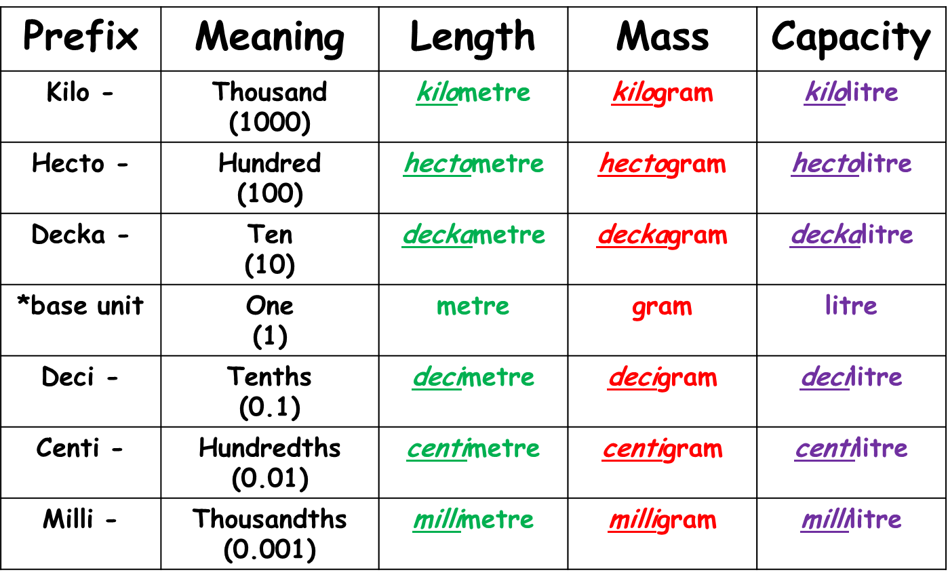

**Questions:**

**1.** Change 72 km/h into m/s.

........................................................... m / s

**(Total for question = 3 marks)**

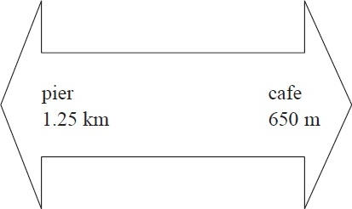**2**. John is walking along a path. He sees this sign.  
How far is it from the pier to the cafe along the path?

...........................................................

**(Total for Question is 3 marks)**

**3**. Sameena has 10 m of ribbon on a reel.   
She cuts 3 pieces of ribbon from the ribbon on the reel.

The lengths of the pieces are



Work out how much ribbon Sameena will have left on the reel.

...........................................................

**(Total for question = 4 marks)**

**4**. (a)   Write 3500 m*l* in litres.

........................................................... litres

**(1)**

(b)   Write 3 kilograms in grams

........................................................... grams

**(1)**

(c)   Change 3 m2 to cm2.

........................................................... cm2

**(2)**

**(Total for question = 4 marks)**

**5**. Change 530 centimetres into metres.

........................................................... metres

**(Total for question is 1 mark)**

**6**. Change 4500g to kg.

........................................................... kg

**(Total for question = 1 mark)**

**7**. (a)   Write 3 metres in centimetres.

........................................................... centimetres

**(1)**

(b)  Write 4000 grams in kilograms.

........................................................... kilograms

**(1)**

(c)  Write 700 millilitres in litres.

........................................................... litres

**(1)**

**(Total for question = 3 marks)**

**8**. (a) Write 35 mm in cm.

      ...........................................................

**(1)**

(b) Write 2.4 kg in g.

      ...........................................................

**(1)**

**(Total for Question is 2 marks)**

**9**. A rectangle has an area of 4 m2. Write this area in cm2.

........................................................... cm2

**(Total for question = 2 marks)**

**10**. (a)   Write 2.3 kg in grams.

........................................................... g

**(1)**

(b)  Write 350 mm in centimetres.

........................................................... cm

**(1)**

(c)  Change 27 000 cm3 to litres.

........................................................... litres

**(1)**

**(Total for question = 3 marks)**

**11**. Ruth is 1.23 m tall. Lee is 6 cm shorter than Ruth. How tall is Lee?

...........................................................

**(Total for question = 2 marks)**

**12**. Logan says,

           "140 millilitres is more than 1.2 litres".

Is he right?  
 You must explain your answer.

  …………………………………………………………………………………………………………..

  …………………………………………………………………………………………………………..

  …………………………………………………………………………………………………………..

  …………………………………………………………………………………………………………..

**(Total for Question is 2 marks)**

**13**. (a) Change 300 cm to m.

      ...........................................................

**(1)**

(b) Change 5800 g to kg.

      ...........................................................

**(1)**

(c) Change 8.5 cm to mm.

    ...........................................................

**(1)**

**(Total for Question is 3 marks)**

**14**. * Andy cycles to keep fit.   
He wants to cycle a total of 70 km each week.

Andy went on four cycle rides last week.

Here are the distances he cycled.

18.2 km            14 km           250 m           20 ½ km           12050m

Did Andy cycle a total of 70 km last week?   
You must show how you got your answer.

**(Total for question = 4 marks)**

**15**. Kelan is packing plates in a wooden box.

The empty box has a weight of 4.3 kg.

Each plate has a weight of 760 g.

When the box is packed with plates, the total weight must not be more than 25 kg.

Work out the greatest number of plates Kelan can pack in the box.

...........................................................

**(Total for Question is 4 marks)**

**Speed, Distance and Time**

**Things to remember:**

* There are 60 seconds in a minute and 60 minutes in an hour.
* 5 miles = 8 km

**Questions:**  
**1.** The distance from Fulbeck to Ganby is 10 miles.

The distance from Ganby to Horton is 18 miles.



Raksha is going to drive from Fulbeck to Ganby.   
Then she will drive from Ganby to Horton.

Raksha leaves Fulbeck at 10 00   
She drives from Fulbeck to Ganby at an average speed of 40mph.

Raksha wants to get to Horton at 10 35

Work out the average speed Raksha must drive at from Ganby to Horton.

........................................................... mph

**(Total for question = 3 marks)**

**2.** Peter goes for a walk.  
 He walks 15 miles in 6 hours.

(a) Work out Peter's average speed.  
       Give your answer in miles per hour.

.......................................................... mph

**(2)**

5 miles = 8 km.  
 Sunita says that Peter walked more than 20 km.

*(b) Is Sunita right?  
         You must show all your working.

**(2)**

**(Total for Question is 4 marks)**

**3.** *A*, *B* and *C* are 3 service stations on a motorway.

*AB* = 25 miles and *BC* = 25 miles



Aysha drives along the motorway from *A* to *C.*

ysha drives at an average speed of 50 mph from *A* to *B*.  
 She drives at an average speed of 60 mph from *B* to *C*.

Work out the difference in the time Aysha takes to drive from *A* to *B* and the time Aysha  
 takes to drive from *B* to *C*.  
 Give your answer in minutes.

.......................................................... minutes

**(Total for Question is 3 marks)**

**Real Life Graphs**

**Things to remember:**

* Make sure you look carefully at the scales on the axes:
  + What is it going up in?
  + What do they represent? Time? Distance travelled? Distance from start?
* Use a ruler to complete graphs

**Questions:**  
**1.** At 9 am, Bradley began a journey on his bicycle.

From 9 am to 9.36 am, he cycled at an average speed of 15 km/h.   
From 9.36 am to 10.45 am, he cycled a further 8 km.

(a)   Draw a travel graph to show Bradley's journey.

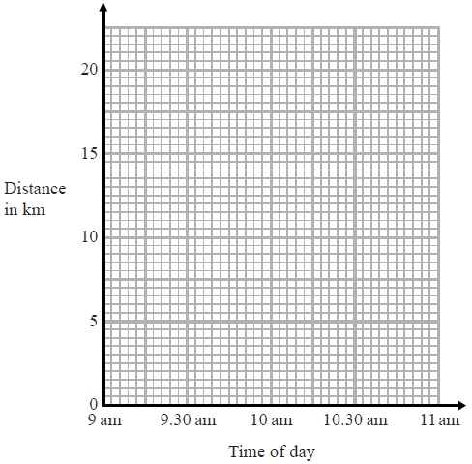

**(3)**

From 10.45 am to 11 am, Bradley cycled at an average speed of 18 km/h.

(b)   Work out the distance Bradley cycled from 10.45 am to 11 am.

........................................................... km

**(2)**

**(Total for question is 5 marks)**

**2**. Jane walked from her home to the ice rink and then walked back home.

The travel graph for Jane's journey to the ice rink and back home is shown below.

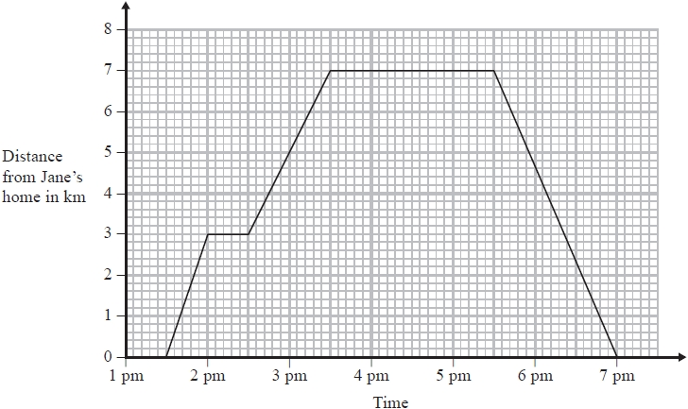

On the way to the ice rink Jane stopped at her friend's house.

(a)   How long did Jane stay at her friend's house?

...........................................................

**(1)**

(b)   How far is it from her friend's house to the ice rink?

........................................................... km

**(1)**

(c)   What time did Jane leave the ice rink?

...........................................................

**(1)**

**(Total for question = 3 marks)**

**3**. Simon went for a cycle ride. He left home at 2 pm.

The travel graph represents part of Simon's cycle ride.

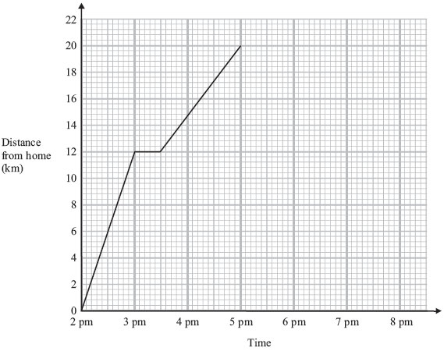

At 3 pm Simon stopped for a rest.

(a) How many minutes did he rest?

      ...........................................................

**(1)**

(b) How far was Simon from home at 5 pm?

      ...........................................................

**(1)**

At 5 pm Simon stopped for 30 minutes.   
 Then he cycled home at a steady speed.   
 It took him 1 hour 30 minutes to get home.

(c) Complete the travel graph.

**(2)**

**(Total for Question is 4 marks)**

**4**. On Monday, Holly walked from her home to school.  
 She stopped at her friend's house on the way to school.

On Tuesday, Holly cycled from her home to school.

The travel graphs show Holly's journey on Monday and on Tuesday.

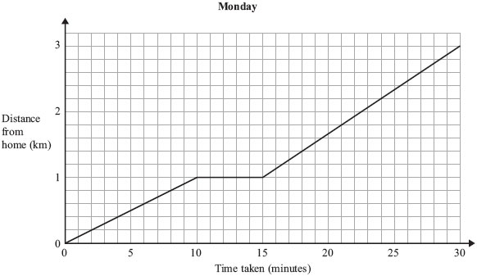

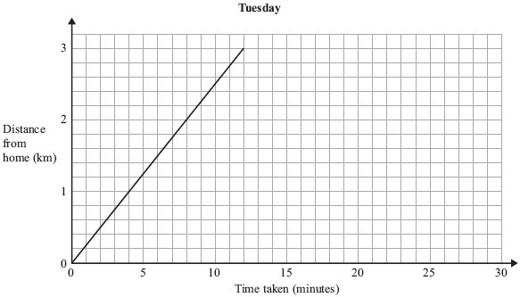

(a) Write down the distance from Holly's home to school.

. . . . . . . . . . . . . . . . . . . . . . km

**(1)**

(b) Write down how long Holly stopped at her friend's house on Monday.

. . . . . . . . . . . . . . . . . . . . . . minutes

**(1)**

Holly took less time to get to school on Tuesday than on Monday.

(c) How many minutes less?

. . . . . . . . . . . . . . . . . . . . . . minutes

**(2)**

**(Total for Question is 4 marks)**

**5.** Sarah goes to the gym on her way to work.  
The table shows what she wants to do before arriving at work.

|  |  |
| --- | --- |
| **Activity** | **Time (mins)** |
| Drive from home to gym | 10 |
| Exercise at gym | 45 |
| Shower and change | 20 |
| Drive from gym to work | 25 |

She has to arrive at work at 08 50

(a) What is the latest time she can leave home?

. . . . . . . . . . . . . . . . . . . . . .

**(3)**

  Each Saturday, Sarah cycles from her house to the gym.

The travel graph shows Sarah's journey to the gym.

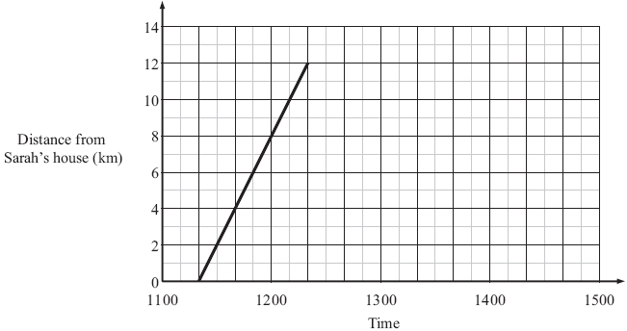

(b) What time does she leave home?

. . . . . . . . . . . . . . . . . . . . . .

**(1)**

(c) How far is the gym from Sarah's house?

. . . . . . . . . . . . . . . . . . . . . . km

**(1)**

Sarah stays at the gym for 1½ hours.

She then cycles back to her house at 18 km/h.

(d) Complete the travel graph.

**(3)**

**(Total for Question is 8 marks)**

**Similar Length, Area and Volume (LAV)**

**Things to remember:**

* Linear scale factor = x
* Area scale factor = x²
* Volume scale factor = x³

**Questions:**

**1.** Two cylinders, **P** and **Q**, are mathematically similar.

The total surface area of cylinder **P** is 90*π* cm². The total surface area of cylinder **Q** is 810*π* cm². The length of cylinder **P** is 4 cm.

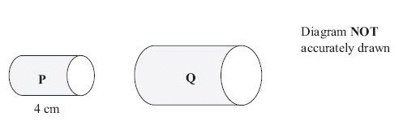

(a) Work out the length of cylinder **Q**.

........................................................... cm

**(3)**

The volume of cylinder **P** is 100*π* cm³.

(b) Work out the volume of cylinder **Q**.  
Give your answer as a multiple of *π*

........................................................... cm³

**(2)**

**(Total 5 marks)**

**2.** Diagram **NOT**  accurately drawn

Two prisms, **A** and **B**, are mathematically similar. The volume of prism **A** is 12 000 cm³. The volume of prism **B** is 49 152 cm³. The total surface area of prism **B** is 9728 cm².



Calculate the total surface area of prism

........................................................... cm²

**(Total 4 marks**

**3.** Diagram **NOT** accurately drawn

Two cones, **P** and **Q**, are mathematically similar. The total surface area of cone **P** is 24 cm². The total surface area of cone **Q** is 96 cm². The height of cone **P** is 4 cm.

(a) Work out the height of cone **Q***.*

........................................................... cm

**(3)**

The volume of cone **P** is 12 cm3.

(b) Work out the volume of cone **Q**.

........................................................... cm³

**(2)**

**(Total 5 marks**

**4.** Diagram **NOT** accurately drawn

Two solid shapes, **A** and **B**, are mathematically similar. The base of shape **A** is a circle with radius 4 cm. The base of shape **B** is a circle with radius 8 cm. The surface area of shape **A** is 80 cm².

(a) Work out the surface area of shape **B**.

........................................................... cm²

**(2)**

The volume of shape **B** is 600 cm³.

(b) Work out the volume of shape **A**.

........................................................... cm³

**(2)**

**(Total 4 marks)**