Numeracy Assessment
Calculators not allowed

Name: ______________________________

Class: ______________________________

Teacher: ______________________________

Remember:
- The test is 1 hour long.
- You must not use a calculator for any question in this test.
- You will need a pen or pencil.
- Try to answer all questions.
- Write all your answers and working in the spaces provided in this test paper – do not use any rough paper. Marks may be awarded for working.
- Check your work carefully.
- Don’t spend too long on one question. Leave it and try the next one.

1. | Write these numbers in words:  2721  ____________________________________________________  2 370 804  ____________________________________________________  ____________________________________________________  Write these numbers in figures:  Nine thousand, one hundred and fifteen  ____________________________________________________  Seventeen point five four  ____________________________________________________ | / 4
2. | What is the value of the 7 in each of these numbers?  274 ________________ 17 526 ________________ | / 2
3. | C) Write these numbers in order, starting with the lowest:  356 ; 365 ; 305 ; 3,506 ; 360 ; 256  ____________________________________________________  2.7 ; 7.2 ; 2.07 ; 7.02 ; 27.2 ; 0.27  ____________________________________________________  12 ; - 3 ; -9 ; 2 ; 0 ; -12  ____________________________________________________ | / 3

4. | D) Continue the sequence and write the rule for each set of numbers:  1) 2 , 5, 8 , 11 , _______ , _______ , _______  The rule is _______  2) 23 , 19 , 15 , _______ , _______ , _______  The rule is _______  3) -30 , -20 , -10 , _______ , _______ , _______  The rule is _______ | / 3
5. | Round these numbers to  (i) the nearest 10: (ii) the nearest 100  367 ________________ 3770 ________________  (iii) the nearest 1000: (iv) 1 decimal place  4820 ________________ 12.48 ________________ | / 4
6. | Complete this table by multiplying OR dividing the numbers given:  Number x 10 x 100  32  17.5  Number ÷ 10 ÷ 100  800  35 | / 8
7. | Simplify fully 8/24  ________________  Find 4/5 of 30  ________________ | / 2
8. | Find 35% of 260  ________________ | / 1
9. | Divide £35 into the ratio 3:4  ________________ | / 1
10. | Name the following shapes:  _______________ _______________ _______________  _______________ _______________ _______________ | / 6
11. | 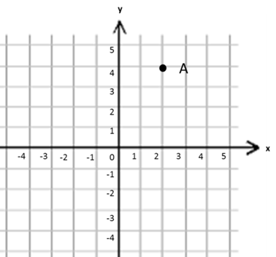  What coordinate does point A  represent? ( ___ , ___ )  Show the coordinate (4, -2) on  the grid above and label it B. | / 2

12. | 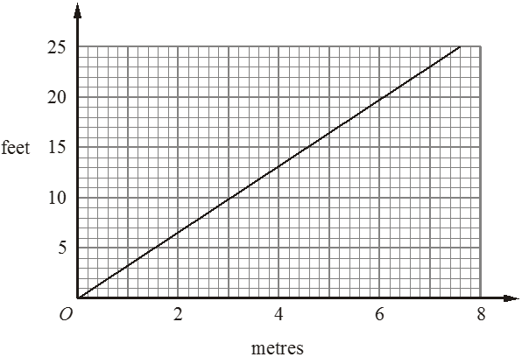  This conversion graph can be used to change between metres and feet.  (i) Use the conversion graph to change 6 metres to feet.  ________________ feet  (ii) Use the conversion graph to change 7 feet to metres.  ________________ metres | / 2
13. | 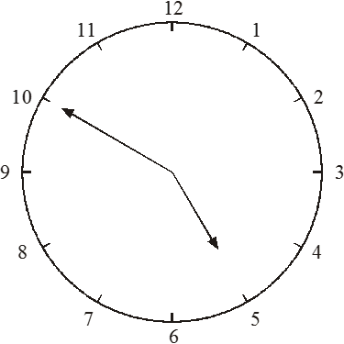  (i) Write down the time shown on the clock.  ________________  (ii) What time will the clock read 1 hour 30 minutes later?  ________________ | / 2
14. | Colin carried out a survey. He asked 36 Year 10 students which type of film they liked best. He used the results to draw this pie chart.  (i) How many students said comedy?  ________________  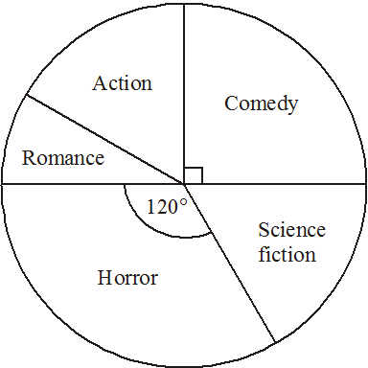  (ii) How many students said horror? ________________ | / 2

15. | 6 x 3 63 ÷ 9  850 ÷ 5 426 x 127  2.4 x 6 78 ÷ 0.2  435 + 197 602 - 28  I buy a computer game for £28 and a DVD for £12.65. How much have I spent? I have £10.77 and spend £8.34. How much money do I have left? | / 2  / 2  / 2  / 2  / 2

