**Pythagoras’ Theorem and Trigonometry**

**(F)**

Pre-Intervention Assessment

Name: _______________________________

Class: _______________________________

Date: _______________________________

|  |  |  |
| --- | --- | --- |
| **Question** | **Objective** | **RAG** |
| 1 | Apply Pythagoras’ Theorem |  |
| 2 | Use SOH CAH TOA to calculate missing sides |  |
| 3 | Use SOH CAH TOA to calculate missing angles |  |

**1.** *ABC* is a right-angled triangle.   
*AC* = 6 cm   
*AB* = 13 cm

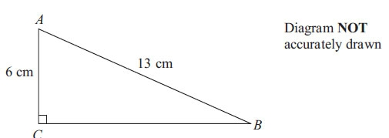

Work out the length of *BC*.  
Give your answer correct to 3 significant figures.

........................................................... cm

**2.** Diagram **NOT** accurately drawn

*AC* = 12 cm.  
Angle *ABC* = 90°.  
Angle *ACB* = 32°.

Calculate the length of *AB.*Give your answer correct to 3 significant figures.

........................................................... cm

**3**. Diagram **NOT**  accurately drawn

Work out the value of *x*.  
Give your answer correct to 1 decimal place.

........................................................... °

[Glue here]