Mathematics Assessment

Bands 3-5 Problem Solving – Test 1
Calculators allowed on questions with this symbol:

Name: ______________________________

Class: ______________________________

Teacher: ______________________________

Remember:
- The test is 1 hour long.
- You will need: pen, pencil, rubber and a ruler.
- Try to answer all questions.
- Write all your answers and working in the spaces provided in this test paper – do not use any rough paper. Marks may be awarded for working.
- Check your work carefully.
- Don’t spend too long on one question. Leave it and try the next one.

1. | Susan did a puzzle in 5 minutes and 55 seconds. Jamal did the same puzzle in 11 minutes and 42 seconds. Susan says, ‘I did the puzzle in less than half the time Jamal did the puzzle. Is Susan right? You must show all your working. | / 3
2. | Terry is going to make some concrete mix. He needs to mix cement, sand and gravel in the ratio 2 : 3 : 5 by weight. He estimates he needs to make 220 kg of concrete mix.  Terry has:  - 50 kg of cement  - 90 kg of sand  - 100 kg of gravel  Does Terry have enough cement, sand and gravel to make the concrete mix? | / 4
3. | 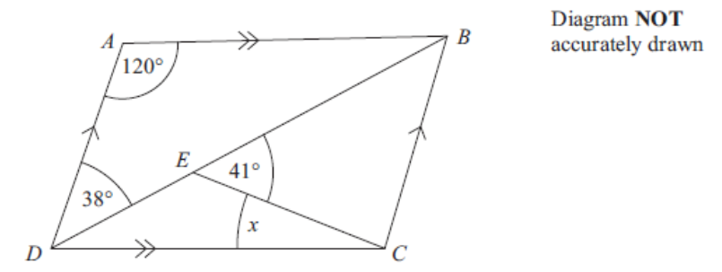  ABCD is a parallelogram. Angle ADB = 38°. Angle BEC = 41°. Angle DAB = 120°. Calculate the size of angle x. You must give reasons for your answer.  x = ________ ° | / 4
4. | On this grid are two shapes, A and B. Shape B is an enlargement of shape A, but some parts of B are missing. The centre of enlargement is on the dotted line.  - Shade in squares to complete shape B.  - Find the centre of enlargement and mark it on the diagram with an ‘X’.  - What is the scale factor of the enlargement? _______ | / 4
5. | Salima sees an advery for a summer holiday:  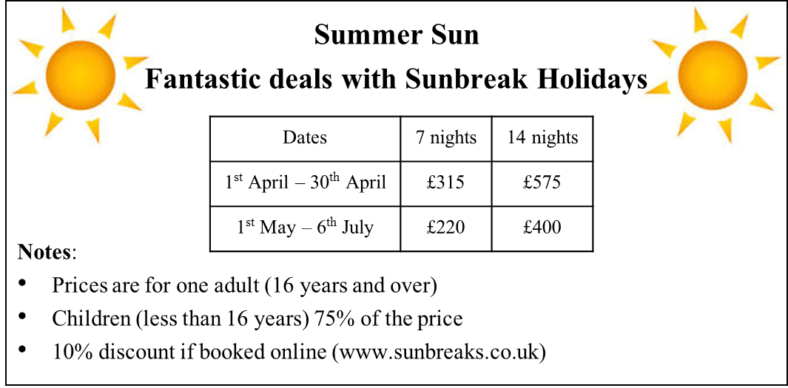  Salima books a 7 night holday in April for 2 adults. The travel agent adds a percentage surchange to the cost of the holiday for booking fees. Salima’s final bill is £642.60. What was the percentage surcharge?  __________ % | / 4
6. | A cube is cut into three parts by two vertical slices.  Find the volume of the shaded part.  _______________ cm³ | / 5
7. | Noah has some marbles. He gives Keira 20% of his marbles. He gives Ali 50% of his marbles. Noah has 18 marbles left. How many marbles did he have to start with?  ____________ | / 4
8. | Janice has three coins in her pocket, and they are all different from each other. Jeremy has three coins in his pocket and they are all the same as each other. Jeremy has twice as much money as Janice. What are the coins they each have?  Janice __________ __________ __________  Jeremy __________ __________ __________ | / 2
9. | The diagram shows a triangle inside a rectangle.  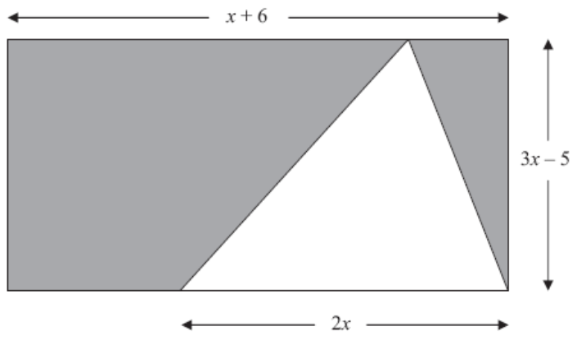  All measurements are given in centimetres. Show that the total area, in cm², of the shaded regions is 18x – 30. | / 5
10. | The diagram shows 15 identical circles, arranged as a rectangle, and a shaded triangle. The vertices of the triangle are at the centres of circles. Calculate the area of the shaded triangle.  ____________ cm² | / 5
11. | Three dice are each numbered 1 to 6. Two of them are red and one is blue. All three dice are rolled. What is the probability that the total on the two red dice will be equal to the score on the blue dice?  ________________ | / 7
12. | Here is a graph. What is the equation of the line?  __________________ | / 2

