**Probability (H)**

Post-Intervention Assessment

Name: _______________________________

Class: _______________________________

Date: _______________________________

|  |  |  |
| --- | --- | --- |
| **Question** | **Objective** | **RAG** |
| 1 | Calculate probability from Venn Diagrams |  |
| 2 | Draw and complete probability trees |  |
| 3 | Calculate with conditional probability |  |
| 4 | Solve probability problems involving algebra |  |

**1.** 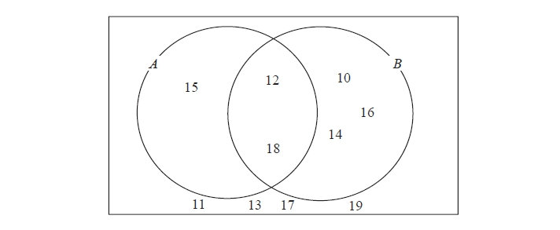Here is a Venn diagram.

(a)   Write down the numbers that

are in set

(i)   *A* ∪ *B*

.............................................

(ii)   *A* ∩ *B*

.............................................

One of the numbers in the diagram is chosen at random.

(b)  Find the probability that the number is in set *A'*

...........................................................

**2**. Mary has a drawing pin.  
When the drawing pin is dropped it can land either ‘point up’ or ‘point down’.  
The probability of it landing ‘point up’ is 0.4

Mary drops the drawing pin twice.

(a) Complete the probability tree diagram.



(b) Work out the probability that the drawing pin will land ‘point up’ both times.

...........................................................

**3**. Paul has 8 cards.   
There is a number on each card.

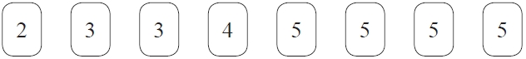

Paul takes at random 3 of the cards.   
He adds together the 3 numbers on the cards to get a total *T*.

Work out the probability that *T* is an odd number.

...........................................................

**4**.  There are 10 pens in a box.

There are *x* red pens in the box.   
All the other pens are blue.

Jack takes at random two pens from the box.

Find an expression, in terms of *x*, for the probability that Jack takes one pen of each colour.   
Give your answer in its simplest form.

...........................................................

[Glue here]