Bands 3 – 5 Problem Solving – Test 1 Answers

1. | 5 mins 55 secs x 2 = 11 mins 50 secs  or  11 mins 42 secs ÷ 2 = 5 mins 51 secs  Susan is not correct | 1 mark for working  1 mark for correct answer in mins/secs  1 mark for correct conclusion | 3
2. | 220 ÷ 10 = 22 kg (1 part)  2 x 22 = 44 kg cement needed (he has enough cement)  3 x 22 = 66 kg sand needed (he has enough sand)  5 x 22 = 110 kg gravel needed (he does not have enough gravel) | 1 mark for each element calculated  1 mark for correct conclusion | 4
3. | ADC = 180 – 120 = 60° because supplementary angles sum to 180°  EDC = 60 – 38 = 22°  DEC = 180 – 41 = 139° because angles on a straight line sum to 180°  x = 180 – (139 + 22) = 19° because angles in a triangle sum to 180° | 1 mark for ADC or EDC calculated  1 mark for DEC calculated  2 marks for correct answer (only award if at least 2 reasons seen) | 4
4. | 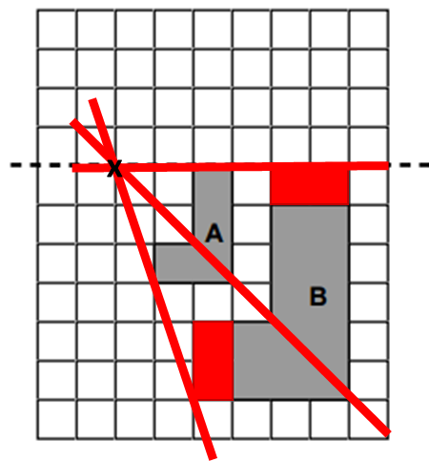  Scale factor 2 | 1 mark for each part of shading on shape B  1 mark for centre of enlargement identified  1 mark for scale factor 2 | 4
5. | 2 x £315 = £630  £642.60 - £630 = £12.60  £12.60 x 100 = 2%  630 | 1 mark for cost of 2 adults  1 mark for calculating amount of surcharge  1 mark for dividing by original amount  1 mark for correct answer (accept percentage only) | 4
6. | 20³ = 8000 cm³ total  8000 ÷ 2 = 4000 cm³ large triangular prism  ½ x 10 x 10 x 20 = 1000 cm³ small triangular prism  8000 – (4000 + 1000) = 3000 cm³ | 1 mark for total volume  1 mark for volume of large triangular prism  1 mark for volume of small triangular prism  1 mark for subtracting prisms from total volume  1 mark for correct answer | 5
7. | 100% - (50% + 20%) = 100% - 70% = 30%  30% = 18  10% = 6  100% = 60 | 1 mark for 70% given away  1 mark for 30% left  1 mark for calculating 10%  1 mark for correct answer | 4
8. | Janice 50p 20p 5p  Jeremy 50p 50p 50p | 1 mark for each correct set | 2
9. | (3x – 5)(x + 6) – ½(2x)(3x – 5)  = 3x² + 18x – 5x – 30 – 3x² + 5x  = 18x – 30 | 1 mark for expression for area of rectangle  1 mark for expression for area of triangle  1 mark for expanding brackets  1 mark for simplifying x² or x  1 mark for correct answer | 5
10. | 35 ÷ 5 = 7 cm diameter  7 ÷ 2 = 3.5 cm radius  Base = 8 x 3.5 = 28 cm  Height = 4 x 3.5 = 14 cm  Area = ½ x 28 x 14 = 196 cm² | 1 mark for calculating radius or diameter  1 mark for calculating base  1 mark for calculating height  1 mark for ½ x base x height  1 mark for correct answer | 5

11. | 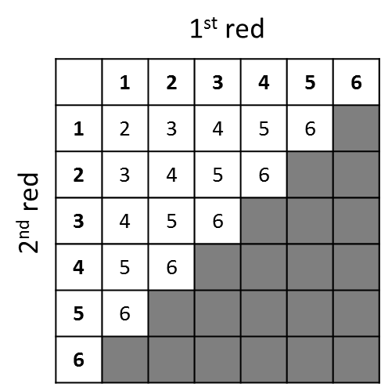  P(red total 2) and P(blue 2) = $\frac{1}{36}$ x $\frac{1}{6}$ = $\frac{1}{216}$  P(red total 3) and P(blue 3) = $\frac{2}{36}$ x $\frac{1}{6}$ = $\frac{2}{216}$  P(red total 4) and P(blue 4) = $\frac{3}{36}$ x $\frac{1}{6}$ = $\frac{3}{216}$  P(red total 5) and P(blue 5) = $\frac{4}{36}$ x $\frac{1}{6}$ = $\frac{4}{216}$  P(red total 6) and P(blue 6) = $\frac{5}{36}$ x $\frac{1}{6}$ = $\frac{5}{216}$  $\frac{1}{216}$ + $\frac{2}{216}$ + $\frac{3}{216}$ + $\frac{4}{216}$ + $\frac{5}{216}$ = $\frac{15}{216}$ | 2 marks for sample space diagram  3 marks for red and blue combination probabilities (1 mark if only 1 seen, 2 marks if at least 3 seen, 3 marks for all 5)  1 mark for adding probabilities together  1 mark for correct answer | 7
12. | y = 2x + 8 | 1 mark for gradient correct  1 mark for y-intercept correct | 2

