Lines, Angles and Shapes (H)

Pre-Intervention Assessment

Name: _______________________________

Class: _______________________________

Date: _______________________________

Question | Objective | RAG
1 | Calculate interior and exterior angles of a regular polygon
2 | Use the conditions for congruent triangles in formal geometrical proofs
3 | Understand the relationship between a radius and a tangent
4 | Apply circle theorems

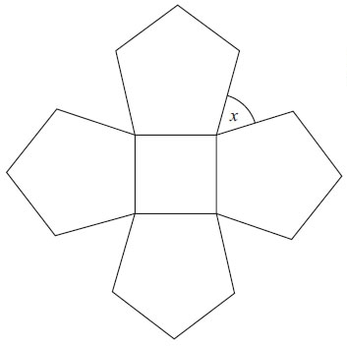
1. The diagram shows a square and 4 regular
pentagons.
Work out the size of the angle marked x.

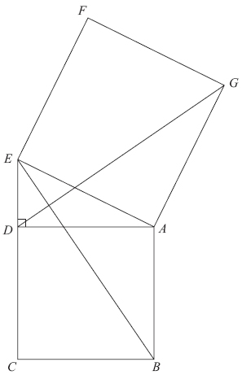
2. Diagram not drawn accurately.
In the diagram,
ADE is a right-angled triangle,
ABCD and AEFG are squares.
Prove that triangle ABE is congruent to triangle ADG.

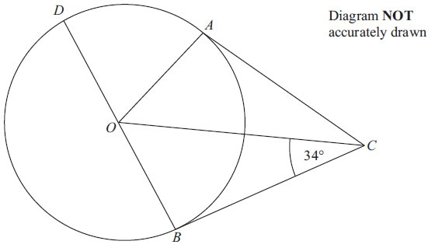
3. A, B and D are points on the circumference of a circle, centre O.
BOD is a diameter of the circle.
BC and AC are tangents to the circle.
Angle OCB = 34°.
Work out the size of angle DOA.

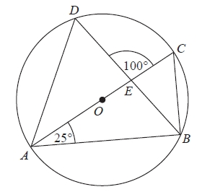
4. A, B, C and D are points on the circumference of a circle, centre O.
AC is a diameter of the circle.
AC and BD intersect at E.
Angle CAB = 25°
Angle DEC = 100°
Work out the size of angle DAC.
You must show all your working.

[Glue here]

