Area of non-right-angled triangles - GREEN

Calculate the area of these shapes.

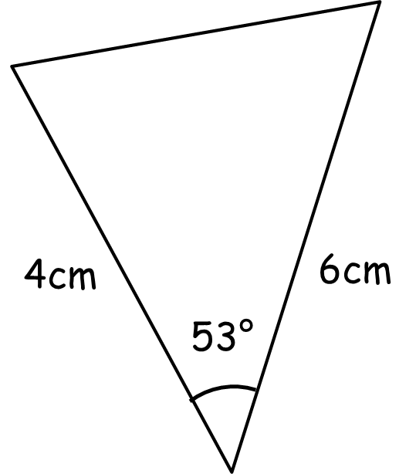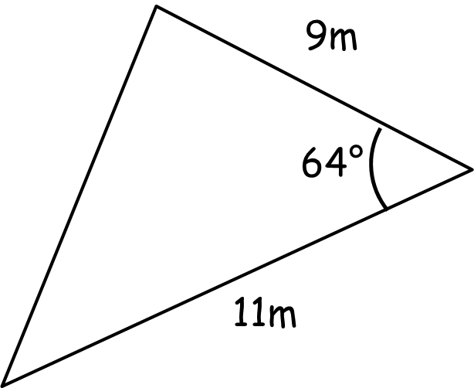

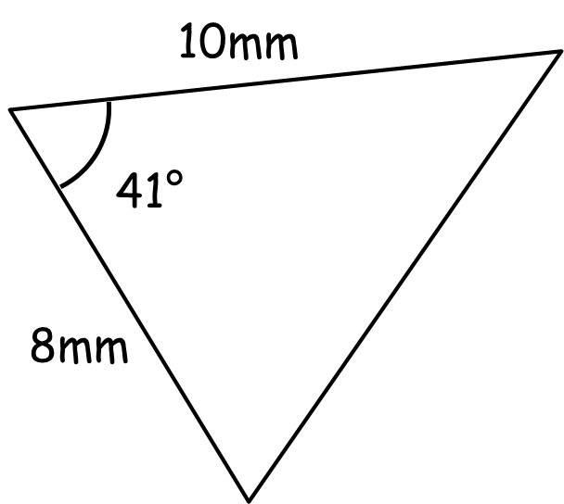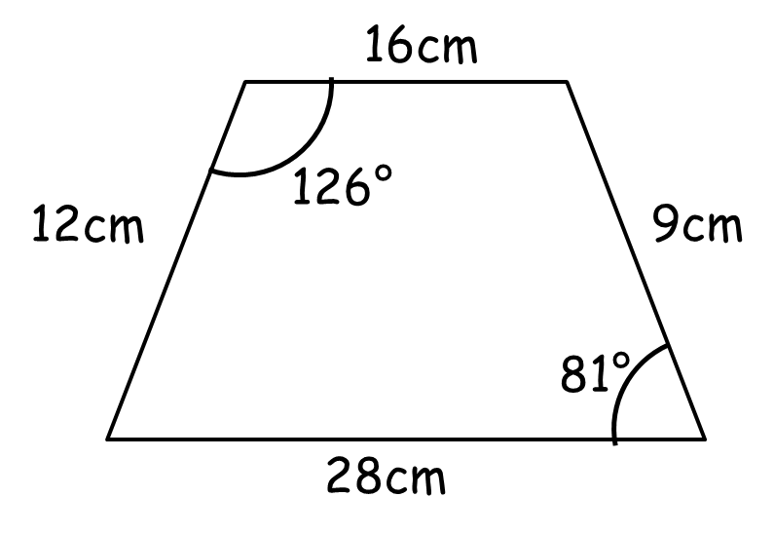

Calculate the length of a and the size of angle B.

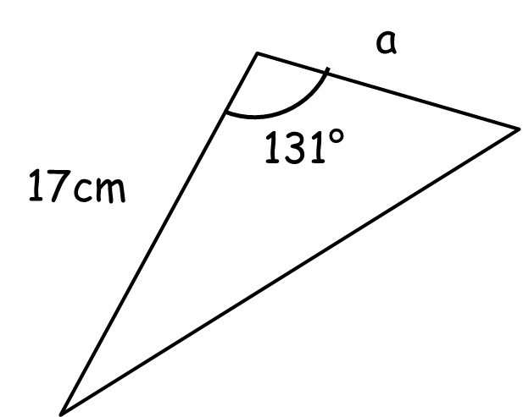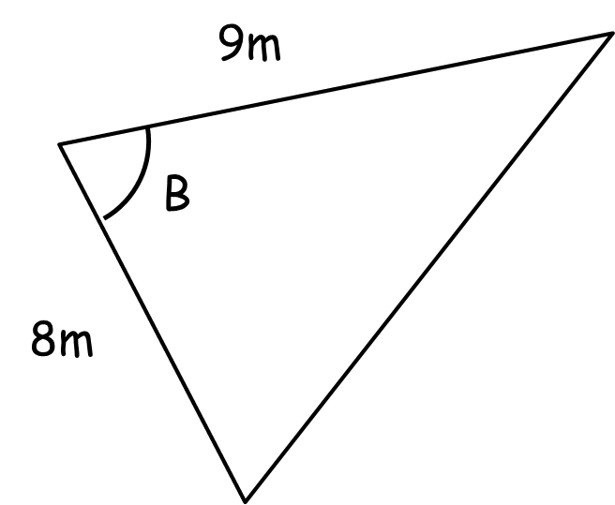

Area = 25cm² Area = 30m²

Area of non-right-angled triangles - AMBER

Calculate the area of these shapes.

½ ab sinC

Calculate the length of a and the size of angle B.

Hint: Set up an equation…

Area = 25cm² Area = 30m²

Area of non-right-angled triangles - RED

Calculate the area of these shapes.

½ ab sinC

Area = ½ x 4 x 6 x sin53

= 12 sin63 =

Calculate the length of a and the size of angle B.

Hint: Set up an equation…

Area = 25cm² Area = 30m²

½ x 17 x a x sin131 = 25 ½ x 8 x 9 x sinB = 30

