Volumes of Cubes and Cuboids GREEN

Question 1
Calculate the volumes of the cuboids below.
a) b) c)
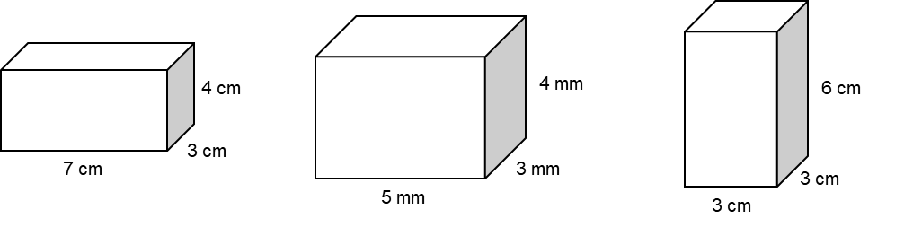

Question 2
Calculate the missing lengths on the cuboids below.
a) b) c)
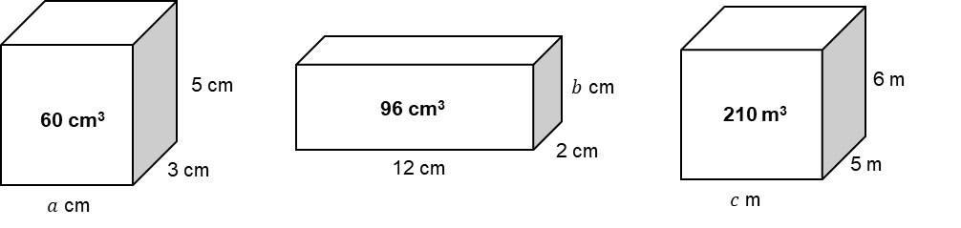

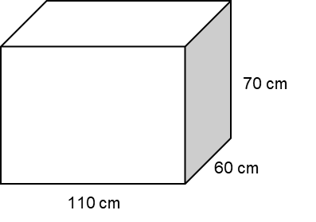
Question 3
The diagram shows an empty water container.
The container is going to be filled using a hose pipe.
The water will flow into the container at a rate of 2 litres per second.
How long will it take for the container to be filled completely?

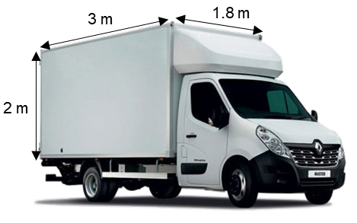
Question 4
Claire has a van.
She is using the van to deliver boxes.
Each box is a cuboid, 60 cm by 30 cm by 40 cm.
The van has the space for the boxes in the shape of a cuboid with length 3 m, width 1.8 m and height 2 m
Work out how many boxes can Claire fit into the van.

Volumes of Cubes and Cuboids AMBER

Question 1
Calculate the volumes of the cuboids below.
a) b) c)

Question 2
Calculate the missing lengths on the cuboids below.
a) b) c)
$60=a×3×5$ $96=$

1 L = 1000 cm³
Question 3
The diagram shows an empty water container.
The container is going to be filled using a hose pipe.
The water will flow into the container at a rate of 2 litres per second.
How long will it take for the container to be filled completely?

Question 4
Claire has a van.
She is using the van to deliver boxes.
Each box is a cuboid, 60 cm by 30 cm by 40 cm.
The van has the space for the boxes in the shape of a cuboid with length 3 m, width 1.8 m and height 2 m
Work out how many boxes can Claire fit into the van.

Divide the dimensions of the van by the dimensions of the boxes
Volumes of Cubes and Cuboids RED

Question 1
Volume = length × width × height
Calculate the volumes of the cuboids below.
a) b) c)

Question 2
Calculate the missing lengths on the cuboids below.
a) b) c)
$60=a×3×5$ $96=12×2×b$ $210=$
$60=15a$ $96=$

1 L = 1000 cm³
Question 3
The diagram shows an empty water container.
The container is going to be filled using a hose pipe.
The water will flow into the container at a rate of 2 litres per second.
How long will it take for the container to be filled completely?

Volume $=110×60×70=$

Question 4
Claire has a van.
She is using the van to deliver boxes.
Each box is a cuboid, 60 cm by 30 cm by 40 cm.
The van has the space for the boxes in the shape of a cuboid with length 3 m, width 1.8 m and height 2 m
Work out how many boxes can Claire fit into the van.

$300 cm÷60 cm=$
$180 cm÷$
$200 cm÷$
Divide the dimensions of the van by the dimensions of the boxes

