Trigonometry SOH CAH TOA GREEN

Question 1 – Calculate the missing sides on the triangles below.

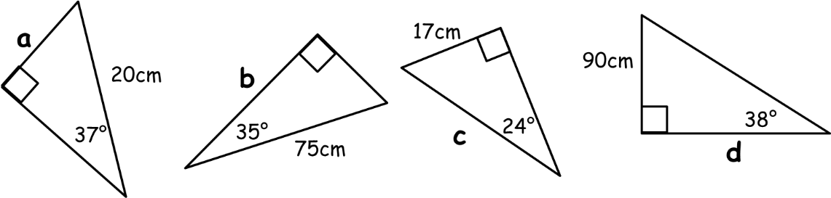

Question 2 - Calculate the missing angles on the triangles below.

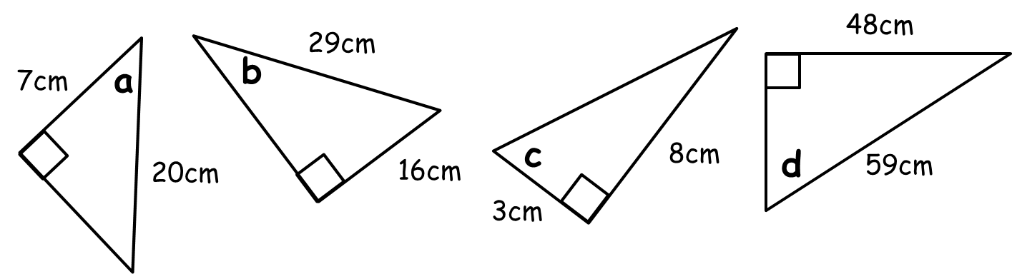

Question 3
A ladder of length 3.5m rests against a vertical wall and makes an angle of 40º with the floor. How far up the wall does the ladder reach?

Question 4
Find the angle X in the triangle below.

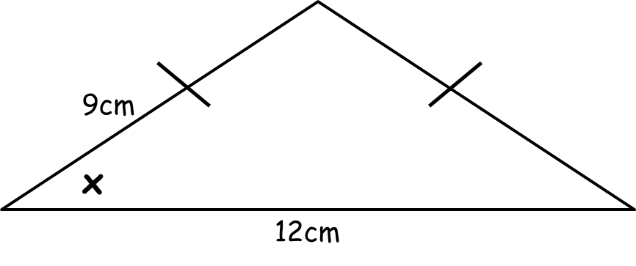

Question 5
A rope 10m long from the top of a vertical pole to a point on the ground makes an angle of 23º with the pole. How high is the pole?

Trigonometry SOH CAH TOA AMBER

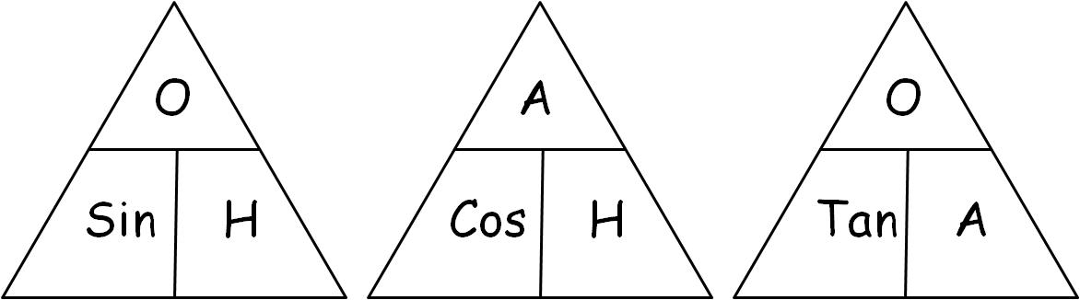

Question 1 – Calculate the missing sides on the triangles below.

Question 2 - Calculate the missing angles on the triangles below.

Question 3
A ladder of length 3.5m rests against a vertical wall and makes an angle of 40º with the floor. How far up the wall does the ladder reach? (Hint: if it’s tricky, draw a piccy!)

Question 4
Find the angle X in the isosceles triangle below.

Question 5
A rope 10m long from the top of a vertical pole to a point on the ground makes an angle of 23º with the pole. How high is the pole? (Hint: if it’s tricky, draw a piccy!)

Trigonometry SOH CAH TOA RED
1. Label your sides first, you’ll need O, H and A...
2. Choose if you need SOH, CAH or TOA...
3. Cover the one you need with your thumb,
4. Write the equation,
5. Solve it, then you’re done!

Question 1 – Calculate the missing sides on the triangles below.

Question 2 - Calculate the missing angles on the triangles below.

Question 3
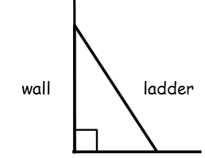
A ladder of length 3.5m rests against a vertical wall and makes an angle of 40º with the floor. How far up the wall does the ladder reach?

Question 4
Find the angle X in the isosceles triangle below.

Question 5
A rope 10m long from the top of a vertical pole to a point on the ground makes an angle of 23º with the pole. How high is the pole?

