Band 2 – Test 3 Answers

1. | $\frac{1}{6}$ $\frac{1}{4}$ $\frac{1}{3}$ $\frac{2}{5}$ | 1 mark lost for each incorrect place | 2
2. | £32 384 ml | 1 mark for 1/7 = £8 seen  1 mark for 10% or 1% seen  1 mark for each correct answer | 4
3. | Fraction Decimal Percentage  $\frac{1}{8}$ 0.125 12.5%  $\frac{7}{10}$ 0.7 70%  $\frac{9}{10}$ 0.9 90% | 1 mark for each correct answer | 3
4. | 600 g of spaghetti  180 g of bacon  3 tablespoons of oil  6 eggs  75 g of cheese | 1 mark for 4 : 6 or x 1.5 seen  1 mark for 2 quantities correct  1 mark for all quantities correct | 3
5. | Jim’s Store is best value  Food Mart 1 yoghurt = 36p  Jim’s Store 1 yoghurt = 35p | 1 mark for each piece of working  1 mark for correct conclusion | 3
6. | 3 × 3 – 5 = 4  20 ÷ (12 – 2) = 2  7 + 8 ÷ 4 = 9 | 1 mark for each correct answer | 3
7. | 11.5 | Correct answer | 1
8. | __120___ ___150___  1 and 120 1 and 150  2 and 60 2 and 75  3 and 40 3 and 50  4 and 30 5 and 30  5 and 24 6 and 25  6 and 20 10 and 15  8 and 15  10 and 12  HCF = 30 | 1 mark for each list of factors  1 mark for 30 | 3
9. | 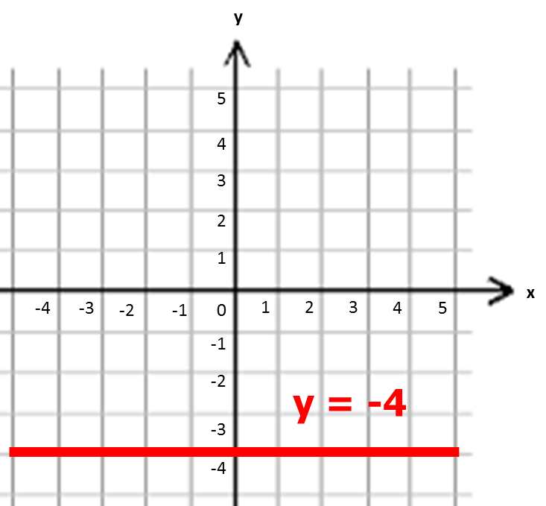 | Correct answer | 1
10. | 6n - 4 | 1 mark for 6n  1 mark for -4 | 2
11. | 9x + y | 1 mark for x simplified correctly  1 mark for y simplified correctly | 2
12. | 8 – 14 = -6 | 1 mark for 1 correct substitution  1 mark for correct answer | 2
13. | 3a – 4 = 17  3a = 21  a = 7 | 1 mark for 3a = 21  1 mark for correct answer | 2
14. | 287º | 1 mark for 42 + 65 or 107 or 73  1 mark for correct answer | 2
15. | Correct sketch | 1 mark for each length/angle given | 3
16. |  | 2 marks for correct net | 2

17. |  | Correct answer | 2
18. | ½ x (2 + 6) x 3 = 12 cm² | 1 mark for correct working  1 mark for correct answer | 2
19. | 9 x 1000 = 9000 mm³ | 1 mark for 1000 seen  1 mark for correct answer | 2
20. | 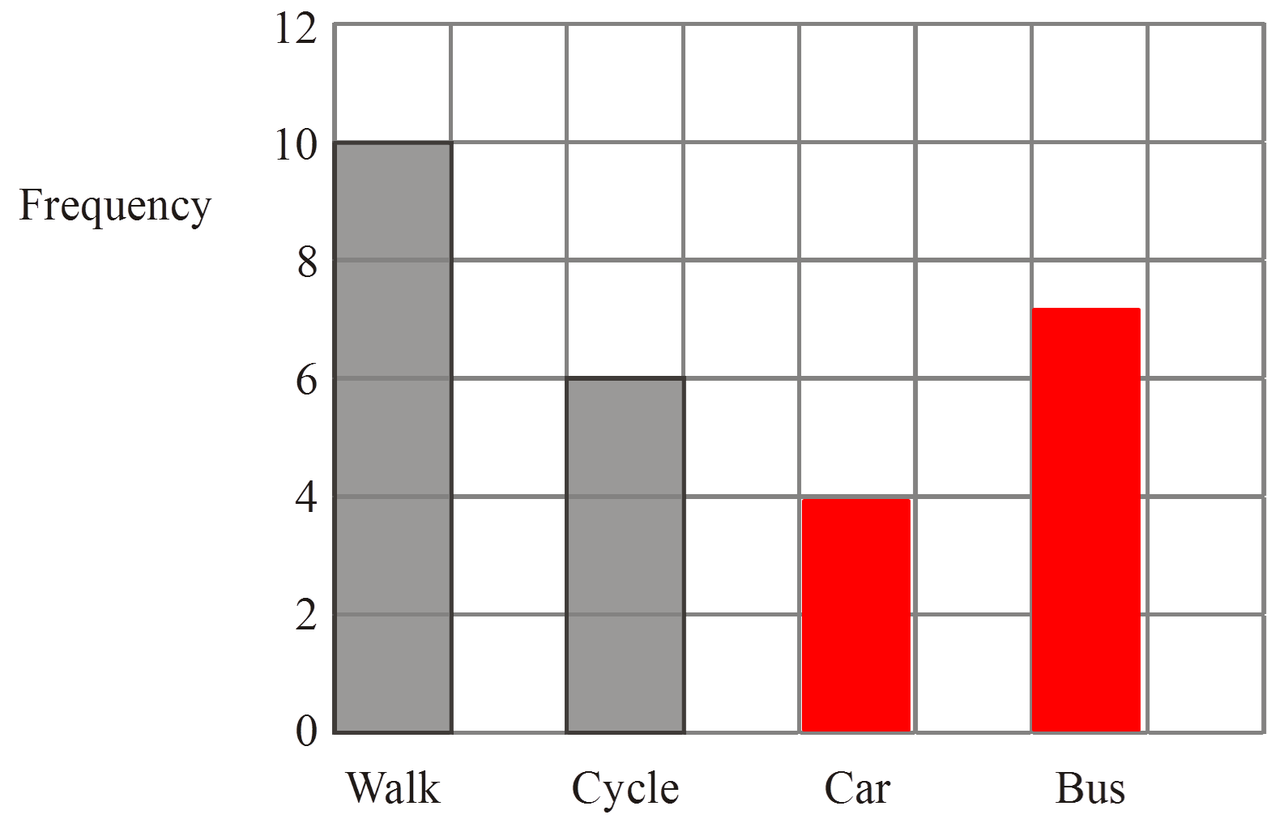 | 1 mark for each correct answer | 2

21. | Mode = 0 Mean = 2.8 | 1 mark for correct answer for mode  1 mark for 28 ÷ 10 = 2.8  1 mark for correct answer for mean | 3
22. | 1 – (0.35 + 0.24 + 0.19) = 1 – 0.78 = 0.22 | 1 mark for 0.78 seen  1 mark for correct answer | 2
23. | Basketball Swimming Football Total  Female 10 12 15 37  Male 9 17 7 33  Total 19 29 22 70 | 2 marks for all correct  1 mark lost for each incorrect | 2

