**Area and Perimeter (F)**

Pre-Intervention Assessment

Name: _______________________________

Class: _______________________________

Date: _______________________________

|  |  |  |
| --- | --- | --- |
| **Question** | **Objective** | **RAG** |
| 1 | Calculate the area and perimeter of rectangles and triangles |  |
| 2 | Calculate the area and perimeter of compound shapes |  |
| 3 | Calculate the area and perimeter of circles |  |

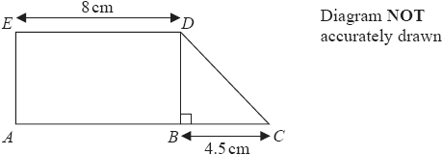**1.** Diagram NOT drawn accurately  *ABDE* is a rectangle.

*ED* is 8cm.

*BDC* is a right-angled triangle.   
*BC* is 4.5cm.

*ABC* is a straight line.

The area of the rectangle *ABDE* is 40cm2.   
Work out the area of the triangle *BDC*.

...........................................................cm2

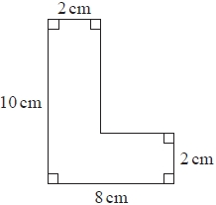**2**. Work out the area of the shape.

…………………………………………………cm2

**3**. Diagram NOT accurately drawn 

A circle has a radius of 6.1 cm.  
Work out the area of the circle.

.......................................... cm²

[Glue here]