Band 6 – Test 1 Answers

1. | 100x = 213.63636…  - x = 2.13636…  99x = 211.5  x = $\frac{211.5}{99}=2\frac{135}{990}=2\frac{3}{22}$ | 1 mark for x100  1 mark for calculating x  1 mark for answer in simplest form | 3
2. | 35.55  $\sqrt{\frac{2 x 35.55}{9.85}}$ = 2.686684… = 2.7 seconds | 1 mark for correct LB of d  1 mark for correct UB of g  1 mark for correct substitution  1 mark for answer rounded correctly | 4
3. | √72 = √36 x √2 = 6√2 | 1 mark for correct working  1 mark for correct answer | 2
4. | Gradient = -1 ÷ 2 = -½  y = -½x + 6 | 1 mark for gradient  1 mark for y-intercept  1 mark for correct answer | 3
5. | x -2 -1 0 1 2  y ¼ ½ 1 2 4  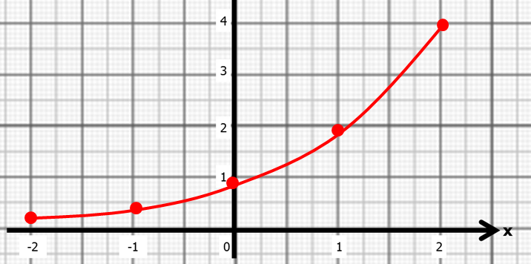 | 1 mark for at least 2 y values correct  Or 2 marks for all y values correct  1 mark for coordinates plotted correctly  1 mark for correct graph drawn | 4
6. | x³ - x² + 7 = 0  x³ = x² - 7  x = $\sqrt[3]{x^{2}-7}$  x₁ = -1.817…  x₂ = -1.546…  x₃ = -1.664…  x₄ = -1.617… = -1.617 | 1 mark for isolating x³  1 mark for correct answer  1 mark for at least 2 correct iterations  1 mark for answer rounded correctly | 4
7. | 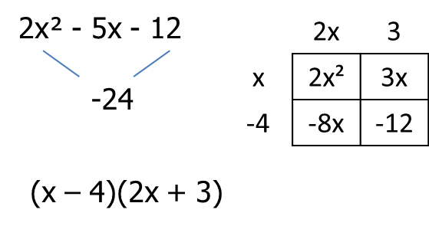  x = 4 or -3/2 | 1 mark for correct working  1 mark for correct factorisation  1 mark for correct answer | 3
8. | $$x=\frac{--5±\sqrt{5^{2}-4(1)(-8)}}{2(1)}$$  $$x=\frac{5±\sqrt{5^{2}+32}}{2}$$  x = 6.27 or -1.27 | 1 mark for correct substitution  1 mark for each correct answer | 3
9. | 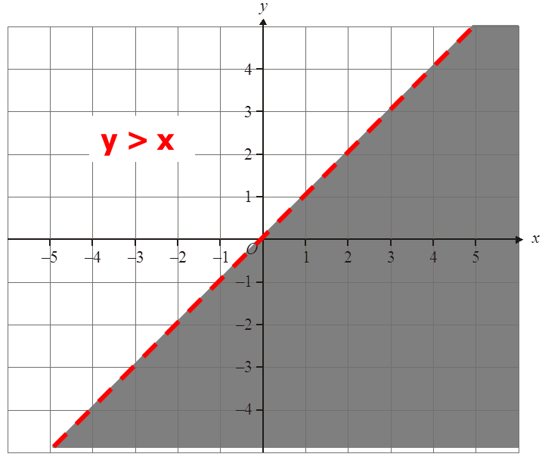 | 1 mark for dotted line  1 mark for correct side indicated | 2
10. | 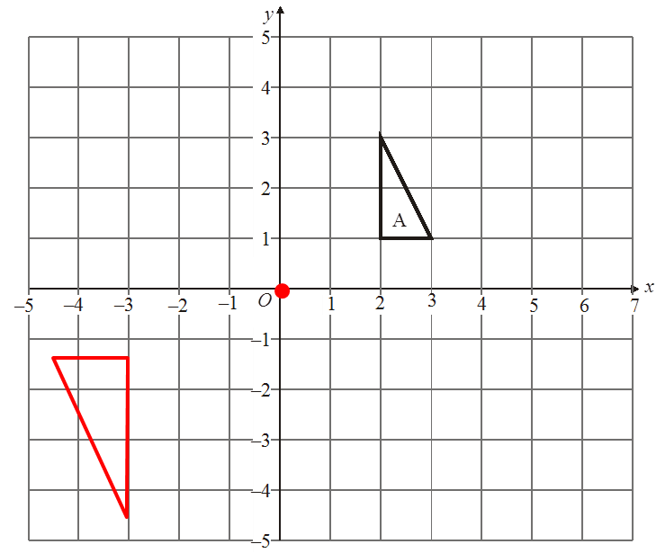 | 1 mark for C of E correctly identified  1 mark for SF 1½  1 mark for correct enlargement | 3
11. | $\sqrt{8^{2}+ {10}^{2}}= \sqrt{168}$ = 12.8 cm  Diagonal is shorter than the pencil therefore will not fit | 1 mark for correct working  1 mark for 12..8  1 mark for correct conclusion | 3
12. | $\sqrt{5^{2}+ 7^{2}}$ = 8.6 cm  tan⁻¹(3 ÷ 8.6) = 19.2º | 1 mark for 8.6  1 mark for tan used  1 mark for correct working  1 mark for answer rounded correctly | 4
13. | ½x²sin60 = 36  x = 9.118… = 9.11 cm | 1 mark for correct equation for x  1 mark for correct working  1 mark for correct answer | 3
14. | 180 x 2² = 720 cm² | 1 mark for sf 2  1 mark for correct working  1 mark for correct answer | 3
15. | Area (A cm²) Frequency Midpoint M x f  0 < A ≤ 10 38 5 190  10 < A ≤ 25 36 17.5 630  25 < A ≤ 40 30 32.5 975  40 < A ≤ 60 46 50 2300  4095 = 27.3 cm²  150 | 1 mark for correct third column  1 mark for correct fourth column  1 mark for Σmf  Σf  1 mark for correct answer rounded correctly | 4
16. | 90 < t ≤ 100  80 < t ≤ 90 | 1 mark for each correct answer | 2

