Mathematics Assessment

Bands 2-4 Problem Solving – Test 2
Calculators not allowed

Name: ______________________________

Class: ______________________________

Teacher: ______________________________

Remember:
- The test is 1 hour long.
- You must not use a calculator for any question in this test.
- You will need: pen, pencil, rubber and a ruler.
- Try to answer all questions.
- Write all your answers and working in the spaces provided in this test paper – do not use any rough paper. Marks may be awarded for working.
- Check your work carefully.
- Don’t spend too long on one question. Leave it and try the next one.

1. | This hexagon has a perimeter of 24cm. Three of the hexagons are used to make this shape. What is the perimeter of the shape?  _______ cm | / 2
2. | Dan can put up 30 tiles in one hour. He always works at the same speed. He tiles a wall that needs 140 tiles. He starts work at 7.30 a.m. He has a 20 minute break in the morning and 45 minutes for lunch. Work out the time that Dan should finish tiling the wall.  _________ | / 4
3. | Peter works out the cost of the gas he used last year. At the start of the year, the gas meter reading was 12967 units. At the end of the year, the gas meter reading was 14059 units. Each unit of gas he used cost 44p. Work out the mean cost per month of the gas he used last year.  £ ______________ | / 5
4. | Potatoes cost £15 for a 25 kg sack at a farm shop. The same type of potatoes are on offer, costing £1.30 for a 2 kg bag, at a supermarket. Where are the potatoes better value, at the farm shop or at the supermarket? You must show your working. | / 4
5. | 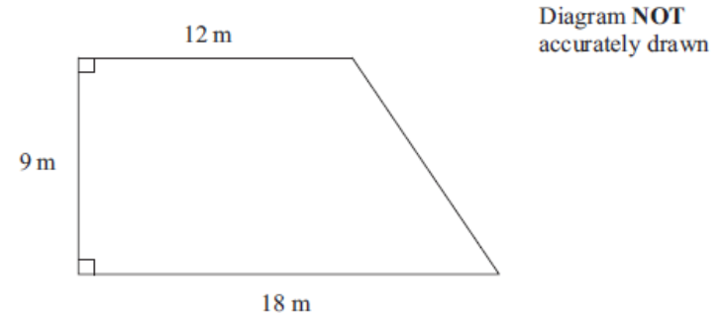  Here is a diagram of Jim’s garden. Jim wants to cover his garden with grass seed to make a lawn. Grass seed is sold in bags. There is enough grass seed in each bag to cover 20 m² of garden. Each bag of grass seed costs £9.99. Work out the least cost of putting grass seed on Jim’s garden.  £ ______________ | / 4
6. | 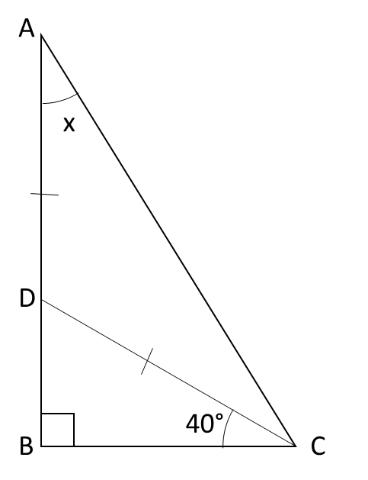  Triangle ABC is a right-angled triangle. ADB is a straight line.  DA = DC  Angle BCD = 40°  Work out the size of the angle marked x. You must give reasons for each stage of your working.  x = _______ ° | / 4
7. | ‘Purple fire’ paint is made by mixing red and blue paint in the ratio 3 : 1. ‘Purple sea’ paint is made by mixing red and blue paint in the ratio 1 : 3. 1 litre of purple fire paint is mixed with 500 millilitres of purple sea by mistake. How much red paint needs to be added to the mixture to make it purple fire again?  _____________ | / 5
8. | Marcus thinks of a number between 25 and 35. He divides the number by 2 and then subtracts 0.5. He takes this answer, divides it by 2 and then subtracts 0.5. He repeats this process a number of times and gets zero. What number did he start with?  ________ | / 3
9. | Mr Watkins needs to buy some oil for his central heating. Mr Watkins can put up to 1200 litres of oil in his oil tank. There is already 650 litres of oil in the tank. Mr Watkins is going to fill the tank with oil. The price of oil is 70p per litre. Mr Watkins gets 5% off the price of the oil. How much does Mr Watkins pay for the oil he needs to buy?  £ _______________ | / 5
10. | Amy has organised a Christmas party for some children.  Each child will get a party bag. Each party bag contains:  - 1 balloon,  - 1 bar of chocolate,  - and 1 toy.  Amy buys some packets of balloons. Each packet contains 10 balloons. She buys some boxes of chocolate bars. Each box contains 18 chocolate bars. She also buys some packets of toys. Each packet contains 12 toys. A packet of balloons costs £2.10. A box of bars of chocolate costs £4.50. A packet of toys costs £13.20. Work out the total cost of the contents of one party bag.  £ _______________  Amy makes up all of the party bags. There are no balloons, chocolate bars or toys left over. Work out the least total number of party bags that Amy makes up.  ____________ | / 6
11. | Stephen imports cars from the USA. He sells them in the UK. He has just bought a car in the USA costing $24 000. It cost him £900 to import the car to the UK. The exchange rate is £1 = $1.20. Stephen needs to make a profit of 20% on his total costs. Work out the least amount that Stephen must sell the car for in the UK. Give your answer in pounds.  £ _______________ | / 3
12. | Barbara uses her car to work as a volunteer driver at her local hospital. She is paid 30p for every mile she drives. On average she drives 2000 miles each month. Here is some information about the running costs of Barbara’s car:  Fuel consumption 50 miles per gallon  Other running costs 10 pence per mile  Petrol costs £5 per gallon. After paying for fuel and other running costs, Barbara saves the money left over. Barbara is planning to use this money for a holiday that will cost £3000. Will Barbara have enough money after saving for a year? | / 6

