End of Unit Test Name: ____________________________
Probability - HIGHER

1. (a) In a statistical experiment a fair, ordinary dice is rolled. Tick a box to show the
correct ending to the sentence below.

When this statistical experiment is repeated you will:

always get the same outcome

usually get the same outcome

usually get a different outcome

always get a different outcome
(1)
(b) Tick a box to show the correct ending to the sentence below.
An estimate of probability based on a statistical experiment is more reliable with
more trials

fewer trials

more time between trials

less time between trials
(1)
(Total 2 marks)

2. An ordinary fair dice is rolled 120 times. How many times would you expect to roll a 6?

…………………………………………………………………………………………………………..

…………………………………………………………………………………………………………..

…………………………………………………………………………………………………………..

Answer ......................................................................
(Total 2 marks)

3. A team has 7 boys and 3 girls. Stevie chooses two of the team at random.
(a) Complete the probability tree diagram.

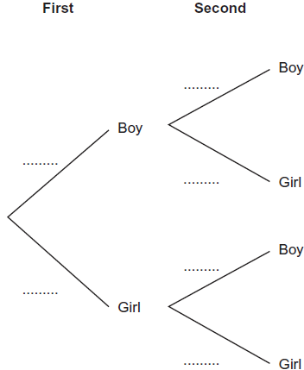
(3)
(b) Work out the probability that he chooses one boy and one girl.

…………………………………………………………………………………………………..

…………………………………………………………………………………………………..

…………………………………………………………………………………………………..

…………………………………………………………………………………………………..

Answer ......................................................................
(3)
(Total 6 marks)

4. The probability that Simon passes his driving test is $\frac{3}{5}$. The probability that Kim passes her driving test is $\frac{4}{7}$. Work out the probability that at least one of them passes the driving test.

…………………………………………………………………………………………………………..

…………………………………………………………………………………………………………..

…………………………………………………………………………………………………………..

…………………………………………………………………………………………………………..

…………………………………………………………………………………………………………..

Answer ......................................................................
(Total 3 marks)
5. (a) Shade the Venn diagram to show the region $(A∪B)'$.

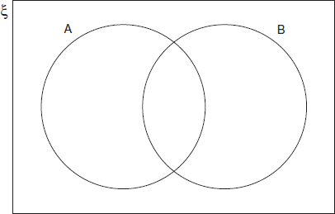
(1)
(b) Shade the Venn diagram to show the region $A∩B'$.

(1)
(Total 2 marks)

6. Here is a Venn diagram. It shows information about the number of students who have a laptop or a TV. Set L represents students with a laptop. Set T represents students with a TV.

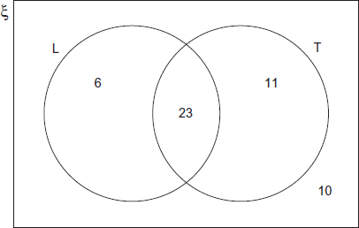

There are 50 students altogether. A student is chosen at random.

(a) Work out $P(L)$.
Answer .............................................................................
(1)
(b) Work out $P(L∩T)$.
Answer .............................................................................
(1)
(c) Complete the following using set notation.
$P($………………………$)= \frac{21}{50}$
(1)
(d) Complete the following using set notation.
$P($………………………$)= \frac{4}{5}$
(2)
(Total 5 marks)
(Total for test = 20 marks)

