**Surface Area of a Cone**

**RED**: Calculate the surface area of these cones.

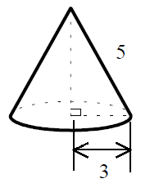 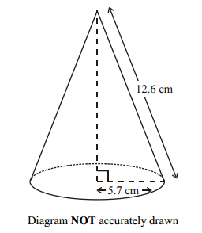 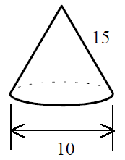

**AMBER**: Use Pythagoras’ Theorem to find the length of the slope, and then the surface area of these cones.

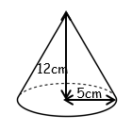 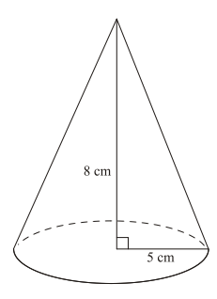 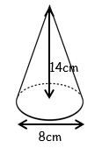

**GREEN**: Calculate the surface area. Find the sloping height.

