Frequency Polygons GREEN



**1.** 60 students take a science test.  
The test is marked out of 50.

This table shows information about the students’ marks.

|  |  |  |  |  |  |
| --- | --- | --- | --- | --- | --- |
| **Science mark** | 0–10 | 11–20 | 21–30 | 31–40 | 41–50 |
| **Frequency** | 4 | 13 | 17 | 19 | 7 |

On the grid, draw a frequency polygon to show this information.



(Total 2 marks)

**2.** 30 students ran a cross-country race.  
Each student’s time was recorded.

The table shows information about these times.

|  |  |
| --- | --- |
| Time (*t* minutes) | Frequency |
| 10 ≤ *t* < 14 | 2 |
| 14 ≤ *t* < 18 | 5 |
| 18 ≤ *t* < 22 | 12 |
| 22 ≤ *t* < 26 | 8 |
| 26 ≤ *t* < 30 | 3 |

On the grid, draw a frequency polygon to show this information.



(Total 2 marks)

**3.** The table shows some information about the weights (*w* grams) of 60 apples.

|  |  |
| --- | --- |
| **Weight (*w* grams)** | **Frequency** |
| 100 ≤ *w* < 110 | 5 |
| 110 ≤ *w* < 120 | 9 |
| 120 ≤ *w* < 130 | 14 |
| 130 ≤ *w* < 140 | 24 |
| 140 ≤ *w* < 150 | 8 |

Draw a frequency polygon to show this information.



(Total 2 marks)

**4.** The age when 100 people from the UK and the USA got married for the first time is shown on the frequency polygon below. Compare the data.

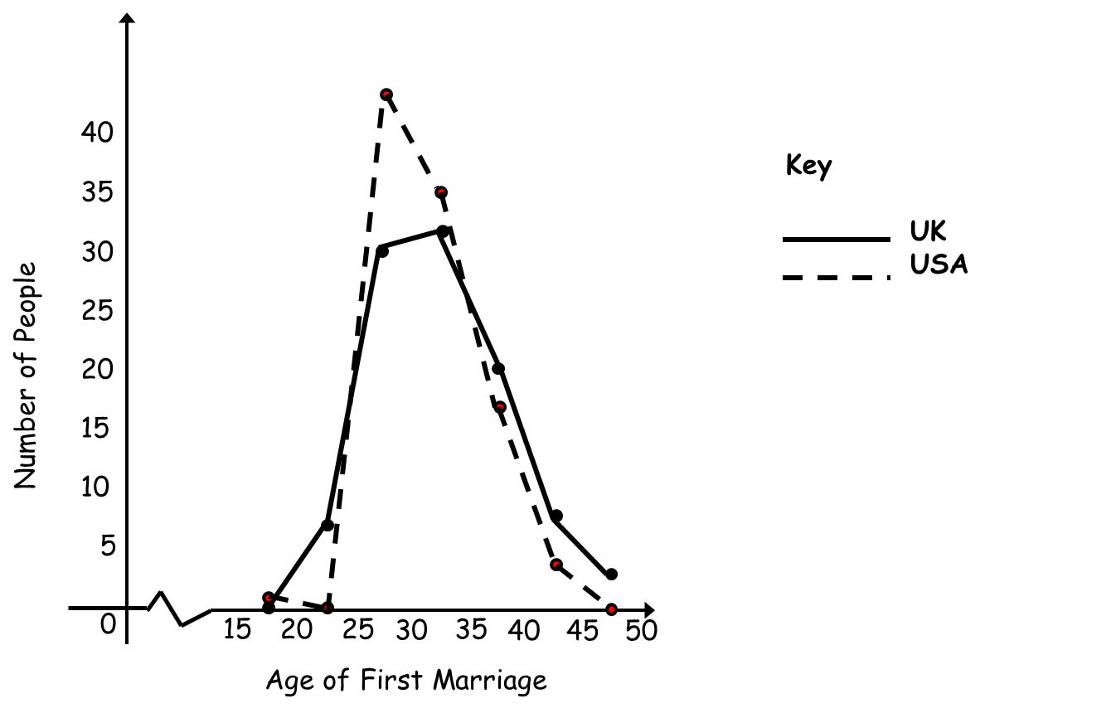

**……………………………………………………………………………………………………**

**……………………………………………………………………………………………………**

**……………………………………………………………………………………………………**

**……………………………………………………………………………………………………**

(Total 2 marks)

Frequency Polygons AMBER

1. Calculate the midpoints.
2. Plot the coordinates.
3. Join with a straight line.

**1.** 60 students take a science test.  
The test is marked out of 50.

This table shows information about the students’ marks.

|  |  |  |  |  |  |
| --- | --- | --- | --- | --- | --- |
| **Science mark** | 0–10 | 11–20 | 21–30 | 31–40 | 41–50 |
| **Frequency** | 4 | 13 | 17 | 19 | 7 |

On the grid, draw a frequency polygon to show this information.



(Total 2 marks)

**2.** 30 students ran a cross-country race.  
Each student’s time was recorded.

The table shows information about these times.

1. Calculate the midpoints.
2. Plot the coordinates.
3. Join with a straight line.

|  |  |
| --- | --- |
| Time (*t* minutes) | Frequency |
| 10 ≤ *t* < 14 | 2 |
| 14 ≤ *t* < 18 | 5 |
| 18 ≤ *t* < 22 | 12 |
| 22 ≤ *t* < 26 | 8 |
| 26 ≤ *t* < 30 | 3 |

On the grid, draw a frequency polygon to show this information.



(Total 2 marks)

**3.** The table shows some information about the weights (*w* grams) of 60 apples.

|  |  |
| --- | --- |
| **Weight (*w* grams)** | **Frequency**   1. Calculate the midpoints. 2. Plot the coordinates. 3. Join with a straight line. |
| 100 ≤ *w* < 110 | 5 |
| 110 ≤ *w* < 120 | 9 |
| 120 ≤ *w* < 130 | 14 |
| 130 ≤ *w* < 140 | 24 |
| 140 ≤ *w* < 150 | 8 |

Draw a frequency polygon to show this information.



(Total 2 marks)

**4.** The age when 100 people from the UK and the USA got married for the first time is shown on the frequency polygon below. Compare the data.



What’s the same and what’s different?

**……………………………………………………………………………………………………**

**……………………………………………………………………………………………………**

**……………………………………………………………………………………………………**

**……………………………………………………………………………………………………**

**(Total 2 marks)**

Frequency Polygons RED

1. Calculate the midpoints.
2. Plot the coordinates.
3. Join with a **straight line**.

**1.** 60 students take a science test.  
The test is marked out of 50.

This table shows information about the students’ marks.

|  |  |  |  |  |  |
| --- | --- | --- | --- | --- | --- |
| **Science mark** | 0–10 | 11–20 | 21–30 | 31–40 | 41–50 |
| **Frequency** | 4 | 13 | 17 | 19 | 7 |
| **Midpoint** |  |  |  |  |  |

On the grid, draw a frequency polygon to show this information.



(Total 2 marks)

**2.** 30 students ran a cross-country race.  
Each student’s time was recorded.

The table shows information about these times.

1. Calculate the midpoints.
2. Plot the coordinates.
3. Join with a **straight line**.

|  |  |  |
| --- | --- | --- |
| Time (*t* minutes) | Frequency | Midpoint |
| 10 ≤ *t* < 14 | 2 |  |
| 14 ≤ *t* < 18 | 5 |  |
| 18 ≤ *t* < 22 | 12 |  |
| 22 ≤ *t* < 26 | 8 |  |
| 26 ≤ *t* < 30 | 3 |  |

On the grid, draw a frequency polygon to show this information.



(Total 2 marks)

**3.** The table shows some information about the weights (*w* grams) of 60 apples.

|  |  |  |
| --- | --- | --- |
| **Weight (*w* grams)** | **Frequency**   1. Calculate the midpoints. 2. Plot the coordinates. 3. Join with a **straight line**. | **Midpoint** |
| 100 ≤ *w* < 110 | 5 |  |
| 110 ≤ *w* < 120 | 9 |  |
| 120 ≤ *w* < 130 | 14 |  |
| 130 ≤ *w* < 140 | 24 |  |
| 140 ≤ *w* < 150 | 8 |  |

Draw a frequency polygon to show this information.



(Total 2 marks)

**4.** The age when 100 people from the UK and the USA got married for the first time is shown on the frequency polygon below. Compare the data.



What’s the same and what’s different?

Compare the peaks and troughs.

What is the mode for each polygon?

What can you estimate the maximums

and minimums to be?

**……………………………………………………………………………………………………**

**……………………………………………………………………………………………………**

**……………………………………………………………………………………………………**

**……………………………………………………………………………………………………**

**(Total 2 marks)**