**Similar Area and Volume EXTENSION**

**1.**



Cylinder **A** and cylinder **B** are mathematically similar.  
The length of cylinder **A** is 4 cm and the length of cylinder **B** is 6 cm.  
The volume of cylinder **A** is 80 cm3.

Calculate the volume of cylinder **B**.

………………………… cm3

(Total 3 marks)

**2.**

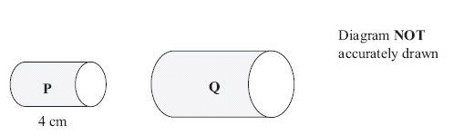

Two cylinders, **P** and **Q**, are mathematically similar. The total surface area of cylinder **P** is 90*π* cm2. The total surface area of cylinder **Q** is 810*π* cm2. The length of cylinder **P** is 4 cm.

(a) Work out the length of cylinder **Q**.

…………… cm

(3)

The volume of cylinder **P** is 100*π* cm3.

(b) Work out the volume of cylinder **Q**.  
Give your answer as a multiple of *π*

…………… cm3

(2)

(Total 5 marks)

**3.**



Diagram **NOT**  accurately drawn

Two prisms, **A** and **B**, are mathematically similar. The volume of prism **A** is 12 000 cm3. The volume of prism **B** is 49 152 cm3. The total surface area of prism **B** is 9728 cm2.

Calculate the total surface area of prism

............................... cm2

(Total 4 marks

**4.**



Diagram **NOT**  
accurately drawn

Two cones, **P** and **Q**, are mathematically similar. The total surface area of cone **P** is 24 cm2. The total surface area of cone **Q** is 96 cm2. The height of cone **P** is 4 cm.

(a) Work out the height of cone **Q***.*

...................................... cm

(3)

The volume of cone **P** is 12 cm3.

(b) Work out the volume of cone **Q**.

..................................... cm3

(2)

(Total 5 marks

**5.**



Diagram **NOT** accurately drawn

Two solid shapes, **A** and **B**, are mathematically similar. The base of shape **A** is a circle with radius 4 cm. The base of shape **B** is a circle with radius 8 cm. The surface area of shape **A** is 80 cm2.

(a) Work out the surface area of shape **B**.

............................ cm2

(2)

The volume of shape **B** is 600 cm3.

(b) Work out the volume of shape **A**.

............................ cm3

(2)

(Total 4 marks)

**6.**



Diagram **NOT** accurately drawn

The two cylinders, A and B, are mathematically similar. The height of cylinder B is twice the height of cylinder A. The total surface area of cylinder A is 180 cm2. Calculate the total surface area of cylinder B.

..........................

(Total 3 marks)