3D Coordinates GREEN

Question 1
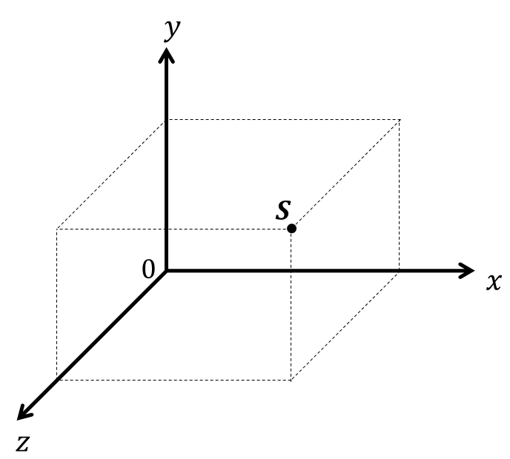

The diagram shows a cuboid drawn on a 3D grid.

Three of the vertices of the cuboid are $P (3, 2, 0)$
$Q (3, 0, 0)$
$R (3, 0, 4)$

a) Label the vertex $Q$ with a cross (×).

The vertex S is shown on the diagram.
b) Write down the coordinates of the vertex $S$.

________________
c) Calculate the volume of the cuboid.

________________ units²
Question 2
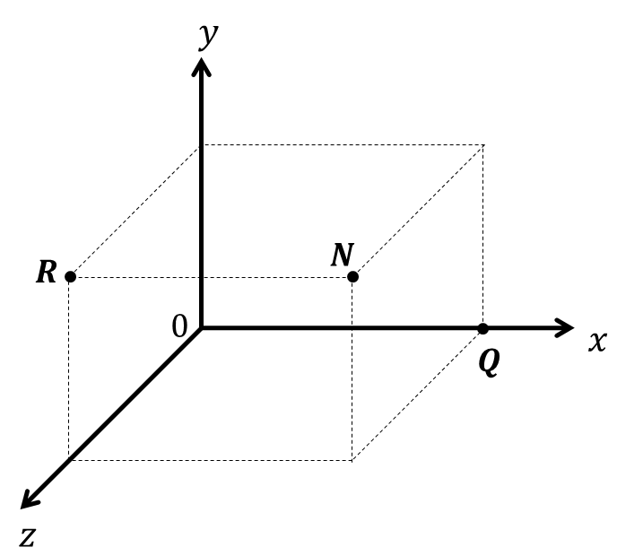

The diagram shows a cuboid drawn on a 3D coordinate grid.

The vertex $N$ of the cuboid has coordinates $(6, 2, 4)$.

a) What are the coordinates of the vertex $R$?

________________
b) What are the coordinates of the midpoint of the line segment $RN$?

________________
c) What are the coordinates of the midpoint of the line segment $RQ$?

________________

3D Coordinates AMBER

Question 1

The diagram shows a cuboid drawn on a 3D grid.
This is your worksheet. Draw all over that diagram to include the information you’ve been given!

Three of the vertices of the cuboid are $P (3, 2, 0)$
$Q (3, 0, 0)$
$R (3, 0, 4)$

a) Label the vertex $Q$ with a cross (×).

The vertex S is shown on the diagram.
b) Write down the coordinates of the vertex $S$.

________________
c) Calculate the volume of the cuboid.
What are the dimensions of the cuboid?

________________ units²
Question 2

The diagram shows a cuboid drawn on a 3D coordinate grid.

The vertex $N$ of the cuboid has coordinates $(6, 2, 4)$.

a) What are the coordinates of the vertex $R$?

________________
b) What are the coordinates of the midpoint of the line segment $RN$?

________________
c) What are the coordinates of the midpoint of the line segment $RQ$?
Start by working out the coordinates of point $Q$.

________________

3D Coordinates RED

Question 1

The diagram shows a cuboid drawn on a 3D grid.
This is your worksheet. Draw all over that diagram to include the information you’ve been given!

Three of the vertices of the cuboid are $P (3, 2, 0)$
$Q (3, 0, 0)$
$R (3, 0, 4)$

a) Label the vertex $Q$ with a cross (×).

The vertex S is shown on the diagram.
b) Write down the coordinates of the vertex $S$.

________________
c) Calculate the volume of the cuboid.
What are the dimensions of the cuboid?

________________ units²
Question 2

The diagram shows a cuboid drawn on a 3D coordinate grid.

The vertex $N$ of the cuboid has coordinates $(6, 2, 4)$.

a) What are the coordinates of the vertex $R$?

________________
b) What are the coordinates of the midpoint of the line segment $RN$?

________________
c) What are the coordinates of the midpoint of the line segment $RQ$?
Start by working out the coordinates of point $Q$.

________________

