Interpreting Histograms - GREEN

- This histogram shows information about the distances in metres that a number of people threw a ball. Draw a frequency table.

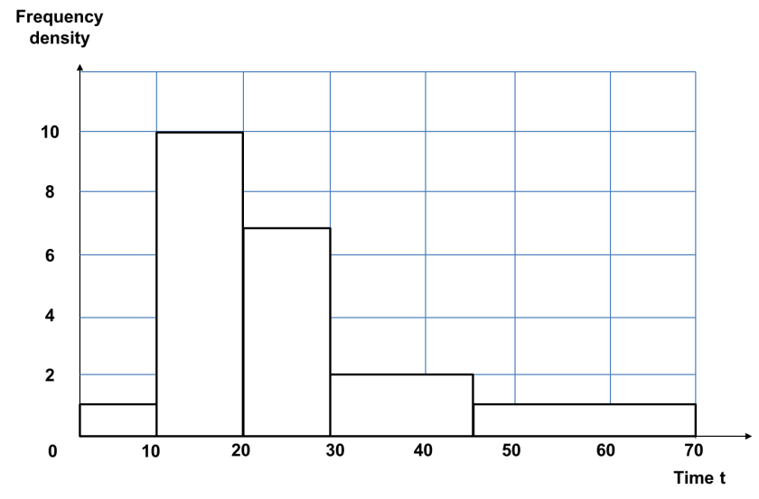

- This histogram shows information about the number of hours of television some students watched one evening. Draw a frequency table.

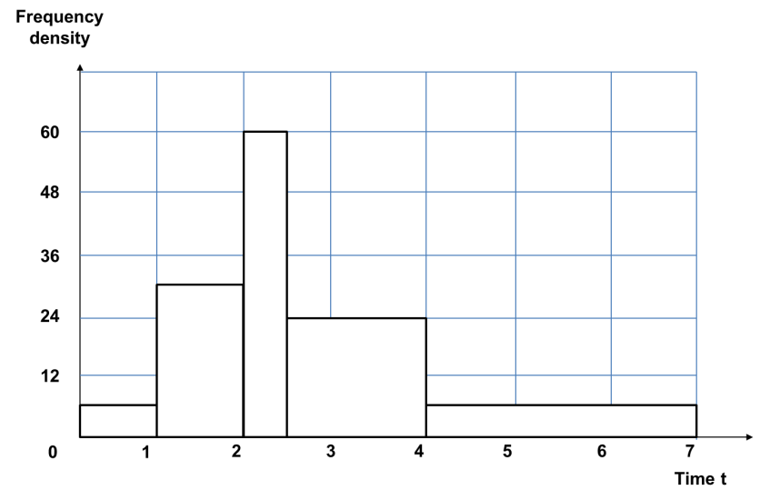

Interpreting Histograms - AMBER

- This histogram shows information about the distances in metres that a number of people threw a ball. Complete the frequency table.
Distance  ($d$ metres) | Frequency
$$0<d≤10$$
$$10<d≤20$$
$$20<d≤30$$
$$30<d≤45$$
$$45<d≤70$$

- This histogram shows information about the number of hours of television some students watched one evening. Complete the frequency table.

Time ($t$ hours) | Frequency
$$0<t≤1$$
$$1<t≤2$$
$2<t≤2\frac{1}{2}$
$2\frac{1}{2}<t≤4$
$$4<t≤7$$

Interpreting Histograms - RED

- This histogram shows information about the distances in metres that a number of people threw a ball. Complete the frequency table.

Distance  ($d$ metres) | Class width | Frequency density | Frequency
$$0<d≤10$$ | $$10$$ | $$1$$ | $$10×1=10$$
$$10<d≤20$$ | $$10$$ | $$10$$
$$20<d≤30$$
$$30<d≤45$$
$$45<d≤70$$

- This histogram shows information about the number of hours of television some students watched one evening. Complete the frequency table.

Time ($t$ hours) | Class width | Frequency density | Frequency
$$0<t≤1$$ | $$1$$ | $$6$$
$$1<t≤2$$ | $$1$$
$2<t≤2\frac{1}{2}$
$2\frac{1}{2}<t≤4$
$$4<t≤7$$

