End of Unit Test Name: ____________________________
Transformations - HIGHER

1) The shape is rotated 90° clockwise about point A.
It is then enlarged by scale factor −2, centre B.
Draw the final shape on the diagram.

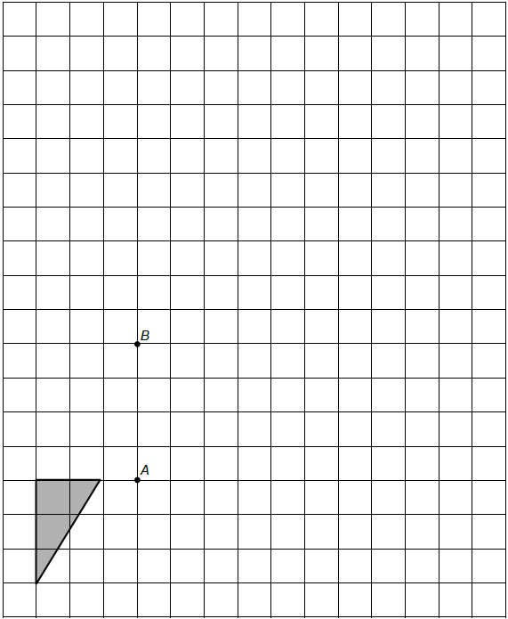
(Total 3 marks)

2) Square OABC is drawn on a centimetre grid.
O is (0, 0) A is (2, 0) B is (2, 2) C is (0, 2)
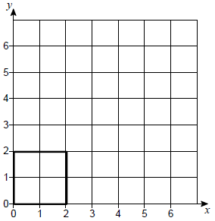
(a) OABC is translated by the vector $\left(\begin{matrix}3 \\ 1\end{matrix}\right)$
Circle the number of invariant points on the perimeter of the square.

0 1 2 4
(1)
(b) OABC is enlarged, scale factor 2, centre (0, 0)
Circle the number of invariant points on the perimeter of the square.

0 1 2 4
(1)
(c) OABC is reflected in the line y = x
Circle the number of invariant points on the perimeter of the square.

0 1 2 4
(1)
(Total 3 marks)

3) The diagram shows shapes A and B.

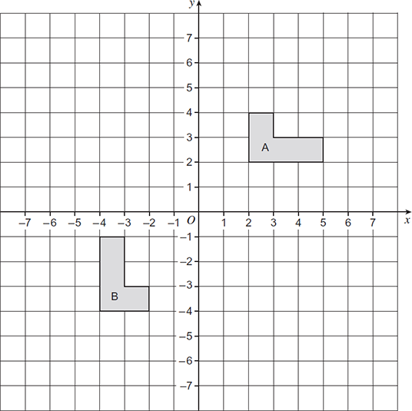

Shape A is mapped onto shape B by a reflection in one of the axes followed by a rotation.
Complete the sentence.

Shape A is mapped onto shape B by a reflection in .........................................................

followed by a rotation .........................................................................................................
(Total 3 marks)
4) a = $\left(\begin{matrix}5 \\ -2\end{matrix}\right)$ b = $\left(\begin{matrix}-2 \\ 3\end{matrix}\right)$
Circle the vector a – b

$\left(\begin{matrix}-3 \\ -5\end{matrix}\right)$ $\left(\begin{matrix}7 \\ 1\end{matrix}\right)$ $\left(\begin{matrix}3 \\ 1\end{matrix}\right)$ $\left(\begin{matrix}7 \\ -5\end{matrix}\right)$
(Total 1 mark)
5) Here are two column vectors.
f = $\left(\begin{matrix}4 \\ 5\end{matrix}\right)$ g = $\left(\begin{matrix}5 \\ -2\end{matrix}\right)$
Work out 3f − 2g

…………………………………………………………………………………………………………

…………………………………………………………………………………………………………

…………………………………………………………………………………………………………

…………………………………………………………………………………………………………

Answer ...................................................................................
(Total 2 marks)

6) In triangle ABC
M is the midpoint of AC
N is the point on BC where BN : NC = 2 : 3

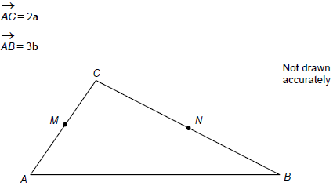
(a) Work out in terms of a and b.
Give your answer in its simplest form.

…………………………………………………………………………………………………

…………………………………………………………………………………………………

…………………………………………………………………………………………………

…………………………………………………………………………………………………

Answer ............................................
(3)
(b) Use your answer to part (a) to explain why MN is not parallel to AB.

…………………………………………………………………………………………………

…………………………………………………………………………………………………
(1)
(Total 4 marks)

7) ABCDE is a pentagon.
M is the midpoint of BC.
N is the midpoint of CD.
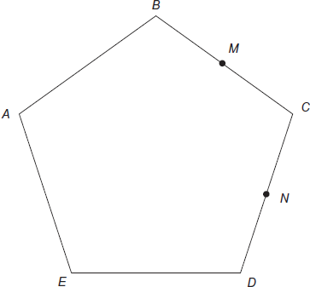

= x
= y
(a) Show that MN is parallel to BD.

…………………………………………………………………………………………………

…………………………………………………………………………………………………

…………………………………………………………………………………………………

…………………………………………………………………………………………………
(3)
(b) Write down the ratio BD : MN in its simplest form.

Answer .......... : ..........
(1)
(Total 4 marks)

(Total for test = 20 marks)

