Band 1 – Test 2 Answers

1. | $\frac{5}{20}$ $\frac{5}{25}$ $\frac{4}{20}$ $\frac{1}{50}$ $\frac{5}{10}$ | 1 mark for each correct answer | 2
2. | 0.05 0.4 0.45 0.504 0.54 | 1 mark lost for each incorrect answer | 2
3. | 3 : 4 | Correct answer | 1
4. | -9 8 | 1 mark for each correct answer | 2
5. | 6 tens of thousand | Correct answer | 1
6. | A factor of 8 = 4 or 8  A multiple of 5 = 10  A prime number = 7 or 11 | 1 mark for each correct answer | 3
7. | 36 = 2 x 2 x 2 x 3 = 2³ x 3 | 1 for one factor found  1 for all factors found  1 for expressed as a product | 3
8. | 3² = 9 √16 = 4 | 1 mark for each correct answer | 2
9. | 26 31 | 1 mark for each correct answer | 2
10. | A = (-1, -3)  Coordinate labelled at (-2, 1) | 1 mark for each correct answer | 2

11. | × 3, – 4  Input Output  1 -1  2 2  3 5  5 11  8 20 | 1 mark for each correct answer | 3
12. | Equilateral Acute | 1 mark for each correct answer | 2
13. | Line drawn measuring 4 cm 37º | 1 mark for each correct answer | 2
14. | 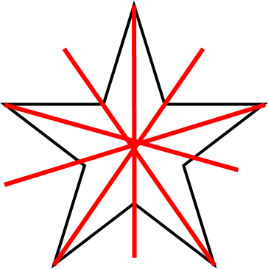 | 2 marks for all lines correct  1 mark lost for 1 extra line or for 1 line missed | 2
15. | Area = 8 x 5 = 40 cm²  Perimeter = 8 + 5 + 8 + 5 = 26 cm | 1 mark for each correct working  1 mark for each correct answer | 4
16. | 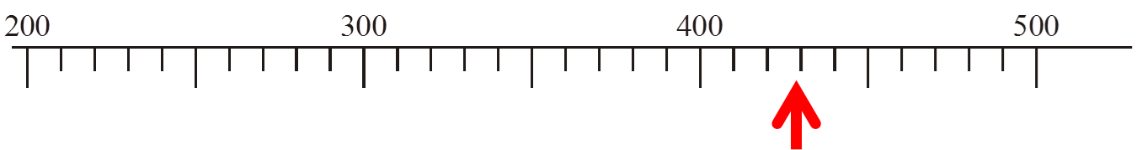 | Correct answer | 1

17. | 08 00  1 hour and 45 minutes  23 | 1 mark for each correct answer | 3
18. | 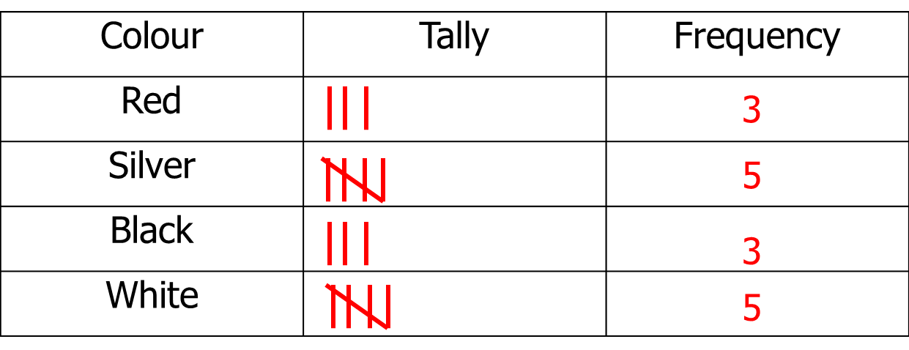 | 2 marks for all tallies correct  1 mark for all frequencies correct | 3
19. | Monday = 30 Tuesday = 25  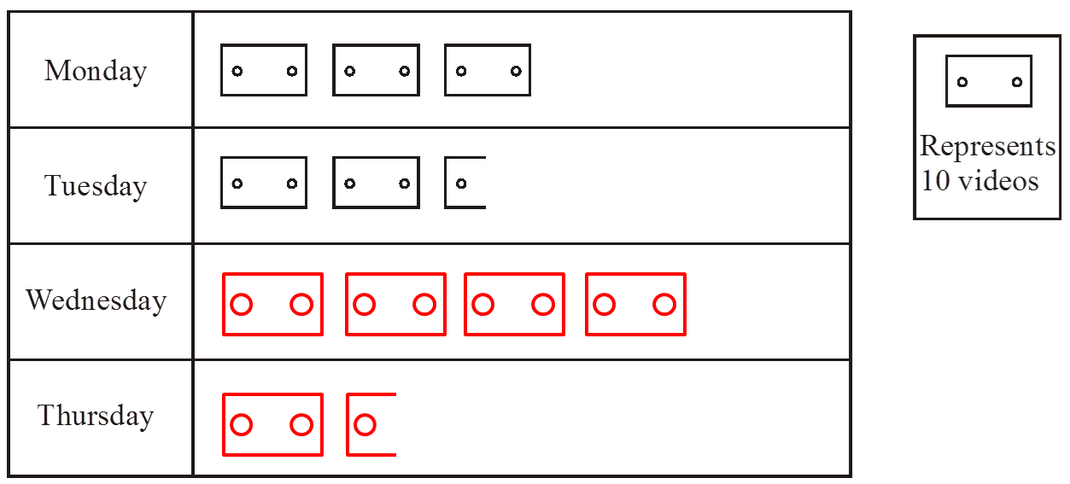 | 1 mark for each answer for Monday and Wednesday  1 mark for each row of pictogram correct | 4
20. | 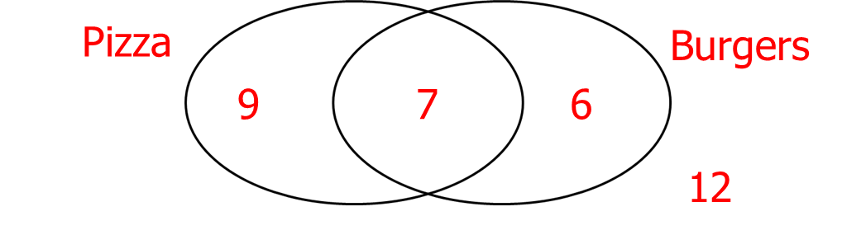  7 children | 1 mark for at least 2 numbers in Venn diagram  1 mark for correct answer | 2

21. | 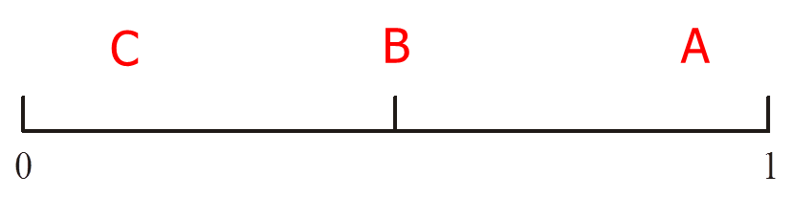 | 1 mark for each correct answer | 3
22. | (B , T) (B, I) (B, C)  (R , T) (R, I) (R, C)  (P , T) (P, I) (P, C) | 2 marks for all correct  1 mark lost for 1 doubled combination or for 1 combination missed | 2

