Band 1 – Test 3 Answers

1. | $\frac{4}{14}$ $\frac{3}{21}$ $\frac{7}{14}$ $\frac{2}{70}$ $\frac{6}{21}$ | 1 mark for each correct answer | 2
2. | 0.02 0.208 0.28 0.8 0.82 | 1 mark lost for each incorrect answer | 2
3. | 3 : 4 | Correct answer | 1
4. | 9 -10 | 1 mark for each correct answer | 2
5. | 4 hundreds | Correct answer | 1
6. | A factor of 20 = 4 or 10  A multiple of 2 = 4, 8, 10 or 14  A prime number = 7 or 11 | 1 mark for each correct answer | 3
7. | 60 = 2 x 2 x 3 x 5 = 2² x 3 x 5 | 1 for one factor found  1 for all factors found  1 for expressed as a product | 3
8. | 6² = 36 √49 = 7 | 1 mark for each correct answer | 2
9. | 5 1 | 1 mark for each correct answer | 2
10. | A = (3, -4)  Coordinate labelled at (-3, -4) | 1 mark for each correct answer | 2

11. | × 2, + 5  Input Output  1 7  2 9  3 11  5 15  8 20 | 1 mark for each correct answer | 3
12. | Scalene Obtuse | 1 mark for each correct answer | 2
13. | Line drawn measuring 3.5 cm 75º | 1 mark for each correct answer | 2
14. | 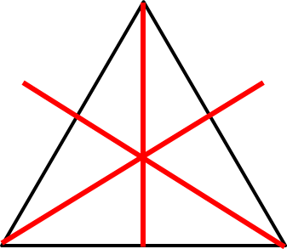 | 2 marks for all lines correct  1 mark lost for 1 extra line or for 1 line missed | 2
15. | Area = 7 x 4 = 28 cm²  Perimeter = 7 + 4 + 7 + 4 = 22 cm | 1 mark for each correct working  1 mark for each correct answer | 4
16. | 3.4 | Correct answer | 1
17. | 08 40  1 hour and 5 minutes  38 | 1 mark for each correct answer | 3

18. | 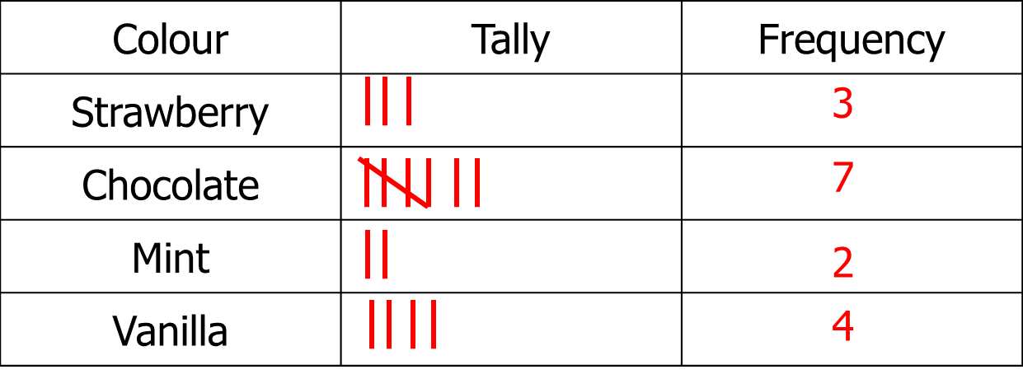 | 2 marks for all tallies correct  1 mark for all frequencies correct | 3
19. | January = 12 3 more in March than February  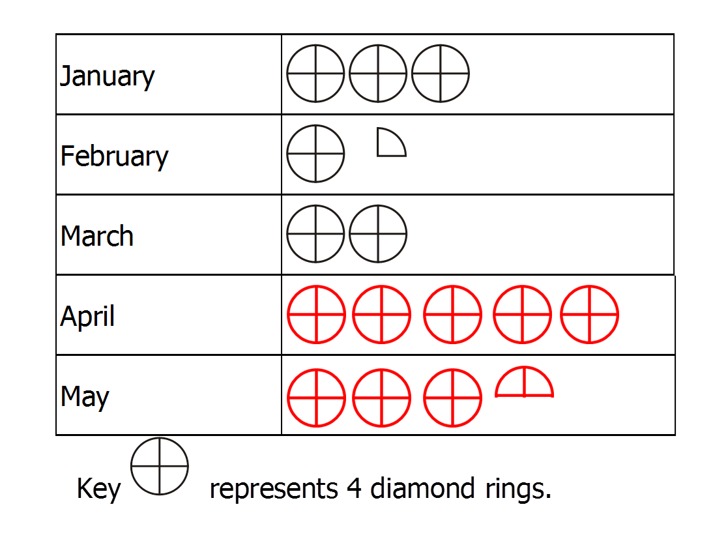 | 1 mark for each answer for Monday and Wednesday  1 mark for each row of pictogram correct | 4

20. | 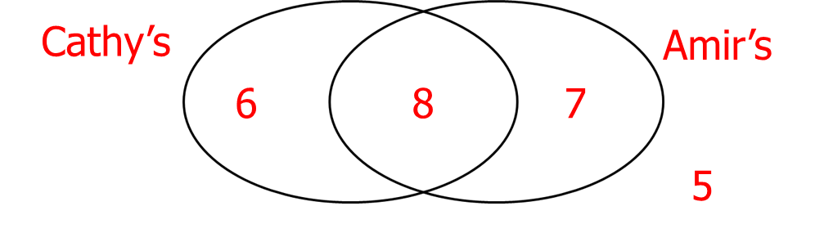  7 children | 1 mark for at least 2 numbers in Venn diagram  1 mark for correct answer | 2
21. | 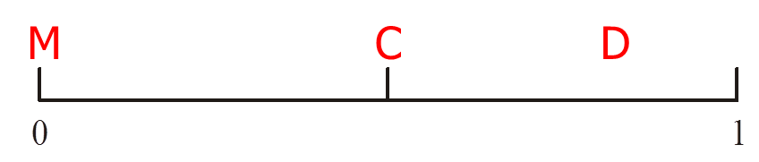 | 1 mark for each correct answer | 3
22. | (1, head) (1, tail)  (2, head) (2, tail)  (3, head) (3, tail)  (4, head) (4, tail)  (5, head) (5, tail)  (6, head) (6, tail) | 2 marks for all correct  1 mark lost for 1 doubled combination or for 1 combination missed | 2

