Drawing Histograms - GREEN

Draw a labeled Histogram for each set of data. Ensure this is done accurately! Remember to think carefully about how you label the $x$-axis…

1. Money Spent in a clothes shop.

Money Spent (£$x$) | Frequency
$$0≤x<20$$ | 40
$$20≤x<30$$ | 50
$$30≤x<40$$ | 55
$$40≤x<50$$ | 40
$$50≤x<100$$ | 50

2. Kilometres travelled by bike.

Distance Travelled ($x$ km) | Frequency
$$0≤x<50$$ | 55
$$5≤x<10$$ | 45
$$10≤x<15$$ | 30
$$15≤x<30$$ | 30
$$30≤x<50$$ | 25

3. People’s earnings in the UK.

Earnings (₤$x$) | Frequency
$$0≤x<10 0000$$ | 5 000
$$10 000≤x<20 000$$ | 120 000
$$20 000≤x<25 000$$ | 50 000
$$25 000≤x<30 000$$ | 32 000
$$30 000≤x<40 000$$ | 12 000
$$40 000≤x<50 000$$ | 5 000
$$50 000≤x<100 000$$ | 10 000

Drawing Histograms - AMBER

Draw a labeled Histogram for each set of data. Ensure this is done accurately! Remember to think carefully about how you label the $x$-axis…

1. Money Spent in a clothes shop.

Money Spent (£$x$) | Frequency | Frequency Density
$$0≤x<20$$ | 40
$$20≤x<30$$ | 50
$$30≤x<40$$ | 55
$$40≤x<50$$ | 40
$$50≤x<100$$ | 50

2. Kilometres travelled by bike.

Distance Travelled ($x$ km) | Frequency | Frequency Density
$$0≤x<50$$ | 55
$$5≤x<10$$ | 45
$$10≤x<15$$ | 30
$$15≤x<30$$ | 30
$$30≤x<50$$ | 25

3. People’s earnings in the UK.

Earnings (₤$x$) | Frequency | Frequency Density
$$0≤x<10 0000$$ | 5 000
$$10 000≤x<20 000$$ | 120 000
$$20 000≤x<25 000$$ | 50 000
$$25 000≤x<30 000$$ | 32 000
$$30 000≤x<40 000$$ | 12 000
$$40 000≤x<50 000$$ | 5 000
$$50 000≤x<100 000$$ | 10 000

Drawing Histograms - RED

Draw a labelled Histogram for each set of data. Ensure this is done accurately!

1. Money Spent in a clothes shop.

Money Spent (£$x$) | Frequency | Frequency Density
$$0≤x<20$$ | 40
$$20≤x<30$$ | 50
$$30≤x<40$$ | 55
$$40≤x<50$$ | 40
$$50≤x<100$$ | 50

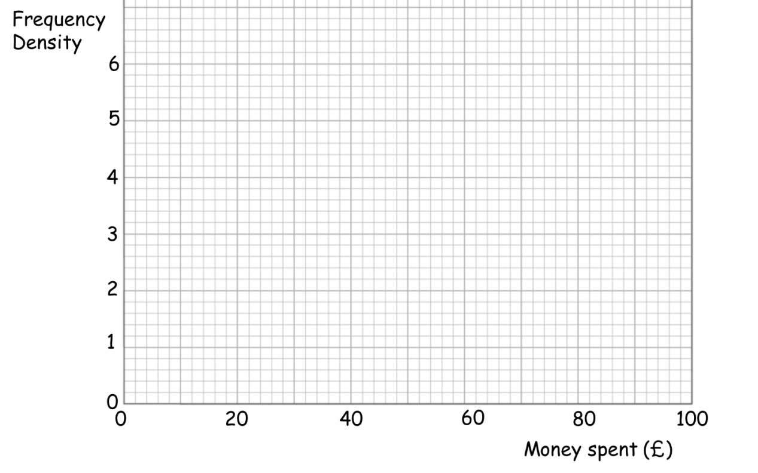
2. Kilometres travelled by bike.

Distance Travelled ($x$ km) | Frequency | Frequency Density
$$0≤x<50$$ | 55
$$5≤x<10$$ | 45
$$10≤x<15$$ | 30
$$15≤x<30$$ | 30
$$30≤x<50$$ | 25

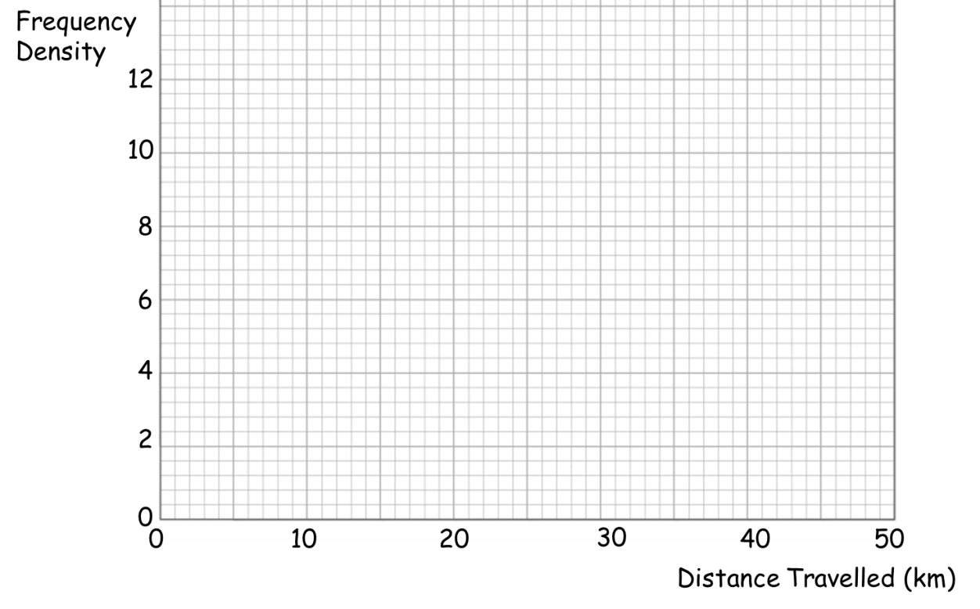
3. People’s earnings in the UK.

Earnings (₤$x$) | Frequency | Frequency Density
$$0≤x<10 0000$$ | 5 000
$$10 000≤x<20 000$$ | 120 000
$$20 000≤x<25 000$$ | 50 000
$$25 000≤x<30 000$$ | 32 000
$$30 000≤x<40 000$$ | 12 000
$$40 000≤x<50 000$$ | 5 000
$$50 000≤x<100 000$$ | 10 000

