Louise makes a spinner. The spinner can land on green or on red. The probability that the spinner will land on green is 0.7. Louise spins the spinner twice.  (a) Complete the probability tree diagram.  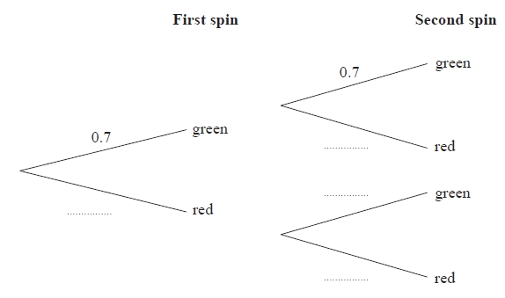  (2)  (b) Work out the probability that the spinner lands on two different colours.  ...........................................................  (3)  (Total for question = 5 marks) | Louise makes a spinner. The spinner can land on green or on red. The probability that the spinner will land on green is 0.7. Louise spins the spinner twice.  (a) Complete the probability tree diagram.  (2)  (b) Work out the probability that the spinner lands on two different colours.  ...........................................................  (3)  (Total for question = 5 marks)
Louise makes a spinner. The spinner can land on green or on red. The probability that the spinner will land on green is 0.7. Louise spins the spinner twice.  (a) Complete the probability tree diagram.  (2)  (b) Work out the probability that the spinner lands on two different colours.  ...........................................................  (3)  (Total for question = 5 marks) | Louise makes a spinner. The spinner can land on green or on red. The probability that the spinner will land on green is 0.7. Louise spins the spinner twice.  (a) Complete the probability tree diagram.  (2)  (b) Work out the probability that the spinner lands on two different colours.  ...........................................................  (3)  (Total for question = 5 marks)
There are 10 socks in a drawer. 7 of the socks are brown. 3 of the socks are grey. Bevan takes at random two socks from the drawer at the same time.  (a) Complete the probability tree diagram.  (2)  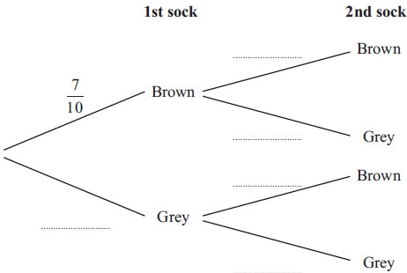  (b) Work out the probability that Bevan takes two socks of the same colour.  ...........................................................  (3)  (Total for Question is 5 marks) | There are 10 socks in a drawer. 7 of the socks are brown. 3 of the socks are grey. Bevan takes at random two socks from the drawer at the same time.  (a) Complete the probability tree diagram.  (2)  (b) Work out the probability that Bevan takes two socks of the same colour.  ...........................................................  (3)  (Total for Question is 5 marks)
There are 10 socks in a drawer. 7 of the socks are brown. 3 of the socks are grey. Bevan takes at random two socks from the drawer at the same time.  (a) Complete the probability tree diagram.  (2)  (b) Work out the probability that Bevan takes two socks of the same colour.  ...........................................................  (3)  (Total for Question is 5 marks) | There are 10 socks in a drawer. 7 of the socks are brown. 3 of the socks are grey. Bevan takes at random two socks from the drawer at the same time.  (a) Complete the probability tree diagram.  (2)  (b) Work out the probability that Bevan takes two socks of the same colour.  ...........................................................  (3)  (Total for Question is 5 marks)
Here is a Venn diagram.  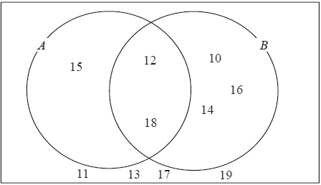  (a) Write down the numbers that are in set  (i) A ∪ B  ...........................................................  (ii) A ∩ B  ...........................................................  (2)  One of the numbers in the diagram is chosen at random.  (b) Find the probability that the number is in set A'  ...........................................................  (2)  (Total for question = 4 marks) | Here is a Venn diagram.  (a) Write down the numbers that are in set  (i) A ∪ B  ...........................................................  (ii) A ∩ B  ...........................................................  (2)  One of the numbers in the diagram is chosen at random.  (b) Find the probability that the number is in set A'  ...........................................................  (2)  (Total for question = 4 marks)
Here is a Venn diagram.  (a) Write down the numbers that are in set  (i) A ∪ B  ...........................................................  (ii) A ∩ B  ...........................................................  (2)  One of the numbers in the diagram is chosen at random.  (b) Find the probability that the number is in set A'  ...........................................................  (2)  (Total for question = 4 marks) | Here is a Venn diagram.  (a) Write down the numbers that are in set  (i) A ∪ B  ...........................................................  (ii) A ∩ B  ...........................................................  (2)  One of the numbers in the diagram is chosen at random.  (b) Find the probability that the number is in set A'  ...........................................................  (2)  (Total for question = 4 marks)

