Area of Trapeziums GREEN

Calculate the area of the following trapeziums.

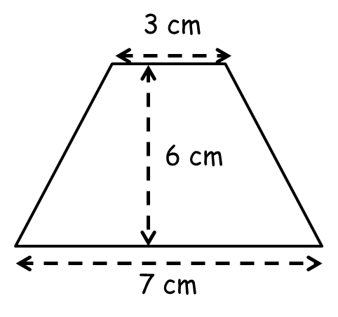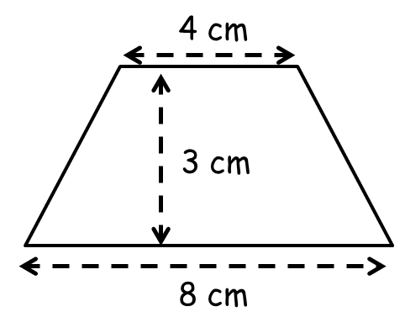

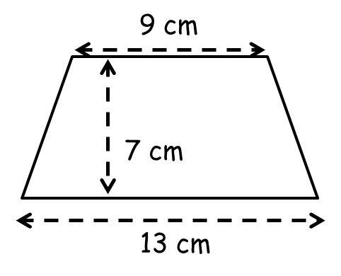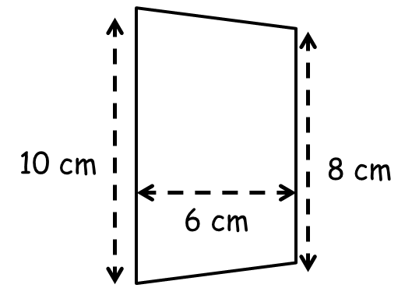

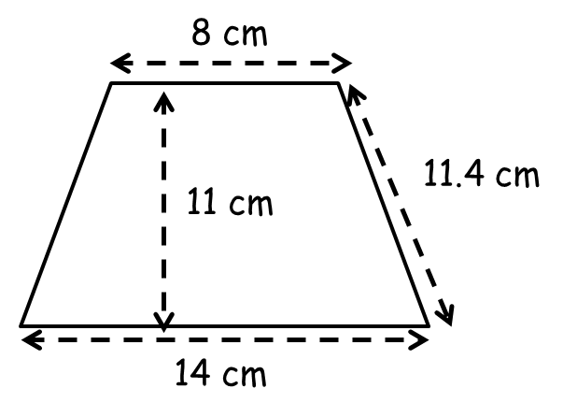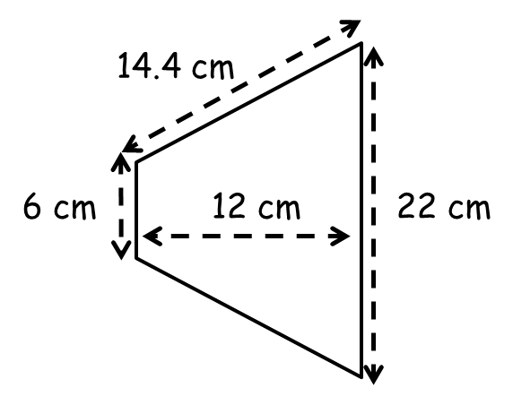

Area of Trapeziums AMBER
Area of trapezium
$=\frac{1}{2}\left(a+b\right)$

Calculate the area of the following trapeziums.

Remember $a$ and $b$ are the parallel sides!

Remember to use the perpendicular height!

Area of Trapeziums RED
Area of trapezium
$=\frac{1}{2}\left(a+b\right)$

Calculate the area of the following trapeziums.

½ x 6 x (3 + 7) ½ x 3 x (4 + 8)
= ½ x 6 x 10 =
=

Remember $a$ and $b$ are the parallel sides!

Remember to use the perpendicular height!

