Surface Area of Cubes and Cuboids GREEN

Question 1
Calculate the surface areas of the cuboids below.
a) b) c)
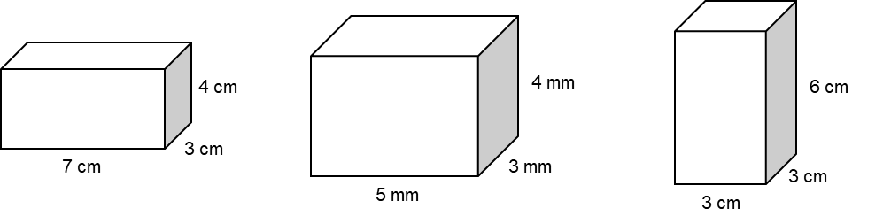

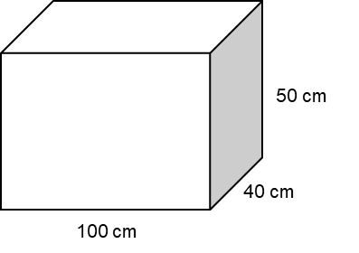
Question 2
Gary is going to paint this box.
One tube of paint can cover 0.5 m².
How many tubes of paint are needed to paint the box?

Question 3
A cuboid has volume of 168 cm³.
The area of the base of the cuboid is 24 cm² and its width is 4 cm.
Work out the surface area of the cuboid.

Question 4
A cube has a volume of 512 cm³.
Calculate its surface area.

Surface Area of Cubes and Cuboids AMBER

Question 1
Calculate the surface areas of the cuboids below.
a) b) c)
Front:
Back:
Left:
Right:
Top:
Bottom:

Total:

Start by calculating the surface area
Question 2
Gary is going to paint this box.
One tube of paint can cover 0.5 m².
How many tubes of paint are needed to paint the box?

Question 3
If it’s tricky, draw a piccy!
A cuboid has volume of 168 cm³.
The area of the base of the cuboid is 24 cm² and its width is 4 cm.
Work out the surface area of the cuboid.

Question 4
If it’s tricky, draw a piccy!
A cube has a volume of 512 cm³.
Calculate its surface area.

Surface Area of Cubes and Cuboids RED

Question 1
Calculate the surface areas of the cuboids below.
a) b) c)
Front: $7×4=$ Front:
Back: Back:
Left: $3×4=$ Left:
Right: Right:
Top: $7×3$ Top:
Bottom: Bottom:

Total: Total:

Start by calculating the surface area
Question 2
Gary is going to paint this box.
One tube of paint can cover 0.5 m².
How many tubes of paint are needed to paint the box?

Front and back: $2×____×____=$
Left and right: $2×____×____=$
Top and bottom: $2×____×____=$

Total:

Question 3
If it’s tricky, draw a piccy!
A cuboid has volume of 168 cm³.
The area of the base of the cuboid is 24 cm² and its width is 4 cm.
Work out the surface area of the cuboid.

Question 4
If it’s tricky, draw a piccy!
A cube has a volume of 512 cm³.
Calculate its surface area.
