Band 2 – Test 2 Answers

1. | $\frac{1}{6}$ $\frac{1}{3}$ $\frac{3}{5}$ $\frac{3}{4}$ | 1 mark lost for each incorrect place | 2
2. | 49 ml £365 | 1 mark for 1/10 = 7ml seen  1 mark for 10% or 1% seen  1 mark for each correct answer | 4
3. | Fraction Decimal Percentage  $\frac{1}{5}$ 0.2 20%  $\frac{3}{10}$ 0.3 30%  $\frac{13}{20}$ 0.65 65% | 1 mark for each correct answer | 3
4. | 150 g of flour  90 g of sugar  75 g of margarine  60 g of chocolate chips  3 eggs | 1 mark for 10 : 15 or x 1.5 seen  1 mark for 2 quantities correct  1 mark for all quantities correct | 3
5. | Pak of 9 is best value  Pack of 9 1 roll = 47p  Pack of 4 1 roll = 49p | 1 mark for each piece of working  1 mark for correct conclusion | 3
6. | BIDMAS 20 – (5 x 3) = 20 – 15 = 5  Pat is correct  21 ÷ 3 = 7 | 1 mark for correct working  1 mark for correct conclusion  1 mark for correct answer | 3
7. | 3.3 | Correct answer | 1
8. | 12 24 36 48 60…  16 32 48 64…  LCM = 48 | 1 mark for each list of factors  1 mark for 24 | 3
9. | 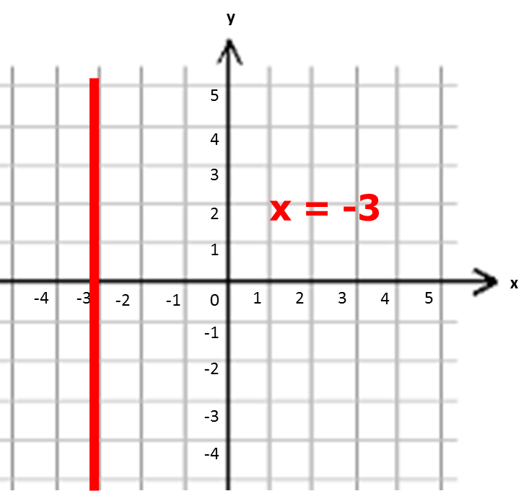 | Correct answer | 1
10. | 4n - 1 | 1 mark for 4n  1 mark for -1 | 2
11. | 5x + 6y | 1 mark for x simplified correctly  1 mark for y simplified correctly | 2
12. | 20 – 2 = 18 | 1 mark for 1 correct substitution  1 mark for correct answer | 2
13. | 5f + 12 = 42  5f = 30  f = 6 | 1 mark for 5f = 30  1 mark for correct answer | 2
14. | 60º  All angles are equal so equilateral | 1 mark for 60º  1 mark for correct answer | 2
15. | Correct sketch | 1 mark for each length/angle given | 3
16. | 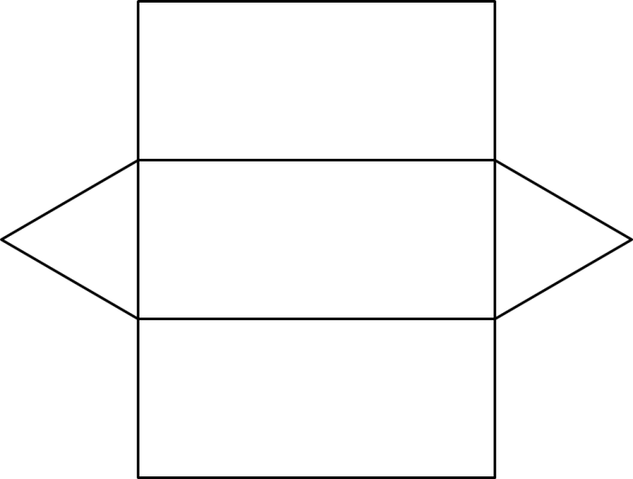 | 2 marks for correct net | 2
17. |  | Correct answer | 2
18. | ½ x 12 x 5 = 30 cm² | 1 mark for correct working  1 mark for correct answer | 2
19. | 7 x 1 000 000 = 7 000 000 cm³ | 1 mark for 1 000 000 seen  1 mark for correct answer | 2
20. | Incorrect scale on y axis between 0 and 2  Missing label on third bar | 1 mark for each correct answer | 2
21. | Range = 4 Median = 3.5 | 1 mark for correct answer for range  1 mark for correct order of numbers  1 mark for correct answer for median | 3
22. | 1 – (0.2 + 0.3 + 0.1) = 1 – 0.6 = 0.4 | 1 mark for 0.6 seen  1 mark for correct answer | 2
23. | Boys Girls Total  Watched tennis 7 17 24  Did not watch tennis 13 19 32  Total 20 36 56 | 2 marks for all correct  1 mark lost for each incorrect | 2

