**Measures (H)**

Intervention Booklet

Name: _______________________________

Class: _______________________________

**Useful websites:**

**www.mathswatchvle.com**

*(Video explanations and questions)*

Username: STH…@twgash

Password: stmaths

**www.methodmaths.com**

*(Past papers online that get instantly marked)*

Centre ID: wga

Username: firstname

Password: lastname

**www.hegartymaths.com**

*(Online tutorials and quizzes)*

Login: first name and last name are case sensitive

**www.bbc.co.uk/schools/gcsebitesize/maths**

**Similar Length, Area and Volume (LAV)**

**Things to remember:**

* Linear scale factor = x
* Area scale factor = x²
* Volume scale factor = x³

**Questions:**

**1.** Two cylinders, **P** and **Q**, are mathematically similar.

The total surface area of cylinder **P** is 90*π* cm². The total surface area of cylinder **Q** is 810*π* cm². The length of cylinder **P** is 4 cm.

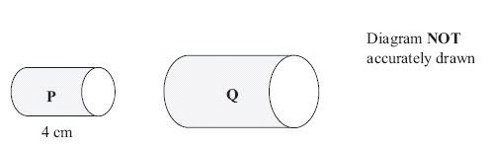

(a) Work out the length of cylinder **Q**.

........................................................... cm

**(3)**

The volume of cylinder **P** is 100*π* cm³.

(b) Work out the volume of cylinder **Q**.  
Give your answer as a multiple of *π*

........................................................... cm³

**(2)**

**(Total 5 marks)**

**2.** Diagram **NOT**  accurately drawn

Two prisms, **A** and **B**, are mathematically similar. The volume of prism **A** is 12 000 cm³. The volume of prism **B** is 49 152 cm³. The total surface area of prism **B** is 9728 cm².



Calculate the total surface area of prism

........................................................... cm²

**(Total 4 marks**

**3.** Diagram **NOT** accurately drawn

Two cones, **P** and **Q**, are mathematically similar. The total surface area of cone **P** is 24 cm². The total surface area of cone **Q** is 96 cm². The height of cone **P** is 4 cm.

(a) Work out the height of cone **Q***.*

........................................................... cm

**(3)**

The volume of cone **P** is 12 cm3.

(b) Work out the volume of cone **Q**.

........................................................... cm³

**(2)**

**(Total 5 marks**

**4.** Diagram **NOT** accurately drawn

Two solid shapes, **A** and **B**, are mathematically similar. The base of shape **A** is a circle with radius 4 cm. The base of shape **B** is a circle with radius 8 cm. The surface area of shape **A** is 80 cm².

(a) Work out the surface area of shape **B**.

........................................................... cm²

**(2)**

The volume of shape **B** is 600 cm³.

(b) Work out the volume of shape **A**.

........................................................... cm³

**(2)**

**(Total 4 marks)**

**Velocity-Time Graphs**

**Things to remember:**

* Velocity is speed with direction
* Acceleration and deceleration is given by the gradient of the graph
* The distance travelled is given by the area under the graph.

**Questions:**

1. A car has an initial speed of *u* m/s.

The car accelerates to a speed of 2*u* m/s in 12 seconds.

The car then travels at a constant speed of 2*u* m/s for 10 seconds.

Assuming that the acceleration is constant, show that the total distance, in metres, travelled

by the car is 38*u*.

**(Total for question = 4 marks)**

**2**. Karol runs in a race.

The graph shows her speed, in metres per second, *t* seconds after the start of the race.

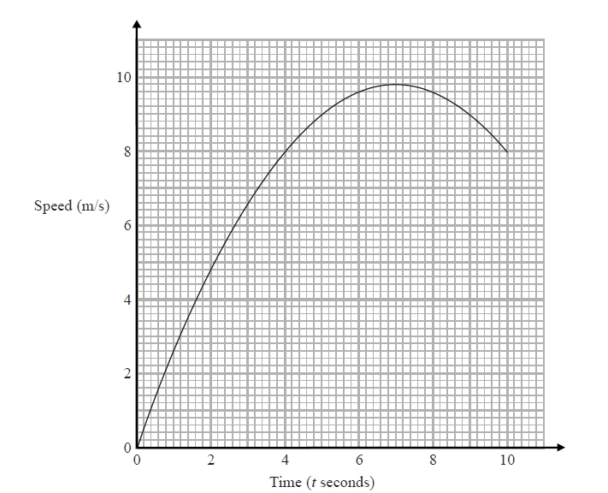

(a)   Calculate an estimate for the gradient of the graph when *t* = 4   
      You must show how you get your answer.

...........................................................

**(3)**

(b)   Describe fully what your answer to part (a) represents.

.......................................................................................................................................

.......................................................................................................................................

**(2)**

(c)   Explain why your answer to part (a) is only an estimate.

.......................................................................................................................................

.......................................................................................................................................

**(1)**

**(Total for question = 6 marks)**

**3**. Here is a speed-time graph for a car journey.   
The journey took 100 seconds.

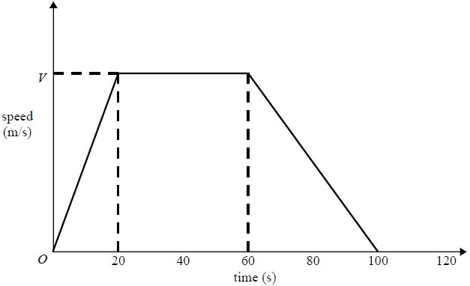

The car travelled 1.75km in the 100 seconds.

(a)   Work out the value of *V*.

...........................................................

**(3)**

(b)   Describe the acceleration of the car for each part of this journey.

.......................................................................................................................................

.......................................................................................................................................

.......................................................................................................................................

.......................................................................................................................................

.......................................................................................................................................

.......................................................................................................................................

.......................................................................................................................................

**(2)**

**(Total for question = 5 marks)**