**Probability (F)**

Intervention Booklet

Name: _______________________________

Class: _______________________________

**Useful websites:**

**www.mathswatchvle.com**

*(Video explanations and questions)*

Username: STH…@twgash

Password: stmaths

**www.methodmaths.com**

*(Past papers online that get instantly marked)*

Centre ID: wga

Username: firstname

Password: lastname

**www.hegartymaths.com**

*(Online tutorials and quizzes)*

Login: first name and last name are case sensitive

**www.bbc.co.uk/schools/gcsebitesize/maths**

**Probability**

**Things to remember:**

* Probability can be expressed as a fraction, decimal or percentage. Do not write it as a ratio.
* All probabilities of an event will add up to 1.

**Questions:**

**1.** Draw a circle around the word, or words, which best describe the following possibilities.

(a) It will rain in Manchester next September.

|  |
| --- |
| impossible unlikely even chance likely certain |

**(1)**

(b) The next baby to be born in London will be a girl.

|  |
| --- |
| impossible unlikely even chance likely certain |

**(1)**

**(Total 2 marks)**

**2.** On the probability scale below, mark

(i) with the letter S, the probability that it will snow in London in June,

(ii) with the letter H, the probability that when a fair coin is thrown once it comes down heads,

(iii) with the letter M, the probability that it will rain in Manchester next year.

|  |  |
| --- | --- |
|  |  |

1. 1

**(Total 3 marks)**

**3.** The diagram shows a fair spinner in the shape of a rectangular octagon.



The spinner can land on A or B or C. Marc spins the spinner.

Write down the probability that the spinner will land on A.

.............................

**(Total 2 marks)**

**4.** A bag contains some beads which are red or green or blue or yellow.

The table shows the number of beads of each colour.

|  |  |  |  |  |
| --- | --- | --- | --- | --- |
| Colour | Red | Green | Blue | Yellow |
| Number of beads | 3 | 2 | 5 | 2 |

Samire takes a bead at random from the bag.  
Write down the probability that she takes a blue bead.

............................

**(Total 2 marks)**

**5.** Richard has a box of toy cars.  
Each car is red or blue or white.

3 of the cars are red. 4 of the cars are blue. 2 of the cars are white.

Richard chooses one car at random from the box.

Write down the probability that Richard will choose a blue car.

……………………

**(Total 2 marks)**

**6.** 60 British students each visited one foreign country last week.  
The two-way table shows some information about these students.

|  |  |  |  |
| --- | --- | --- | --- |
| **France** | **Germany** | **Spain** | **Total** |
| **Female** |  |  | 9 | 34 |
| **Male** | 15 |  |  |  |
| **Total** |  | 25 | 18 | 60 |

(a) Complete the two-way table.

**(3)**

One of these students is picked at random.

(b) Write down the probability that the student visited Germany last week.

..........................

**(1)**

**(Total 4 marks)**

**Sample Space Diagrams**

**Things to remember:**

* A sample space diagram shows all the possible outcomes when two events happen simultaneously.

**Questions:**

**1.** Josh plays a game with two sets of cards.

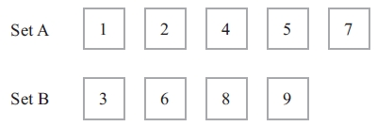

Josh takes at random one card from each set.   
He adds the numbers on the two cards to get the total score.

(a)   Complete the table to show all the possible total scores.

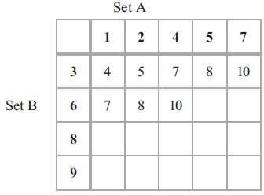

**(1)**

(b)   What is the probability that Josh's total score will be greater than 12?

...........................................................

**(2)**

Josh's year group are raising money for a sponsored skydive.

60 students are each going to play Josh's card game once.   
Each student pays 50p to play the game.

Josh pays £1.50 to any player getting a total of 8

(c)   Show that Josh can expect to make a profit of £21 from his game.

**(4)**

**(Total for Question is 7 marks)**

**1**. Here are a 4–sided spinner and a 5–sided spinner.

The spinners are fair.

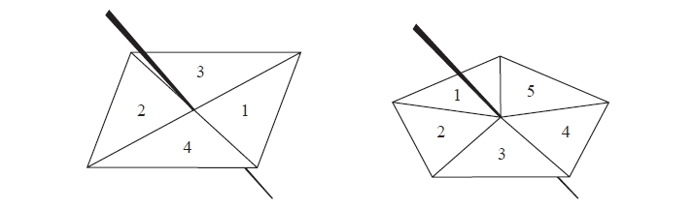

Jeff is going to spin each spinner once.   
Each spinner will land on a number.   
Jeff will get his score by adding these two numbers together.

(a)   Complete the possibility space diagram for each possible score.

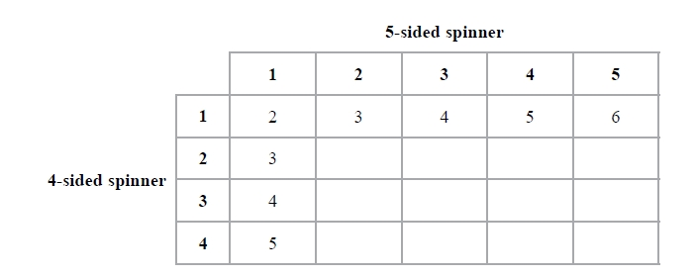

**(1)**

Jeff spins each spinner once.

(b)   Find the probability that Jeff gets

(i)   a score of 3

...........................................................

(ii)   a score of 5 or more.

...........................................................

**(2)**

**(Total for question = 3 marks)**

**Relative Frequency**

**Things to remember:**

* Probabilities of exhaustive events sum to 1
* To calculate relative frequency, multiply the number of trials by the given probability

**Questions:**  
**1.** An electronic game can show red or blue or green or yellow.

The table shows the probabilities that the colour shown will be red or will be green or will be yellow.

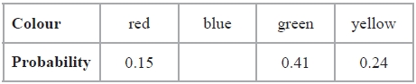

Arthur plays the game.

(a)   Work out the probability that the colour shown will be blue.

...........................................................

**(2)**

Janice is going to play the game 50 times.

(b)   Work out an estimate for the number of times the colour shown will be yellow.

...........................................................

**(2)**

**(Total for question = 4 marks)**

**2.** Karl wants to raise money for charity.   
He designs a game for people to play.

Karl uses a fair 10-sided dice for the game.   
The dice is numbered from 1 to 10

Each person will roll the dice once. A person wins the game if the dice lands on a multiple of 4

Ali plays the game once.

(a)   Work out the probability that Ali will win the game.

...........................................................

**(2)**

Each person pays 30p to play the game once.   
The prize for a win is £1

Karl thinks that the game will be played 100 times.

(b) Work out an estimate for how much money Karl will raise for charity.

...........................................................

**(3)**

**(Total for question = 5 marks)**

**3.** Ali throws a biased dice 200 times.

The table shows information about his results.

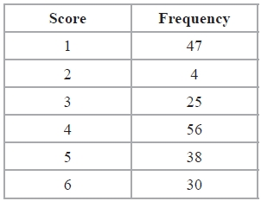

Charlie throws the dice 550 times.   
Work out an estimate for the total number of times that Charlie will get a score of 4

...........................................................

**(Total for Question is 3 marks)**

**4.** Rhiana plays a game.

The probability that she will lose the game is 0.32  
 The probability that she will draw the game is 0.05

Rhiana is going to play the game 200 times.

Work out an estimate for the number of times Rhiana will win the game.

...........................................................

**(Total for Question is 3 marks)**

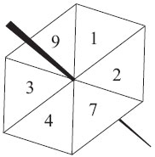**5.** Here is a fair 6-sided spinner.

Jake is going to spin the spinner once.  
(a) Write down the probability that the spinner will land

(i) on 4

...........................................................

(ii) on a number greater than 10

...........................................................

**(2)**

Liz is going to spin the spinner 120 times.

(b) Work out an estimate for the number of times the spinner will land on 7

...........................................................

**(2)**

**(Total for Question is 4 mark)**

**6.** There are only red counters, blue counters, white counters and black counters in a bag.

The table shows the probability that a counter taken at random from the bag will be red or blue.

|  |  |  |  |  |
| --- | --- | --- | --- | --- |
| **Colour** | red | blue | white | black |
| **Probability** | 0.2 | 0.5 |  |  |

The number of white counters in the bag is the same as the number of black counters in the bag.

Tania takes at random a counter from the bag.

(a) Work out the probability that Tania takes a white counter.

...........................................................

**(2)**

There are 240 counters in the bag.

1. Work out the number of red counters in the bag.

...........................................................

**(2)**

**(Total for Question is 4 marks)**

**Set Theory**

**Things to remember:**

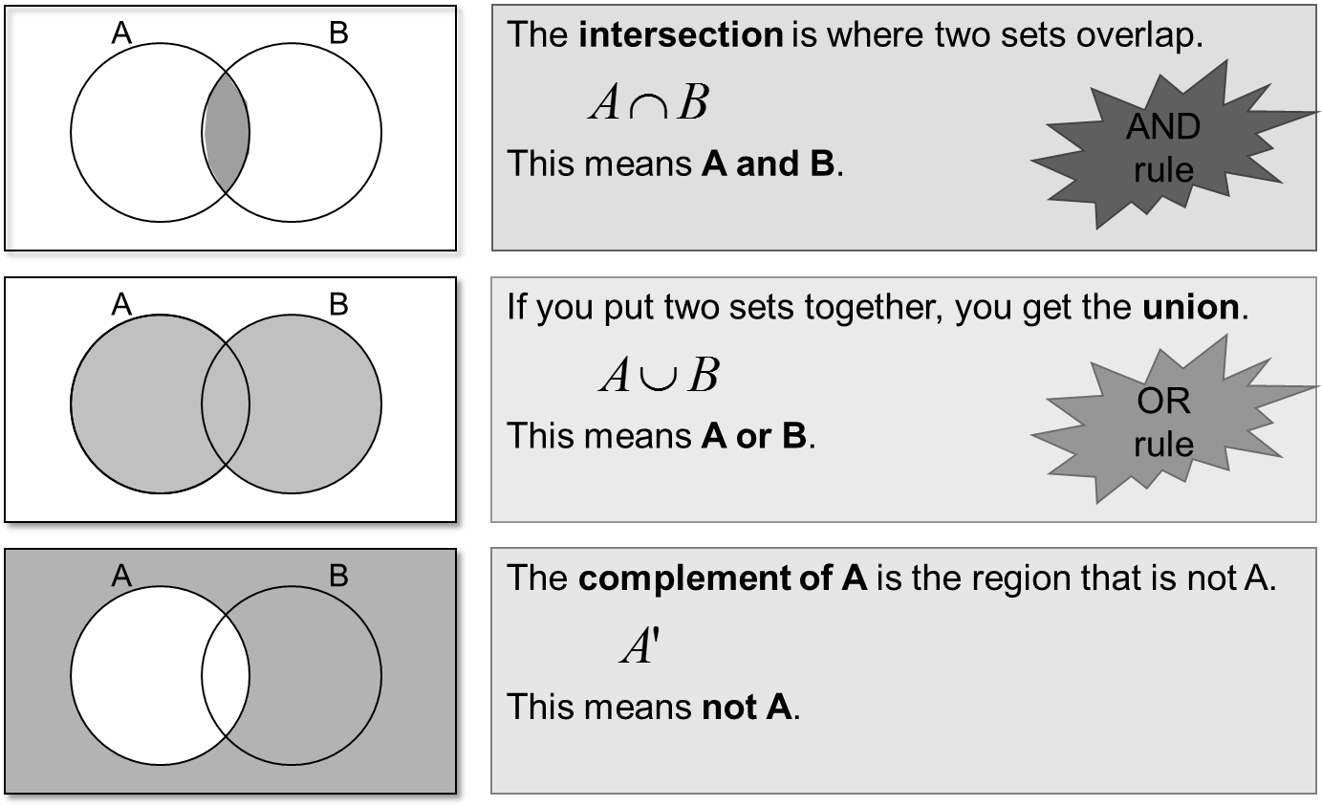

**Questions:**

**1.**

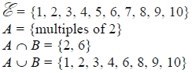

Draw a Venn diagram for this information.

**(Total for question is 4 marks)**

**2.** Sami asked 50 people which drinks they liked from tea, coffee and milk.

All 50 people like at least one of the drinks   
19 people like all three drinks.   
16 people like tea and coffee but do not like milk.   
21 people like coffee and milk.   
24 people like tea and milk.   
40 people like coffee.   
1 person likes only milk.

Sami selects at random one of the 50 people.

(a)   Work out the probability that this person likes tea.

...........................................................

**(4)**

(b)   Given that the person selected at random from the 50 people likes tea, find the probability that this person also likes exactly one other drink.

...........................................................

**(2)**

**(Total for question = 6 marks)**

**Probability Trees**

**Things to remember:**

* The branches must sum to 1;
* Read the question carefully to decide if it is with replacement or without replacement;
* AND means x and OR means +.

**Questions:**

**1.** Amy has 10 CDs in a CD holder.  
Amy’s favourite group is Edex.  
She has 6 Edex CDs in the CD holder.

Amy takes one of these CDs at random.  
She writes down whether or not it is an Edex CD.  
She puts the CD back in the holder.  
Amy again takes one of these CDs at random.

(a) Complete the probability tree diagram.



**(2)**

Amy had 30 CDs.  
The mean playing time of these 30 CDs was 42 minutes.

Amy sold 5 of her CDs.  
The mean playing time of the 25 CDs left was 42.8 minutes.

(b) Calculate the mean playing time of the 5 CDs that Amy sold.

........................................................... minutes

**(3)**

**(Total 5 marks)**

**2.** Amy is going to play one game of snooker and one game of billiards.

The probability that she will win the game of snooker is

The probability that she will win the game of billiards is

Complete the probability tree diagram.

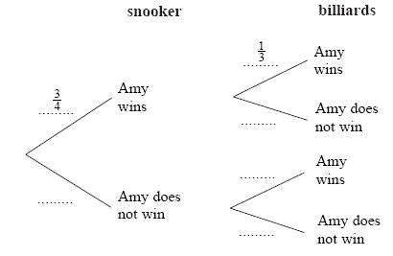

**(Total 2 marks)**

**3.** Loren has two bags.  
The first bag contains 3 red counters and 2 blue counters.  
The second bag contains 2 red counters and 5 blue counters.

Loren takes one counter at random from each bag.

Complete the probability tree diagram.



**(Total 2 marks)**

**4.** Julie has 100 music CDs. 58 of the CDs are classical. 22 of the CDs are folk. The rest of the CDs are jazz. On Saturday, Julie chooses one CD at random from the 100 CDs. On Sunday, Julie chooses one CD at random from the 100 CDs.

(a) Complete the probability tree diagram.

**(2)**



(b) Calculate the probability that Julie will choose a jazz CD on **both** Saturday and  
Sunday.

...........................................................

**(2)**

(c) Calculate the probability that Julie will choose at least one jazz CD on Saturday and  
Sunday.

...........................................................

**(3)**

**(Total 7 marks)**