Upper and Lower Bounds GREEN

1. A field is 100 m wide and 120 m long to the nearest metre.
a) Find the perimeter and area of the field if these measurements are accurate.

b) Find the largest and smallest possible perimeter.

c) Find the largest and smallest possible area.

2. A rectangle’s area is 40 cm² to the nearest whole number. One side of the rectangle is exactly 10 cm. Find the maximum and minimum lengths the other side could have.

3. Usain Bolt runs 100 m, to the nearest metre, in 9.6 seconds, to the nearest tenth of second.
a) What are the greatest and least possible times for Usain?

b) What are the greatest and least possible lengths of the track?

c) What is the fastest possible average speed for Usain?

Upper and Lower Bounds AMBER

1. A field is 100 m wide and 120 m long to the nearest metre.
a) Find the perimeter and area of the field if these measurements are accurate.
Area = base x height, Perimeter = 2 x (base + height)

b) Find the largest and smallest possible perimeter.
LB width = _____ m UB width = _____ m
LB length = _____ m UB length = _____ m

c) Find the largest and smallest possible area.

2. A rectangle’s area is 40 cm² to the nearest whole number. One side of the rectangle is exactly 10 cm. Find the maximum and minimum lengths the other side could have.

3. Usain Bolt runs 100 m, to the nearest metre, in 9.6 seconds, to the nearest tenth of second.
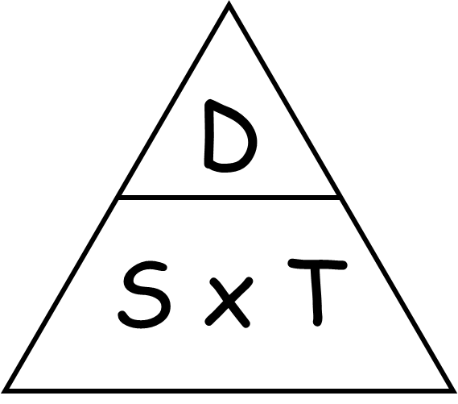
a) What are the greatest and least possible times for Usain?

LB time = _____ seconds UB time = _____ seconds

b) What are the greatest and least possible lengths of the track?

c) What is the fastest possible average speed for Usain?

Upper and Lower Bounds RED

1. A field is 100 m wide and 120 m long to the nearest metre.
a) Find the perimeter and area of the field if these measurements are accurate.
Area = base x height, Perimeter = 2 x (base + height)

b) Find the largest and smallest possible perimeter.
LB width = _____ m UB width = _____ m
LB length = _____ m UB length = _____ m

LB Perimeter = UB Perimeter =

c) Find the largest and smallest possible area.

LB Area = UB Area =

2. A rectangle’s area is 40 cm² to the nearest whole number. One side of the rectangle is exactly 10 cm. Find the maximum and minimum lengths the other side could have.

LB Area = _____ cm² UB Area = _____ cm²

LB Length = _____ ÷ 10 = _____ cm UB Length = _____ ÷ 10 = _____ cm

3. Usain Bolt runs 100 m, to the nearest metre, in 9.6 seconds, to the nearest tenth of second.
a) What are the greatest and least possible times for Usain?

LB time = _____ seconds UB time = _____ seconds

b) What are the greatest and least possible lengths of the track?

LB length = _____ m UB length = _____ m

c) What is the fastest possible average speed for Usain?

Maximum speed = UB distance = _____ =
LB time

