Inequalities (F)

Pre-Intervention Assessment

Name: _______________________________

Class: _______________________________

Date: _______________________________

Question | Objective | RAG
1 | Represent a set of solutions on a number line
2 | Solve linear inequalities
3 | Represent linear inequalities graphically

1. (a) n is an integer.
–1 ≤ n < 4
List the possible values of n.

…........................................................

(b)
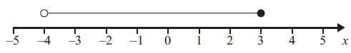
Write down the inequality shown in the diagram.

…........................................................

2. Solve 4 < x – 2 ≤ 7

...........................................................

3. On the grid show, by shading, the region that satisfies all three of the inequalities

x + y < 7 y < 2x y > 3

Label the region R.
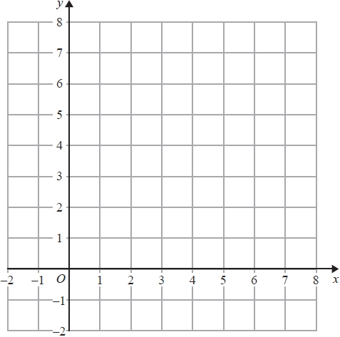

[Glue here]

