Equation of a Line from a Graph GREEN 1

Calculate the equations of the graph below, writing your answers in the form $y=mx+c$

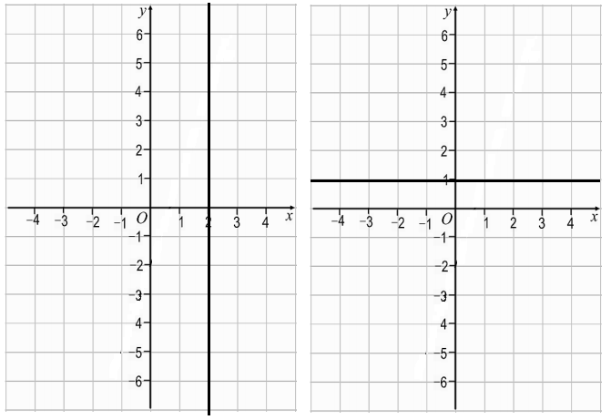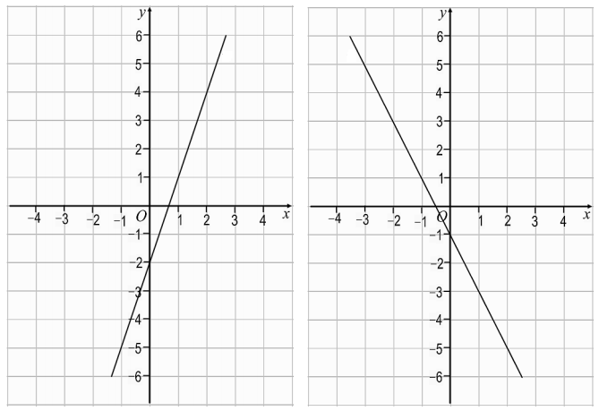

Equation of a Line from a Graph GREEN 2

Calculate the equations of the graph below, writing your answers in the form $y=mx+c$
Look carefully at the scale on the axes!

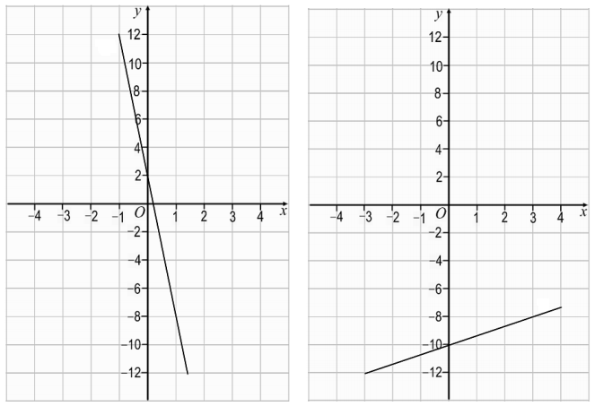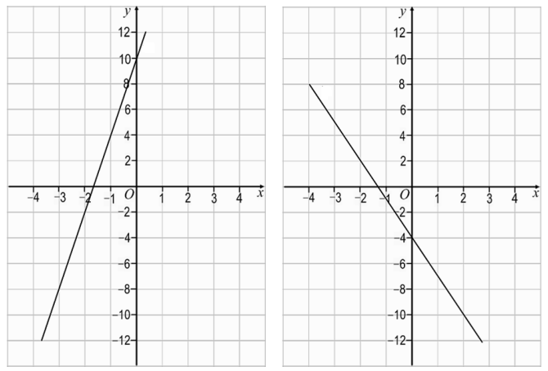

Equation of a Line from a Graph AMBER 1

Calculate the equations of the graph below, writing your answers in the form $y=mx+c$

Negative gradient
Positive gradient

Equation of a Line from a Graph AMBER 2

Calculate the equations of the graph below, writing your answers in the form $y=mx+c$
Look carefully at the scale on the axes!

Negative gradient

Equation of a Line from a Graph RED 1

Calculate the equations of the graph below, writing your answers in the form $y=mx+c$

Negative gradient
Positive gradient

$x=$_______ $y=$_______
$y=mx+c$ $y=mx+c$
$\frac{rise}{run}=\frac{ }{ }=\frac{ }{ }$ $\frac{rise}{run}=\frac{ }{ }=\frac{ }{ }$
$y=______x+c$

Equation of a Line from a Graph RED 2

Calculate the equations of the graph below, writing your answers in the form $y=mx+c$
Look carefully at the scale on the axes!

Negative gradient

