Algebra and Shape GREEN

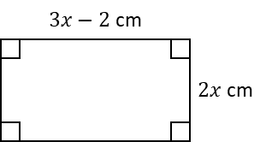
1. The perimeter of this rectangle is $31$ cm.
Find the value of $x$.

$x=$ _________ cm

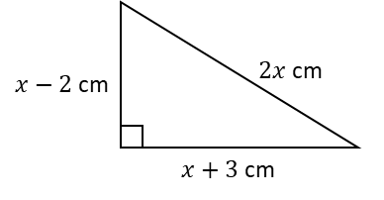
2. The perimeter of this shape is $29$ cm.
What is $x$?

$x=$ _________ cm

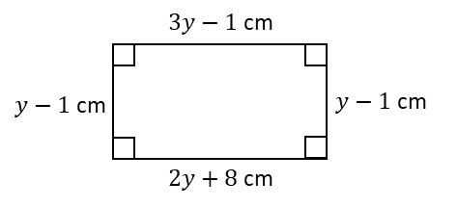
3. A rectangle has the lengths shown.
Find the perimeter of the rectangle.

Perimeter = _________ cm
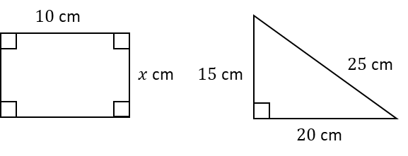
4. The area of the right-angled triangle is equal to the area of the rectangle.
Work out the value of $x$.

$x=$ _________ cm

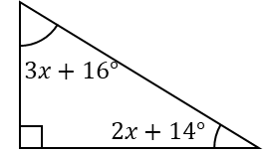
5. The diagram shows a right-angled triangle.
Calculate the value of $x$.

$x=$ _________ º

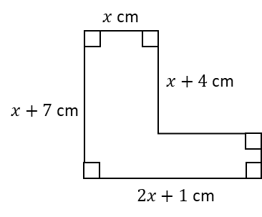
6. The area of this compound shape is $59$ cm².
a) Find the value of $x$.

$x=$ _________ cm

b) Hence calculate the perimeter of the shape.

_________ cm

Algebra and Shape AMBER

1. The perimeter of this rectangle is $31$ cm.
Find the value of $x$.
Perimeter = total distance around the edge of the shape

$x=$ _________ cm

2. The perimeter of this shape is $29$ cm.
What is $x$?

$x=$ _________ cm

3. A rectangle has the lengths shown.
Find the perimeter of the rectangle.
Use the fact that opposite sides of a rectangle are equal

Perimeter = _________ cm
4. The area of the right-angled triangle is equal to the area of the rectangle.
Work out the value of $x$.
Start by calculating the area of the triangle

$x=$ _________ cm

5. The diagram shows a right-angled triangle.
Calculate the value of $x$.
What do angles in a triangle sum to?

$x=$ _________ º

6. The area of this compound shape is $59$ cm².
a) Find the value of $x$.
Split the shape into two rectangles!

$x=$ _________ cm

b) Hence calculate the perimeter of the shape.

_________ cm
Algebra and Shape RED

1. The perimeter of this rectangle is $31$ cm.
Find the value of $x$.
Perimeter = total distance around the edge of the shape

$3x-2+2x+3x-2+2x=31$

$x=$ _________ cm

2. The perimeter of this shape is $29$ cm.
What is $x$?

$x-2+2x+x+3=29$

$x=$ _________ cm

3. A rectangle has the lengths shown.
Find the perimeter of the rectangle.
Use the fact that opposite sides of a rectangle are equal

$3y-1=2y+8$ (solve this!)

Perimeter = _________ cm
4. The area of the right-angled triangle is equal to the area of the rectangle.
Work out the value of $x$.
Start by calculating the area of the triangle

$\frac{1}{2}×15×20=$

$x=$ _________ cm

5. The diagram shows a right-angled triangle.
Calculate the value of $x$.
What do angles in a triangle sum to?

$90+3x+16+2x+14=$

$x=$ _________ º

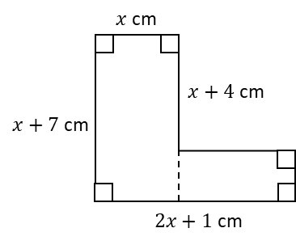
6. The area of this compound shape is $59$ cm².
a) Find the value of $x$.
Split the shape into two rectangles!

$x=$ _________ cm

b) Hence calculate the perimeter of the shape.

_________ cm

