Band 5 – Test 1 Answers

1. | 4500 x 1.04² = £4867.20 | 1 mark for correct multiplier  1 mark for correct index  1 mark for correct answer | 3
2. | S α 1  f²  S = k  f²  125 = k  8²  k = 8000  S = 8000  f²  S = 8000 = 8000 = 500  4² 16 | 1 mark for calculating k  1 mark for correct formula  1 mark for substituting f  1 mark for correct answer | 4
3. | 16^{3/4} = ${\sqrt[4]{16}}^{3}$ = $2^{3}$ = 8 | 1 mark for $\sqrt[4]{}$  1 mark for cubing answer | 2
4. | (3.2 x 10⁵) x (4.5 x 10⁴)  = 3.2 x 4.5 x 10⁹  = 14.40 x 10⁹  = 1.44 x 10¹⁰ | 1 mark for 1440, 14.4 or 1.44 seen  1 mark for correct answer | 2

5. | x -2 -1 0 1 2  y -12 -4 -2 0 8  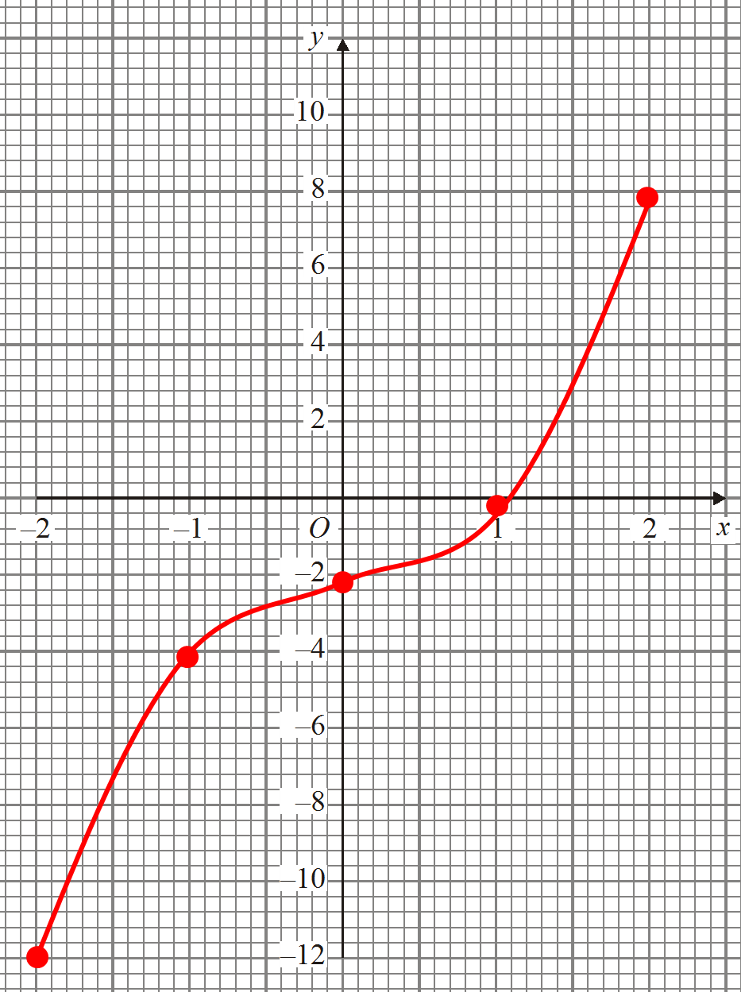 | 1 mark for 2 y values correct  Or 2 marks for all y values correct  1 mark for correct coordinates plotted  1 mark for correct graph drawn | 4

6. | L₂: y = 2x + c  2 = 2(3) + c  c = -4  y = 2x - 4 |  | 1 mark for gradient  1 mark for substituting to find c  1 mark for correct answer | 3
7. | (x – 3)(x – 4)  x = 3 or 4 |  | 1 mark for 3 or 4 seen  1 mark for correct factorisation  1 mark for correct answer | 3
8. | 3x – 4y = 13 x2  2x + 3y = 3 x3  6x – 8y = 26  6x + 9y = 9 -_  -17y = 17  y = -1___  3x – 4y = 13  3x + 4 = 13  3x = 9  x = 3 | 3x – 4y = 13 x3  2x + 3y = 3 x4  9x – 12y = 39  8x + 12y = 12 +  17x = 51  x = 3____  3x – 4y = 13  9 – 4y = 13  -4y = 4  y =-1 | 1 mark for scaling up correctly  1 mark for calculating 1 variable  1 mark for correct substitution  1 mark for calculating other variable  0 marks if non-algebraic method used | 4
9. | P = n² + a  n + a  P(n + a) = n² + a  Pn + an = n² + a  Pa – a = n² - Pn  a(P – 1) = n² - Pn  a = n² - Pn  P – 1 |  | 1 mark for multiplying by denominator  1 mark for expanding brackets  1 mark for factorising  1 mark for correct answer | 4

10. | 5x – 7 < 2x – 1  3x – 7 < -1  3x < 6  x < 2 | 1 mark for 2  1 mark for correct inequality symbol used | 2
11. | CD = AD & DG = DE as both sides of squares  CDG = ADE (= ADG + 90°)  SAS proves congruence | 1 mark for CD = AD & DG = DE  1 mark for CDG = ADE  1 mark for SAS oe in words | 3
12. | 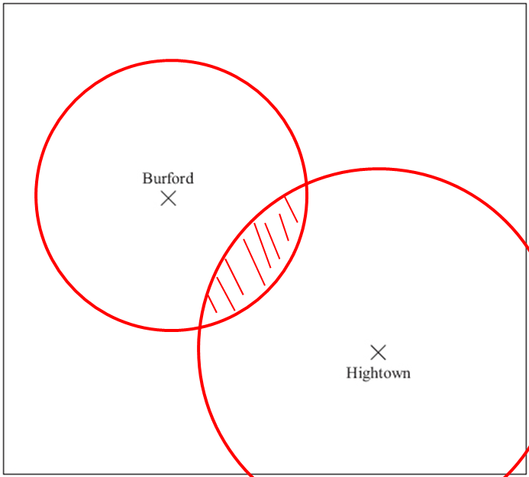 | 1 mark for circle radius 2 cm from Burford  1 mark for circle radius 3 from Hightown  1 mark for correct region shaded | 3

13. | AB = 8.5 x tan38 = 6.640927… = 6.64 cm | 1 mark for use of tan  1 mark for correct working  1 mark for correctly rounded answer | 3
14. | 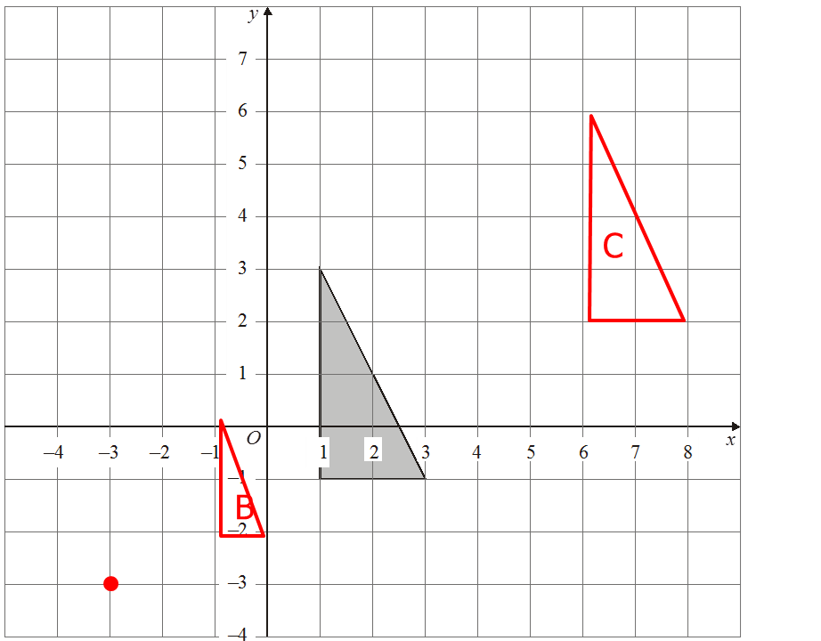 | 1 mark for identifying C of E  1 mark for correct enlargement of ½  1 mark for enlargement in correct place  1 mark for correct x movement  1 mark for correct y movement | 5
15. | _60_ x 24 x π = 12.5663… = 12.6 cm  360 | 1 mark for correct fraction  1 mark for correct working  1 mark for correct answer | 3

16. | 1/3 x π x 5² x 8 = 209.43951… = 209 cm³ | 1 mark for correct base area  1 mark for correct working  1 mark for correct answer | 3
17. | 8 x 1.25 = 10 cm  6 ÷ 1.25 = 4.8 cm | 1 marks for each correct working  1 mark for each correct answer | 4
18. | Goals scored Frequency M x f  1 9 9  2 3 6  3 5 15  4 3 12  Mean = 42 = 2.1  20 | 1 mark for correct third column  1 mark for Σmf  Σf  1 mark for correct answer | 3
19. | _43_ x 40 = 13.030303… = 13 boys  132 | 1 mark for correct working  1 mark for correct answer | 2
20. | 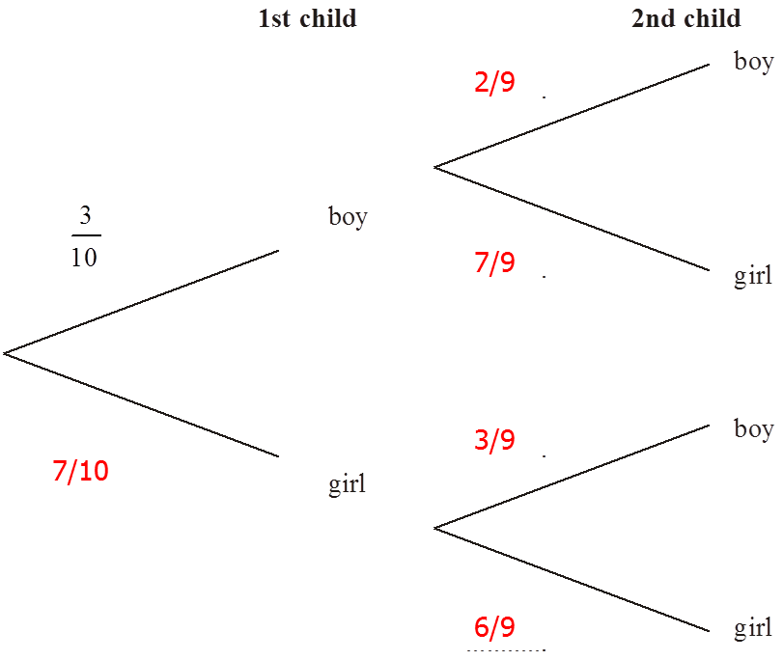  P(G and G) = 7 x 6 = 42  10 9 90 | 1 mark for 1st child correct  1 mark for 2nd child correct  1 mark for correct working  1 mark for correct answer | 4

