Parabolas, Roots and Turning Points GREEN

1. a) Complete the table of values for $y=x^{2}-5x+3$
$$x$$ | $$-1$$ | $$0$$ | $$1$$ | $$2$$ | $$3$$ | $$4$$ | $$5$$
$$y$$ |  | $$3$$ | $$-1$$ |  | $$-3$$ |  | $$3$$

b) On the grid below, draw the graph of $y=x^{2}-5x+3$ for values of $x$ from $x=-1$ to $x=5$

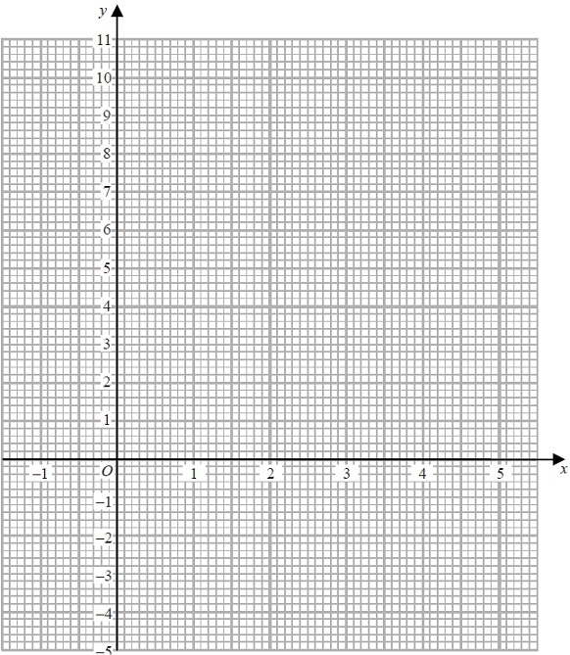
c) Find estimates of the solutions of the equation $x^{2}-5x+3=0$

$x=$ ………………… or …………………
d) Identify the turning point of $y=x^{2}-5x+3$

(…………………, …………………)
2. a) Complete the table of values for $y=x^{2}-2x-1$
$$x$$ | $$-2$$ | $$-1$$ | $$0$$ | $$1$$ | $$2$$ | $$3$$
$$y$$ | $$7$$ |  |  | $$-2$$ | $$-1$$

b) On the grid, draw the graph of $y=x^{2}-2x-1$ for values of $x$ from $x=-2$ to $x=3$

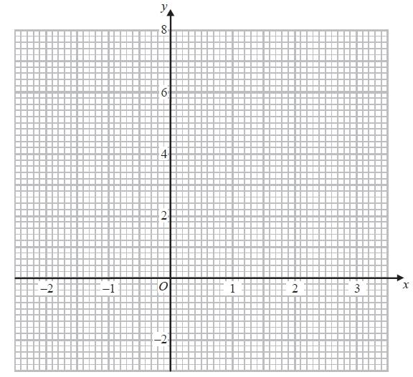

c) Find estimates for the solutions of the equation $x^{2}-2x-1=0$

$x=$ ………………… or …………………

d) Identify the turning point of $y=x^{2}-2x-1$

(…………………, …………………)
3. a) Complete the table of values for $y=x^{2}-3x+2$
$$x$$ | $$-1$$ | $$0$$ | $$1$$ | $$2$$ | $$3$$ | $$4$$ | $$5$$
$$y$$ | $$6$$ |  |  |  | $$2$$ |  | $$12$$

b) On the grid, draw the graph of $y=x^{2}-3x+2$ for values of $x$ from $-1$ to $5$

c) Find estimates for the solutions of the equation $x^{2}-3x+2=4$

$x=$ ………………… or …………………

d) Identify the turning point of $y=x^{2}-3x+2$

(…………………, …………………)
4. a) Complete the table of values for $y=x^{2}-2x-1$
$$x$$ | $$-2$$ | $$-1$$ | $$0$$ | $$1$$ | $$2$$ | $$3$$ | $$4$$
$$y$$ | $$7$$ |  |  | $$-2$$ | $$-1$$

b) On the grid, draw the graph of $y=x^{2}-2x-1$ for values of $x$ from $-2$ to $4$

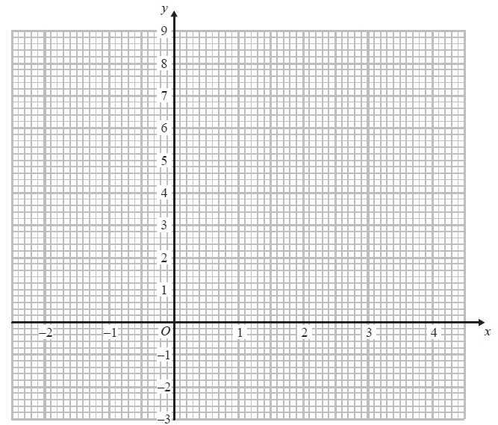

c) Solve $x^{2}-2x-1=2x$

$x=$ ………………… or …………………

d) Identify the turning point of $y=x^{2}-2x-1$

(…………………, …………………)

Parabolas, Roots and Turning Points AMBER

1. a) Complete the table of values for $y=x^{2}-5x+3$
$$x$$ | $$-1$$ | $$0$$ | $$1$$ | $$2$$ | $$3$$ | $$4$$ | $$5$$
$$y$$ |  | $$3$$ | $$-1$$ |  | $$-3$$ |  | $$3$$
Substitute the $x$ values into the equation to get the $y$ values

b) On the grid below, draw the graph of $y=x^{2}-5x+3$ for values of $x$ from $x=-1$ to $x=5$
Remember to join the coordinates with a single smooth curve
The equation is equal to 0 so identify the roots of the equation
c) Find estimates of the solutions of the equation $x^{2}-5x+3=0$

$x=$ ………………… or …………………
d) Identify the turning point of $y=x^{2}-5x+3$
At which coordinate does the graph change direction?

(…………………, …………………)
2. a) Complete the table of values for $y=x^{2}-2x-1$
$$x$$ | $$-2$$ | $$-1$$ | $$0$$ | $$1$$ | $$2$$ | $$3$$
$$y$$ | $$7$$ |  |  | $$-2$$ | $$-1$$

b) On the grid, draw the graph of $y=x^{2}-2x-1$ for values of $x$ from $x=-2$ to $x=3$

Sketch the graph of $y=x+3$ and identify the $x$ values of the intersection points

c) Find estimates for the solutions of the equation
$x^{2}-2x-1=0$

$x=$ ………………… or …………………

d) Identify the turning point of $y=x^{2}-2x-1$

(…………………, …………………)
3. a) Complete the table of values for $y=x^{2}-3x+2$
$$x$$ | $$-1$$ | $$0$$ | $$1$$ | $$2$$ | $$3$$ | $$4$$ | $$5$$
$$y$$ | $$6$$ |  |  |  | $$2$$ |  | $$12$$

b) On the grid, draw the graph of $y=x^{2}-3x+2$ for values of $x$ from $-1$ to $5$

c) Find estimates for the solutions of the equation $x^{2}-3x+2=4$

$x=$ ………………… or …………………

d) Identify the turning point of $y=x^{2}-3x+2$

(…………………, …………………)
4. a) Complete the table of values for $y=x^{2}-2x-1$
$$x$$ | $$-2$$ | $$-1$$ | $$0$$ | $$1$$ | $$2$$ | $$3$$ | $$4$$
$$y$$ | $$7$$ |  |  | $$-2$$ | $$-1$$

b) On the grid, draw the graph of $y=x^{2}-2x-1$ for values of $x$ from $-2$ to $4$

c) Solve $x^{2}-2x-1=2x$

$x=$ ………………… or …………………

d) Identify the turning point of $y=x^{2}-2x-1$

(…………………, …………………)

Parabolas, Roots and Turning Points RED

1. a) Complete the table of values for $y=x^{2}-5x+3$
$$x$$ | $$-1$$ | $$0$$ | $$1$$ | $$2$$ | $$3$$ | $$4$$ | $$5$$
$$y$$ |  | $$3$$ | $$-1$$ |  | $$-3$$ |  | $$3$$
Substitute the $x$ values into the equation to get the $y$ values

b) On the grid below, draw the graph of $y=x^{2}-5x+3$ for values of $x$ from $x=-1$ to $x=5$
Remember to join the coordinates with a single smooth curve
The equation is equal to 0 so identify the roots of the equation
c) Find estimates of the solutions of the equation $x^{2}-5x+3=0$

$x=$ ………………… or …………………
d) Identify the turning point of $y=x^{2}-5x+3$
At which coordinate does the graph change direction?

(…………………, …………………)

2. a) Complete the table of values for $y=x^{2}-2x-1$
$$x$$ | $$-2$$ | $$-1$$ | $$0$$ | $$1$$ | $$2$$ | $$3$$
$$y$$ | $$7$$ |  |  | $$-2$$ | $$-1$$

b) On the grid, draw the graph of $y=x^{2}-2x-1$ for values of $x$ from $x=-2$ to $x=3$
Remember to join the coordinates with a single smooth curve

Sketch the graph of $y=x+3$ and identify the $x$ values of the intersection points

c) Find estimates for the solutions of the equation
$x^{2}-2x-1=0$

$x=$ ………………… or …………………

d) Identify the turning point of $y=x^{2}-2x-1$
At which coordinate does the graph change direction?

(…………………, …………………)
3. a) Complete the table of values for $y=x^{2}-3x+2$
$$x$$ | $$-1$$ | $$0$$ | $$1$$ | $$2$$ | $$3$$ | $$4$$ | $$5$$
$$y$$ | $$6$$ |  |  |  | $$2$$ |  | $$12$$
Substitute the $x$ values into the equation to get the $y$ values

b) On the grid, draw the graph of $y=x^{2}-3x+2$ for values of $x$ from $-1$ to $5$
Remember to join the coordinates with a single smooth curve

Sketch the graph of $y=4$ and identify the $x$ values of the intersection points

c) Find estimates for the solutions of the equation $x^{2}-3x+2=4$

$x=$ ………………… or …………………

d) Identify the turning point of $y=x^{2}-3x+2$
At which coordinate does the graph change direction?

(…………………, …………………)

4. a) Complete the table of values for $y=x^{2}-2x-1$
$$x$$ | $$-2$$ | $$-1$$ | $$0$$ | $$1$$ | $$2$$ | $$3$$ | $$4$$
$$y$$ | $$7$$ |  |  | $$-2$$ | $$-1$$

b) On the grid, draw the graph of $y=x^{2}-2x-1$ for values of $x$ from $-2$ to $4$
Remember to join the coordinates with a single smooth curve

Sketch the graph of $y=2x$ and identify the $x$ values of the intersection points

c) Solve $x^{2}-2x-1=2x$

$x=$ ………………… or …………………

d) Identify the turning point of $y=x^{2}-2x-1$

At which coordinate does the graph change direction?
(…………………, …………………)

