Solving Trigonometric Equations

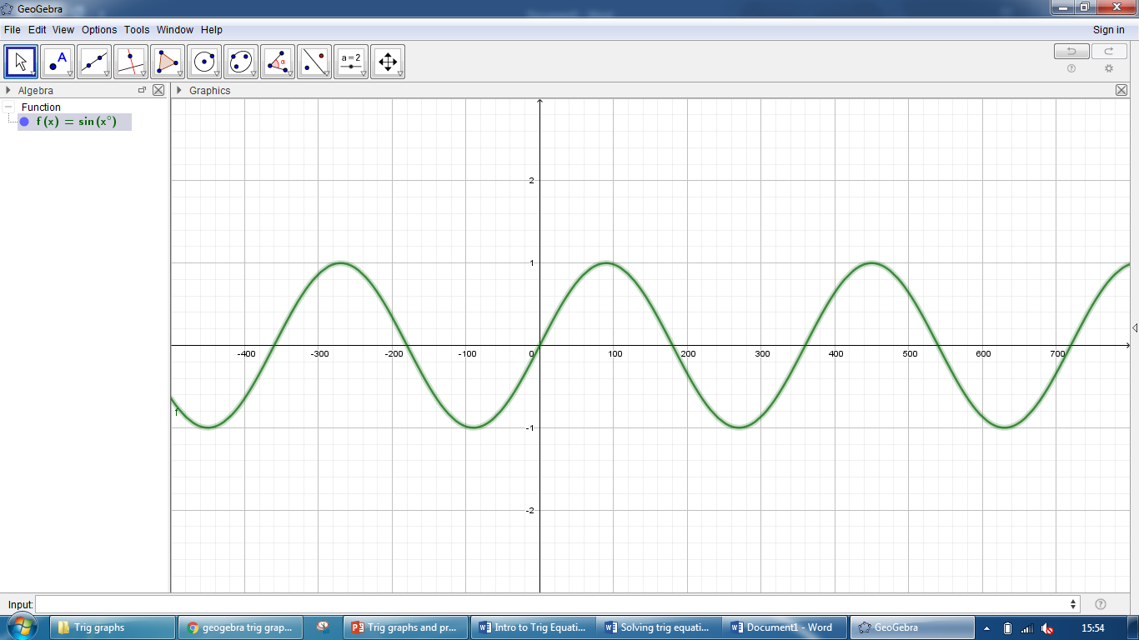

Use these graphs to help you answer the questions below.

Consider:

* Periods
* Rotational symmetry
* Reflective symmetry

Give your answers correct to one decimal place.

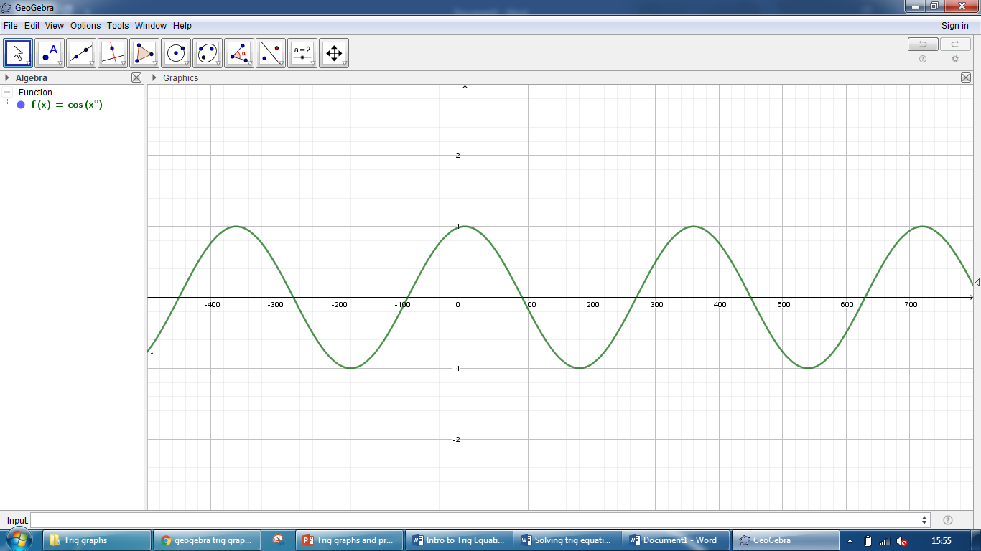

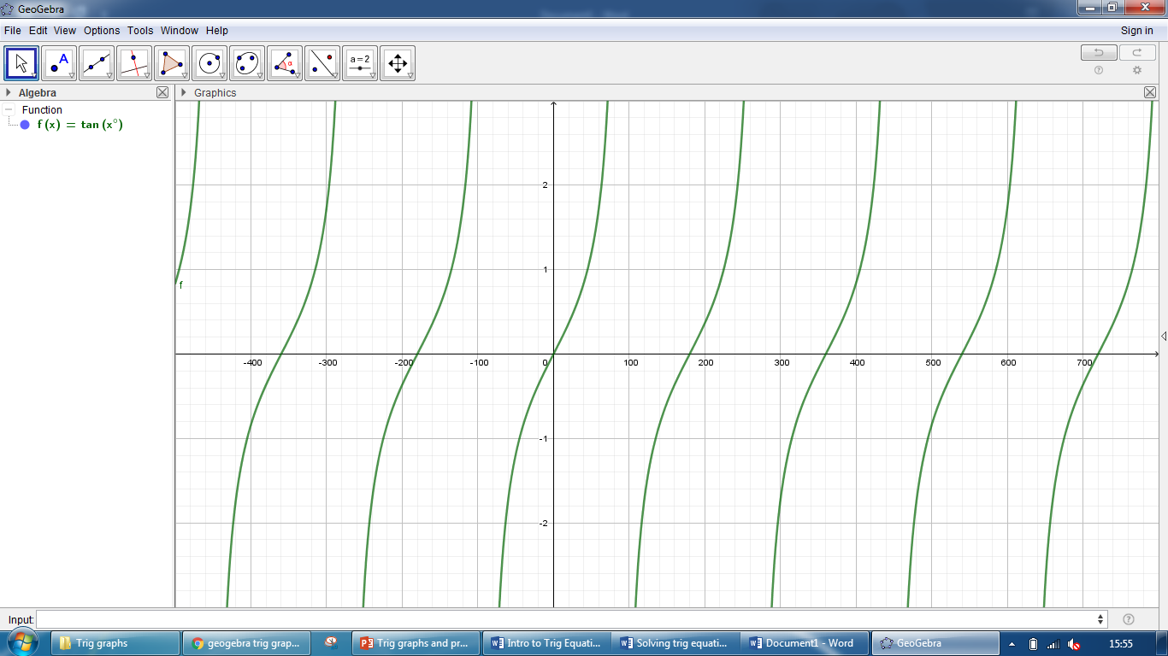

|  |  |  |  |  |
| --- | --- | --- | --- | --- |
| Q | Equation | Domain | Working | Solutions |
| 1 |  |  |  |  |
| 2 |  |  |  |  |
| 3 |  |  |  |  |
| 4 |  |  |  |  |
| 5 |  |  |  |  |
| 6 |  |  |  |  |
| 7 |  |  |  |  |
| 8 |  |  |  |  |
| 9 |  |  |  |  |
| 10 |  |  |  |  |